**Pressures in the Body**

Next to taking a person’s temperature and weight, measuring blood pressure is the most common of all medical examinations. Control of high blood pressure is largely responsible for the significant decreases in heart attack and stroke fatalities achieved in the last three decades. The pressures in various parts of the body can be measured and often provide valuable medical indicators. In this section, we consider a few examples together with some of the physics that accompanies them. Table 1 lists some of the measured pressures in mm Hg, the units most commonly quoted.

## Blood Pressure

Common arterial blood pressure measurements typically produce values of 120 mm Hg and 80 mm Hg, respectively, for systolic and diastolic pressures. Both pressures have health implications. When systolic pressure is chronically high, the risk of stroke and heart attack is increased. If, however, it is too low, fainting is a problem. Systolic pressure increases dramatically during exercise to increase blood flow and returns to normal afterward. This change produces no ill effects and, in fact, may be beneficial to the tone of the circulatory system. Diastolic pressure can be an indicator of fluid balance. When low, it may indicate that a

person is hemorrhaging internally and needs a transfusion. Conversely, high diastolic pressure indicates a ballooning of the blood vessels, which may be due to the transfusion of too much fluid into the circulatory system. High diastolic pressure is also an indication that blood vessels are not dilating properly to pass blood through. This can seriously strain the heart in its attempt to pump blood.

Blood leaves the heart at about 120 mm Hg but its pressure continues to decrease (to almost 0) as it goes from the aorta to smaller arteries to small veins (see Figure 1). The pressure differences in the circulation system are caused by blood flow through the system as well as the position of the person. For a person standing up, the pressure in the feet will be larger than at the heart due to the weight of the blood (P = hρg). If we assume that the distance between the heart and the feet

of a person in an upright position is 1.4 m, then the increase in pressure in the feet relative to that in the heart (for a static column of blood) 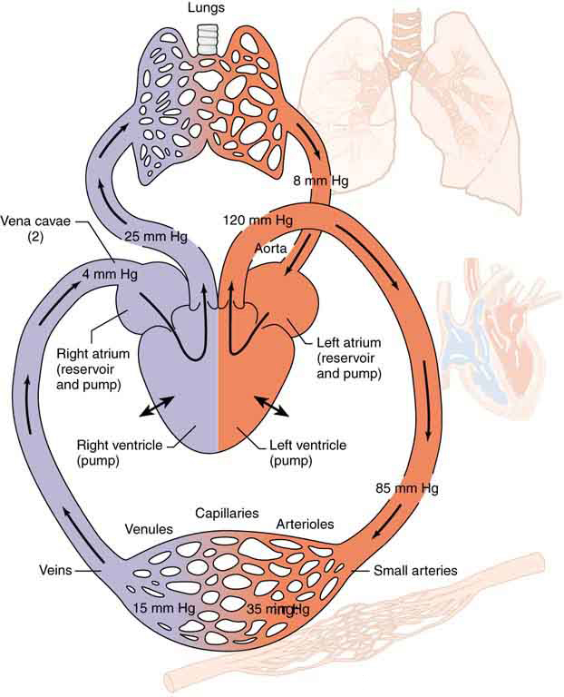

Pressure in the Eye

The shape of the eye is maintained by fluid pressure, called intraocular pressure, which is normally in the range of 12.0 to 24.0 mm Hg. When the circulation of fluid in the eye is blocked, it can lead to a buildup in pressure, a condition called glaucoma. The net pressure can become as great as 85.0 mm Hg, an abnormally large pressure that can permanently damage the optic nerve. To get an idea of the force involved, suppose the back of the eye has an area of 6.0 cm2, and the net pressure is 85.0 mm Hg. Force is given by F = PA. To get F in newtons, we convert the area to m2 (1 m2 = 104 cm2).

This force is the weight of about a 680-g mass. A mass of 680 g resting on the eye (imagine 1.5 lb resting on your eye) would be sufficient to cause it damage. (A normal force here would be the weight of about 120 g, less than one-quarter of our initial value.)

People over 40 years of age are at greatest risk of developing glaucoma and should have their intraocular pressure tested routinely. Most measurements involve exerting a force on the (anesthetized) eye over some area (a pressure) and observing the eye’s response. A noncontact approach uses a puff of air and a measurement is made of the force needed to indent the eye (Figure 2). If the intraocular pressure is high, the eye will deform less and rebound more vigorously than normal. Excessive intraocular pressures can be detected reliably and sometimes controlled effectively.

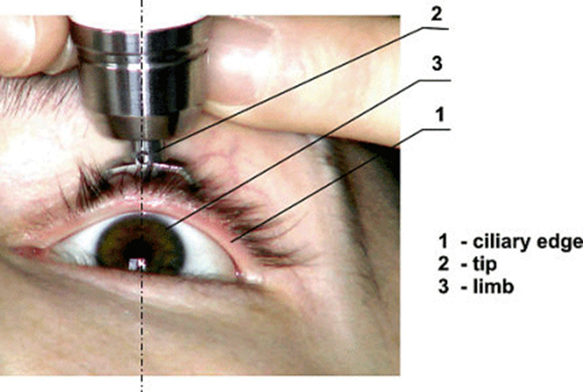

## Pressure Associated with the Lungs

The pressure inside the lungs increases and decreases with each breath. The pressure drops to below atmospheric pressure (negative gauge pressure) when you inhale, causing air to flow into the lungs. It increases above atmospheric pressure (positive gauge pressure) when you exhale, forcing air out. Lung pressure is controlled by several mechanisms. Muscle action in the diaphragm and rib cage is necessary for inhalation; this muscle action increases the volume of the lungs thereby reducing the pressure within them Figure 3. Surface tension in the alveoli creates a positive pressure opposing inhalation. (See [**Cohesion and Adhesion in Liquids: Surface Tension and Capillary Action**](https://courses.lumenlearning.com/physics/chapter/11-9-pressures-in-the-body/chapter/11-8-cohesion-and-adhesion-in-liquids-surface-tension-and-capillary-action/).) You can exhale without muscle action by letting surface tension in the alveoli create its own positive pressure. Muscle action can add to this positive pressure to produce forced exhalation, such as when you blow up a balloon, blow out a candle, or cough. The lungs, in fact, would collapse due to the surface tension in the alveoli, if they were not attached to the inside of the chest wall by liquid adhesion. The gauge pressure in the liquid attaching the lungs to the inside of the chest wall is thus negative, ranging from −4 to −8 mm Hg during exhalation and inhalation, respectively. If air is allowed to enter the chest cavity, it breaks the attachment, and one or both lungs may collapse. Suction is applied to the chest cavity of surgery patients and trauma victims to reestablish negative pressure and inflate the lungs.

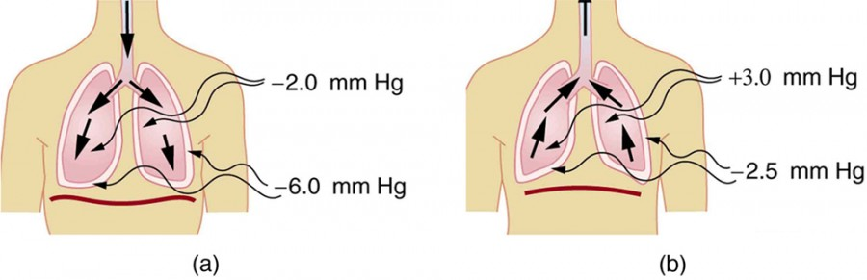

Figure 3. (a) During inhalation, muscles expand the chest, and the diaphragm moves downward, reducing pressure inside the lungs to less than atmospheric (negative gauge pressure). Pressure between the lungs and chest wall is even lower to overcome the positive pressure created by surface tension in the lungs. (b) During gentle exhalation, the muscles simply relax and surface tension in the alveoli creates a positive pressure inside the lungs, forcing air out. Pressure between the chest wall and lungs remains negative to keep them attached to the chest wall, but it is less negative than during inhalation.

## Other Pressures in the Body

### Spinal Column and Skull

Normally, there is a 5- to 12-mm Hg pressure in the fluid surrounding the brain and filling the spinal column. This cerebrospinal fluid serves many purposes, one of which is to supply flotation to the brain. The buoyant force supplied by the fluid nearly equals the weight of the brain, since their densities are nearly equal. If there is a loss of fluid, the brain rests on the inside of the skull, causing severe headaches, constricted blood flow, and serious damage. Spinal fluid pressure is measured by means of a needle inserted between vertebrae that transmits the pressure to a suitable measuring device.

### Bladder Pressure

This bodily pressure is one of which we are often aware. In fact, there is a relationship between

our awareness of this pressure and a subsequent increase in it. Bladder pressure climbs steadily from zero to about 25 mm Hg as the bladder fills to its normal capacity of 500 cm3. This pressure triggers the micturition reflex, which stimulates the feeling of needing to urinate. What is more, it also causes muscles around the bladder to contract, raising the pressure to over 100 mm Hg, accentuating the sensation. Coughing, straining, tensing in cold weather, wearing tight clothes, and experiencing simple nervous tension all can increase bladder pressure and trigger this reflex. So can the weight of a pregnant woman’s fetus, especially if it is kicking vigorously or pushing down with its head! Bladder pressure can be measured by a catheter or by inserting a needle through the bladder wall and transmitting the pressure to an appropriate measuring device. One hazard of high bladder pressure (sometimes created by an obstruction), is that such pressure can force urine back into the kidneys, causing potentially severe damage.

### Pressures in the Skeletal System

These pressures are the largest in the body, due both to the high values of initial force, and the small areas to which this force is applied, such as in the joints.. For example, when a person lifts \an object improperly, a force of 5000 N may be created between vertebrae in the spine, and this may be applied to an area as small as 10 cm2. The pressure created is P = F/A = (5000 N)/(10-3m2) = 5.0 × 106 N/m2 or about 50 atm! This pressure can damage both the spinal discs (the cartilage between vertebrae), as well as the bony vertebrae themselves. Even under normal circumstances, forces between vertebrae in the spine are large enough to create pressures of several atmospheres. Most causes of excessive pressure in the skeletal system can be avoided by lifting properly and avoiding extreme physical activity. (See [**Forces and Torques in Muscles and Joints**](https://courses.lumenlearning.com/physics/chapter/11-9-pressures-in-the-body/chapter/9-6-forces-and-torques-in-muscles-and-joints/).)

There are many other interesting and medically significant pressures in the body. For example, pressure caused by various muscle actions drives food and waste through the digestive system. Stomach pressure behaves much like bladder pressure and is tied to the sensation of hunger. Pressure in the relaxed esophagus is normally negative because pressure in the chest cavity is normally negative. Positive pressure in the stomach may thus force acid into the esophagus, causing “heartburn.” Pressure in the middle ear can result in significant force on the eardrum if it differs greatly from atmospheric pressure, such as while scuba diving. The decrease in external pressure is also noticeable during plane flights (due to a decrease in the weight of air above relative to that at the Earth’s surface). The Eustachian tubes connect the middle ear to the throat and allow us to equalize pressure in the middle ear to avoid an imbalance of force on the eardrum.