**CELL THEORY**

**INTRODUCTION**

• A historic theory

• Universally accepted

• Aristotle – put forward the first concept that all living things consists of certain structural units (384-322 BC)

• Robert Hooke – 1665 – Piece of cork under a primitive microscope observed the so called cells.

• Later in plants by Grew and Malpighi.

• In 1674 – Antan Van Leeuvenhoek – observed free cells and some organization with in cells.

• Though several workers worked in this, finally compiled as a theory by the German Botanist Schleiden and German Zoologist T. Schwann – 1839 - it is not a discovery.

**CELL THEORY**

1. Cell is the Structural and functional unit of life.

2. All living organisms are formed of one or more cells.

**EXTENDED CELL THEORY**

Virchow. R. 1858 – stated that living cells arise from pre existing living.

1. All living organisms are composed of one or more cells.

2. The cell is the basic unit of structure and organization in organisms. 3. Cells arise from pre existing cells.

**MODERN VERSION**

Since it was found that.

• The activity of the organism dependent on the activity of independent cells. • Energy flow (metabolism) occurs with in cells.

• Cells contain DNA which is found in the cell nucleus or cytoplasm.

All cells are basically the same in chemical composition in organisms of similar species.

**MODERN VERSION OF CELL THEORY INCLUDES**

• Energy flow occurs with in cells.

• Heredity information (DNA) is passed on from cell to cell.

• All cells have same basic chemical composition.

**EXCEPTION**

1. Cell theory cannot be applied as such to virus. Because

• They lack an internal organization which is characteristic to cells. • They act as living chemicals.

• They are either considered as “Cellular forms degenerated through parasitism” or as primitive. Organisms that have not reached a cellular state.

2. Unicellular organisms like protozoans, fungus or algae – Because there is hardly any organization like that of a cell.

So these may or may not be considered as exception to cell theory.

**Mitochondrial DNA and Ribosomes**

Although most DNA is packaged in chromosomes within the nucleus, mitochondria also have a small amount of their own DNA. This genetic material is known as mitochondrial DNA or mtDNA. In humans, mitochondrial DNA spans about 16,500 DNA building blocks (base pairs), representing a small fraction of the total DNA in cells.

Mitochondrial DNA contains 37 genes, all of which are essential for normal mitochondrial function. Thirteen of these genes provide instructions for making enzymes involved in oxidative phosphorylation.

The remaining genes provide instructions for making molecules called transfer RNA (tRNA) and ribosomal RNA (rRNA), which are chemical cousins of DNA. These types of RNA help assemble protein building blocks (amino acids) into functioning proteins.

**Organization of human mitochondrial DNA.**

❖ Contains 44% GC content

• 37 genes are distributed of which

• 24 genes encode mature RNA (large and small rRNA and tRNAs) and • 13 genes encode enzymes involved in oxidative phosphorylation

**Characteristics of mitochondrial DNA**

1. **Circular**

2. Multicopy (466-806 nucleoids /cell)

i. **5-10 copies of mtDNA / mitochondrion**

ii. **~1,000 mitochondria / cell**

3. **Small in size ~16 kb in man (**16,569 bp length and 0.68mM diameter) 4. **~1% of cellular DNA**

5. Genes lack introns - **NO INTRONS- polycistronic mRNAs**

6. Maternally inherited

7. More stable for forensic analysis

8. Heteroplasmy (original and mutated forms co-exist)

9. Mitochondrial genetic code has different genetic code as compared to that in nucleus

Codon Mitochondrial Universal

UGA Tryptophan Stop

AUA Methionine Isoleucine

AGA Stop Arginine

AGG Stop Arginine

9. High Mutation rate of ~1/33 generations

**Threshold effect**

Different tissues have different energy needs and thus, a different levels of tolerance for mtDNA mutations. For example, if 70% of mtDNA is mutated in different tissues, cellular dysfunction is not observed in all cases.

Tissue Evidence of disease

Fibroblasts asymptomatic

Liver asymptomatic

Heart dysfunction

Brain dysfunction

Muscle dysfunction This is called **Threshold effect.**

**Mt encephalomyopathies**

► Mutations in every 20-50,000 individuals

► Clinical heterogeneity due to heteroplasmy

► Mostly affects post-mitotic tissues with high oxidative demands like muscle and neurons that results in accumulation of Free radicals, Apoptosis, Diabetes, Neurodegeneration, Aging and Cancer

**Mitochondrial Ribosome**

Mitochondrial ribosome or mitoribosome is a protein complex that is active in mitochondria and functions as a riboprotein or translating mitochondrial mRNAs encoded in mtDNA.

**Structure**

Mammalian mitoribosomes have 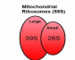

small 28S and large 39S subunits,

together forming a

55S mitoribosome .

**Function**

► Mitochondria contain around 1000 proteins in yeast and 1500 proteins in human organisms;

► however only 8 and 13 proteins are encoded in mtDNA in yeast and human, respectively.

► Most of mitochondrial proteins are synthesized via cytoplasmic ribosomes.

► Proteins that are the key components in the electron transport chain are translated in mitochondria.

**Apoptosis – Programmed Cell Death**

**INTRODUCTION**

* Apoptosis or programmed cell death, is a carefully coordinated collapse of cell, protein degradation, DNA fragmentation followed by rapid engulfment of corpses by neighboring cells. In apoptosis, the cell destroys itself from within and avoids leakage of the cell contents into the extracellular space.
* It is an essential part of life for every multicellular organism from worms to humans.
* Apoptosis plays a major role from embryonic development to senescence.
* In adult tissues cell death exactly balances cell division

**Why should a cell commit suicide?**

1. **Apoptosis is needed for proper development**

Examples:

* + The resorption of the tadpole tail
  + The formation of the fingers and toes of the fetus
  + The sloughing off of the inner lining of the uterus
  + The formation of the proper connections between neurons in the brain

1. **Apoptosis is needed to destroy cells**

Examples:

* + Cells infected with viruses
  + Cells of the immune system
  + Cells with DNA damage
  + Cancer cells

**What makes a cell decide to commit suicide?**

* **Withdrawal of positive signals**

examples :

* + growth factors for neurons
  + Interleukin-2 (IL-2)
* **Receipt of negative signals**

examples :

* + increased levels of oxidants within the cell
  + damage to DNA by oxidants
  + death activators :
    - Tumor necrosis factor alpha (TNF-↑)
    - Lymphotoxin (TNF-β)
    - Fas ligand (FasL)

**MECHANISM OF APOPTOSIS – (Morphological features of apoptosis )**

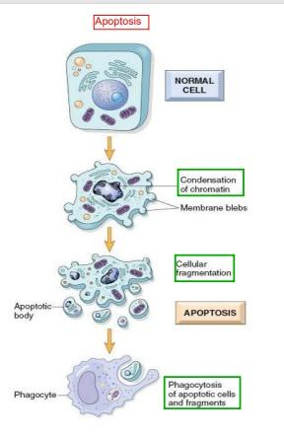

There are three steps in apoptosis

1. Cell Shrinkage: the cell shrinks, shows deformation and looses contact to its neighbouring cells. Its chromatin condenses and marginates at the nuclear membrane,
2. Membrane blebbing: The cell membrane shows irregular buds known as [blebs](https://en.wikipedia.org/wiki/Bleb_(cell_biology)). Initially these are smaller surface blebs. Later these can grow into larger so-called dynamic membrane blebs.
3. Formation of membrane protrusions: Some cell types, under specific conditions, may develop different types of long, thin extensions of the cell membrane called membrane protrusions. Three types have been described: [microtubule](https://en.wikipedia.org/wiki/Microtubule) spikes, **apoptopodia** (*feet of death*), and **beaded apoptopodia** (the latter having a beads-on-a-string appearance
4. [Fragmentation](https://en.wikipedia.org/wiki/Fragmentation_(cell_biology)): The cell breaks apart into multiple [vesicles](https://en.wikipedia.org/wiki/Vesicle_(biology_and_chemistry)) called *apoptotic bodies*, which undergo [phagocytosis](https://en.wikipedia.org/wiki/Phagocytosis). The plasma membrane protrusions may help to bring apoptotic bodies closer to phagocytes.
5. **Removal of dead cells**

The removal of dead cells by neighboring phagocytic cells has been termed [efferocytosis](https://en.wikipedia.org/wiki/Efferocytosis). Dying cells that undergo the final stages of apoptosis display phagocytotic molecules, such as [phosphatidylserine](https://en.wikipedia.org/wiki/Phosphatidylserine), on their cell surface. Phosphatidylserine is normally found on the inner leaflet surface of the plasma membrane, but is redistributed during apoptosis to the extracellular surface. These molecules mark the cell for [phagocytosis](https://en.wikipedia.org/wiki/Phagocytosis) by cells possessing the appropriate receptors, such as macrophages. The removal of dying cells by phagocytes occurs in an orderly manner without eliciting an [inflammatory response](https://en.wikipedia.org/wiki/Inflammatory_response).

**Molecular mechanisms of apoptosis signalling pathways**

**Apoptosis: Pathways**

Any stimuli that can induce and initiate the programmed cell death pathway are called Apoptic signals. The source of apoptic signals can be of two different types such as those from the external (outside the cell) and those signals originated in the cell itself. Based on the source of signals, there are two types of apoptic signaling pathways. They are:

Apoptosis Signaling Pathways:

Apoptosis is executed by the extrinsic or intrinsic death signaling pathway, and results in the activation of the caspase cascade.

**I) Extrinsic Pathway:**

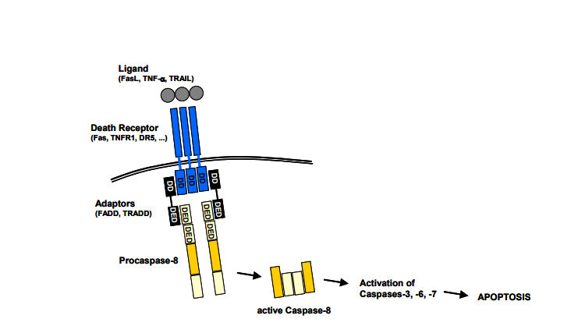The extrinsic pathway begins with the binding of a ligand to one of several death receptors. This interaction triggers receptor oligomerization and the recruitment of adaptor proteins containing death domains (DD), such as TRADD and FADD. The resulting complexes bind and activate pro-caspases-8 and -10. The ligands including FASL, TNF-α, TRAIL and TWEAK may be anchored in the plasma membrane of neighbouring cells or can act as soluble cytokines.

**ii) Intrinsic Pathway:**  The intrinsic pathway of caspase activation can be initiated by a variety of unrelated factors, including DNA damage, growth factor withdrawal, loss of contact with the extracellular matrix, or exposure to glucocorticoids. These stimuli induce signaling cascades that result in the loss of mitochondrial integrity, release of Cyt c, and the subsequent activation of caspase-9. Mitochondrial integrity is regulated by the family of Bcl-2 proteins, a group of more than 20 structurally related proteins that contain one to four Bcl-2 homology (BH) domains. Bcl-2 proteins are divided into 3 distinct subfamilies based on the presence of BH domains and their ability to either promote or inhibit apoptosis. The balance between pro- and anti-apoptotic family members determines whether the cell survives an apoptotic insult or undergoes cell death.

**Intrinsic Apoptic pathway**:

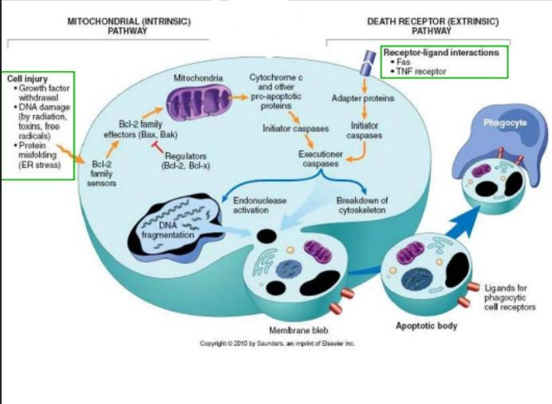

**Necrosis *vs.* Apoptosis**

|  |  |
| --- | --- |
| **Apoptosis** | **Necrosis** |
| * Cellular condensation * Membranes remain intact * Requires ATP * Cell is phagocytosed, no tissue reaction * Ladder-like DNA fragmentation * In vivo, individual cells appear affected | * Cellular swelling * Membranes are broken * ATP is depleted * Cell lyses, eliciting an inflammatory reaction * DNA fragmentation is random, or smeared * In vivo, whole areas of the tissue are affected |

**Significance / Importance of Apoptosis**

1. Removing redundant and damaged cells - In the body, significantly damaged cells that cannot be repaired are eliminated through apoptosis. This also occurs for infected cells and auto-reactive cells of the immune system.
2. Maintaining a specific number of cells in an organism - With mitosis producing well over 100,000 cells each second in the human body, other cells die through apoptosis, which helps maintain a constant number of cells present in the body.
3. Homeostasis - Such cells as B and T cells of the immune system and those of the intestinal epithelium are produced in large numbers. In the case of the [B](https://www.microscopemaster.com/function-of-b-cells.html) and [T cells](https://www.microscopemaster.com/t-cells.html), as many as 95 percent die during maturation through apoptosis. Here, apoptosis plays an important role in check and balancing of the cells in order to avoid autoimmunity.
4. Development and morphogenesis - Apoptosis is involved in the death of about 50 percent of neurons in early development, the formation of reproductive organs, as well as the ablation of cells that are not needed (a good example of this is included cells of the tadpole tail as it matures)
5. Deficient apoptosis - Defects of the process have been linked to certain cancers, enhanced viral infections as well as autoimmune diseases. On the other hand, excessive apoptosis has been associated with increased Neurodegenerative diseases, risk of ischemic disease and AIDs.