GOVERNMENT COLLEGE FOR WOMEN(A)

KUMBAKONAM

DEPARTMENT OF COMPUTER SCIENCE

**STAFF : S.SUNDARESWARI**

**SUBJECT : REGISTER TRANSFER AND MICROOPERATIONS**

**DATE : 24/09/2020**

**INTEGRATED CIRCUITS :**

The first integrated circuits contained only a few transistors and so were called “Small-Scale Integration **(SSI)**. They used circuits containing transistors numbering in the tens. They were very crucial in development of early computers. SSI was followed by introduction of the devices which contained hundreds of transistors on each chip, and so were called “Medium-Scale Integration (**MSI**).

MSI were attractive economically because which they cost little more systems to be produced using smaller circuit boards, less assembly work, and a number of other advantages.

Next development was of Large Scale Integration (LSI). The development of LSI was driven by economic factors and each chip comprised tens of thousands of transistors. It was in 1970s, when LSI started getting manufactured in huge quantities.

LSI was followed by Very Large Scale Integration (VLSI) where hundreds of thousands of transistors were used and still being developed. It was for the first time that a CPU was fabricated on a single integrated circuit, to create a microprocessor. In 1986, with the introduction of first one megabit RAM chips, more than one million transistors were integrated.

Microprocessor chips produced in 1994 contained more than three million transistors. ULSI refer to “Ultra-Large Scale Integration” and correspond to more than 1 million of transistors. However there is no qualitative leap between VLSI and ULSI, hence normally in technical texts the “VLSI” term cover ULSI.

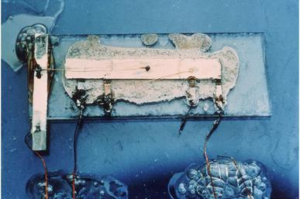

**Jack Kilpy - 1958 – IC**

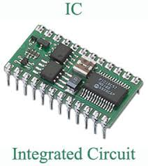

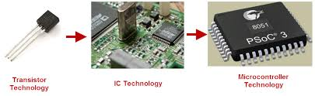

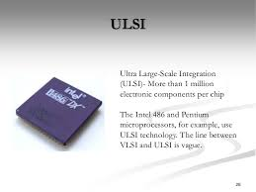

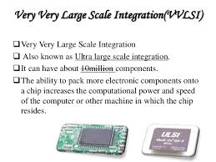

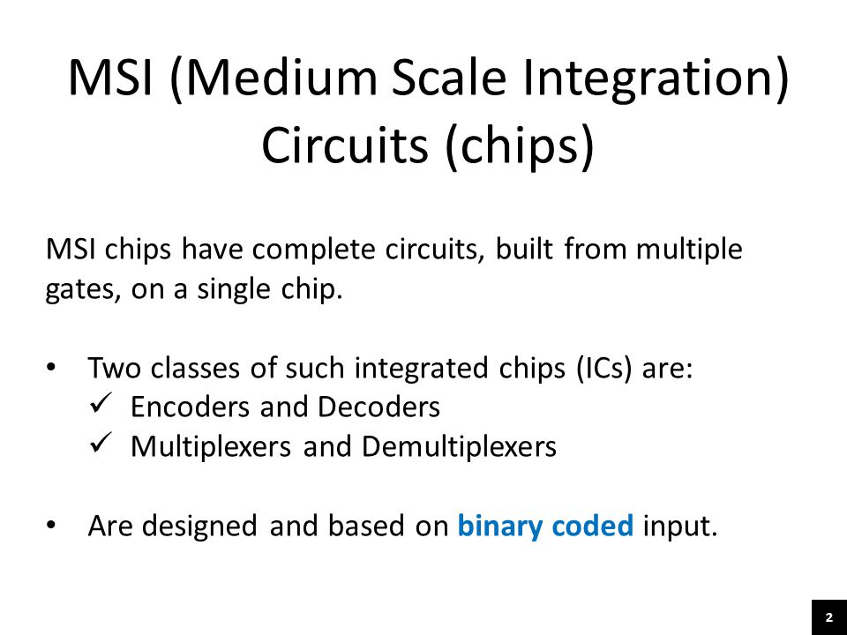

**INTERGRATED CIRCUIT (IC) IS A SMALL SILICON SEMICONDUCTOR CRYSTAL CALLED A CHIP.**

**SSI - LESS THAN 10 GATES.**

**MSI – 10 to 200 GATES (DECODERS,ADDERS,REGISTERS)**

**LSI – 200 to FEW THOUSAND GATES**

**(PROCESSOR & MEMORY CHIP)**

**VLSI – THOUSANDS OF GATES**

**DIGITAL LOGIC FAMILY**

**TTL (TRANSISTOR-transistor Logic) - Standard Model**

**ECL (Emitter-coupled logic) – - High speed operation-Super computers & Signal processors**

**MOS(Metal – Oxide semiconductor) –High component density – Unipolar transistor.**

**PMOS or NMOS**

**CMOS – (Complementary metal-oxide semiconductor) – Bipolar .It uses both PMOS and NMOS.**

**DECODER**

**A DECODER IS A COMBINATIONAL CIRCUIT THAT CONVERTS BINARY INFORMATION FROM THE n CODED INPUTS TO A MAXIMUM OF 2n UNIQUE OUTPUTS.**