Unit IV

Basic Behavioral Modeling

UML 2.1 defines thirteen basic diagram types, divided into two general sets: structural modeling diagrams and behavioral modeling diagrams. The UML is used to define a software system – to detail the artifacts in the systems, to document and construct; it is the language the blueprint is written in.

Interactions
In UML, the dynamic aspects of a system can be modeled using interactions. Interactions contain messages that are exchanged between objects. A message can be an invocation of an operation or a signal. The messages may also include creation and destruction of other objects.

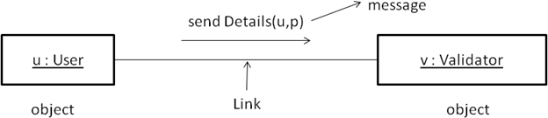

Interaction (Definition)
An interaction is a behavior that contains a set of messages exchanged among a set of objects within a context to accomplish a purpose. A message is specification of a communication between objects that conveys information with the expectation that the activity will succeed.
Objects and Roles
The objects that participate in an interaction are either concrete things or prototypical things. As a concrete thing, an object represents something in the real world. For example, p an instance of the class Person, might denote a particular human. Alternately, as a prototypical thing, p might represent any instance of Person.

A link is a semantic connection among objects. In general, a link is an instance of association. Wherever, a class has an association with another class, there may be a link between the instances of the two classes.
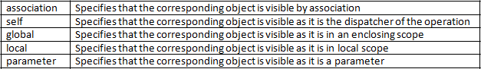
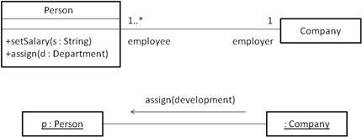
Wherever there is a link between two objects, one object can send messages to another object. We can adorn the appropriate end of the link with any of the following standard stereotypes:
Messages
A message is the specification of communication among objects that conveys information with the expectation that activity will succeed. The receipt of a message instance may be considered an instance of an event.
When a message is passed, the action that results is an executable statement that forms an abstraction of a computational procedure. An action may result in a change of state. In UML, we can model several kinds of actions like:
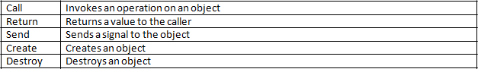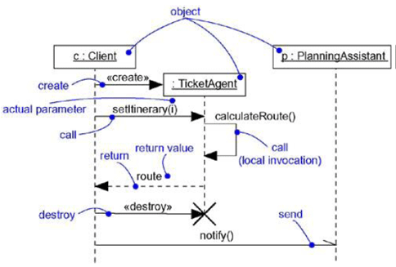

Sequencing
When an object passes a message to another object, the receiving object might in turn send a message to another object, which might send a message to yet a different object and so on.
This stream of messages forms a sequence. So, we can define a sequence as a stream of messages. Any sequence must have a beginning. The start of every sequence is associated with some process or thread.
To model the sequence of a message, we can explicitly represent the order of the message relative to the start of the sequence by prefixing the message with a sequence number set apart by a colon separator.
Most commonly, we can specify a procedural or nested flow of control, rendering using a filled solid arrowhead. Less common but also possible, we can specify a flat flow of control, rendered using a stick arrowhead.
We will use flat sequences only when modeling interactions in the context of use cases that involve the system as a whole, together with actors outside the system.
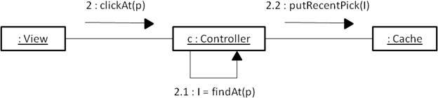
In all other cases, we will use procedural sequences, because they represent ordinary, nested operation calls of the type we find in most programming languages.

Representation
When we model an interaction, we typically include both objects and messages. We can visualize those objects and messages involved in an interaction in two ways: by emphasizing the time ordering of messages and by emphasizing the structural organization of the objects that send and receive messages.
In UML, the first kind of representation is called a sequence diagram and the second kind of representation is called a collaboration diagram. Both sequence and collaboration diagrams are known as interaction diagrams.
Sequence diagrams and collaboration diagrams are isomorphic, meaning that we can take one and transform it into the other without loss of information. Sequence diagram lets us to model the lifeline of an object. An object’s lifeline represents the existence of the object at a particular time.
A collaboration diagram lets us to model the structural links that may exist among the objects in the interaction.
Common Modeling Techniques Modeling a flow of control
To model a flow of control,
- Set the context for the interaction, whether it is the system as a whole, a class or an individual operation.
- Identify the objects and their initial properties which participate in the interaction.
- Identify the links between objects for communication through messages.
- In time order, specify the messages that pass from object to object. Use parameters and return values as necessary.
- To add semantics, adorn each object at every moment in time with its state and role.

Consider the following example of railway reservation system’s sequence and collaboration diagrams:
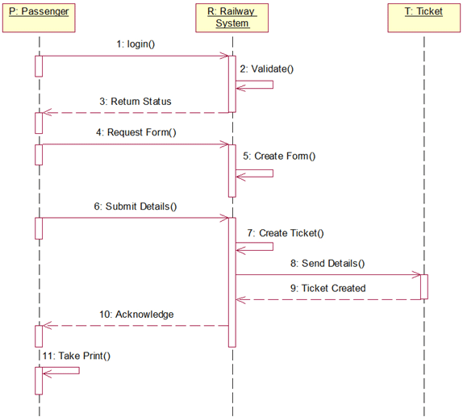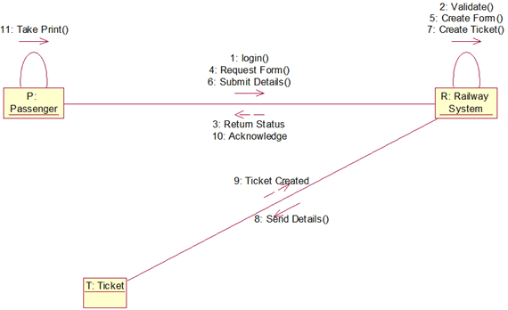

Interaction diagrams

Introduction
An interaction diagram represents an interaction, which contains a set of objects and the relationships between them including the messages exchanged between the objects.
A sequence diagram is an interaction diagram in which the focus is on time ordering of messages. Collaboration diagram is another interaction diagram in which the focus is on the structural organization of the objects. Both sequence diagrams and collaboration diagrams are isomorphic diagrams.
Common Properties
Interaction diagrams share the properties which are common to all the diagrams in UML. They are: a name which identifies the diagram and the graphical contents which are a projection into the model.
Contents
Interaction diagrams commonly contain:
1. Objects 2. Links 3. Messages
Like all other diagrams, interaction diagrams may contain notes and constraints.
Sequence Diagrams
A sequence diagram is one of the two interaction diagrams. The sequence diagram emphasizes on the time ordering of messages. In a sequence diagram, the objects that participate in the interaction are arranged at the top along the x-axis.
Generally, the object which initiates the interaction is placed on the left and the next important object to its right and so on. The messages dispatched by the objects are arranged from top to bottom along the y-axis. This gives the user the detail about the flow of control over time.

Sequence diagram has two features that distinguish them from collaboration diagrams. First, there is the object lifeline, which is a vertical dashed line that represents the existence of an object over a period of time. Most of the objects are alive throughout the interaction.
Objects may also be created during the interaction with the receipt of the message stereotyped with create. Objects may also be destroyed during the interaction with the receipt of the message stereotyped with destroy.
Second, there is focus of control which is represented as a thin rectangle over the life line of the object. The focus of control represents the points in time at which the object is performing an action. We can also represent recursion by using a self message.
Collaboration Diagrams
A collaboration diagram is one of the two interaction diagrams. The collaboration diagram emphasizes on the structural organization of the objects in the interaction.
A collaboration diagram is made up of objects which are the vertices and these are connected by links. Finally, the messages are represented over the links between the objects. This gives the user the detail about the flow of control in the context of structural organization of objects that collaborate.
Collaboration diagram has two features that distinguish them from the sequence diagrams. First, there is a path which indicates one object is linked to another. Second, there is a sequence number to indicate the time ordering of a message by prefixing the message with a number.
We can use Dewey decimal numbering system for the sequence numbers. For example a message can be numbered as 1 and the next messages in the nested sequence can be numbered 1.1 and so on.

Common Uses
We use interaction diagrams to model the dynamic aspects (interactions) of the system. When we use an interaction diagram to model some dynamic aspect of a system, we do so in the context of the system as a whole, a subsystem, an operation or a class. We typically use the interaction diagrams in two ways:
- To model flows of control by time ordering
- To model flows of control by organization
Common Modeling Techniques
Modeling flow of control by time ordering
To model a flow of control by time ordering,
- Set the context for the interaction, whether it is a system, subsystem, operation or class or one scenario of a use case or collaboration.
- Identify the objects that take part in the interaction and lay them out at the top along the x-axis in a sequence diagram.
- Set the life line for each object.
- Layout the messages between objects from the top along the y-axis.
- To visualize the points at which the object is performing an action, use the focus of control.
- To specify time constraints, adorn each message with the time and space constraints.
- To specify the flow of control in a more formal manner, attach pre and post conditions to each message.
Modeling flow of control by organization
To model a flow of control by organization,
- Set the context for the interaction, whether it is a system, subsystem, operation or class or one scenario of a use case or collaboration.
- Identify the objects that take part in the interaction and lay them out in a collaboration diagram as the vertices in a graph.
- Set the initial properties of each of these objects.
- Specify the links among these objects.
- Starting with the messages that initiate the interaction, attach each subsequent message to the appropriate link, setting its sequence number, as appropriate. Use Dewey numbering system to specify nested flow of control.
- To specify time constraints, adorn each message with the time and space constraints.
- To specify the flow of control in a more formal manner, attach pre and post conditions to each message.

