Unit 3

Introduction to UML

Unified Modeling Language (UML) is a general purpose modelling language. The main aim of UML is define a standard way to visualize the way a system has been designed. It is quite similar to blueprints used in other fields of engineering.
UML is not a programming language, it is rather a visual language. We use UML diagrams to portray the behavior and structure of a system. UML helps software engineers, businessmen and system architects with modelling, design and analysis. The Object Management Group (OMG) adopted Unified Modelling Language as a standard in 1997. Its been managed by OMG ever since. International Organization for Standardization (ISO) published UML as an approved standard in 2005. UML has been revised over the years and is reviewed periodically.

Uses of UML:
- Complex applications need collaboration and planning from multiple teams and hence require a clear and concise way to communicate amongst them.
- Businessmen do not understand code. So UML becomes essential to communicate with non programmers essential requirements, functionalities and processes of the system.
- A lot of time is saved down the line when teams are able to visualize processes, user interactions and static structure of the system.

Object Oriented Concepts Used in UML –
- Class – A class defines the blue print i.e. structure and functions of an object.
- Objects – Objects help us to decompose large systems and help us to modularize our system. Modularity helps to divide our system into understandable components so that we can build our system piece by piece. An object is the fundamental unit (building block) of a system which is used to depict an entity.
- Inheritance – Inheritance is a mechanism by which child classes inherit the properties of their parent classes.
- Abstraction – Mechanism by which implementation details are hidden from user.
- Encapsulation – Binding data together and protecting it from the outer world is referred to as encapsulation.
- Polymorphism – Mechanism by which functions or entities are able to exist in different forms.

Importance of Modeling
UML is a pictorial language used to make software blueprints. UML can be described as a general purpose visual modeling language to visualize, specify, construct, and document software system. Although UML is generally used to model software systems, it is not limited within this boundary.
The Unified Modeling Language (UML) is a standard language for specifying, visualizing, constructing, and documenting the artifacts of software systems, as well as for business modeling and other non-software systems. ... It has been found that all the UML diagrams plays vital role in s/w development.
Research has found that modeling decreases student error, positively affects the perceived importance of a task and increases self-regulated learning. For effective modeling, teachers should use think-aloud to make important connections and share their expert thinking with their students.
Modeling serves multiple purposes in the software world, some of which are systems modeling for system determination (such as for real time system behavior) or scientific modeling used for better understanding of scientific phenomenon (which can also be used in real time systems to perform real time operations).

Principles of Modeling

The use of modeling has a rich history in all the engineering disciplines. That experience suggests four basic principles of modeling.
- First,

The choice of what models to create has a profound influence on how a problem is attacked and how a solution is shaped.
- Second,

Every model may be expressed at different levels of precision.

- Third,

The best models are connected to reality.
- Fourth,

No single model or view is sufficient. Every nontrivial system is best approached through a small set of nearly independent models with multiple viewpoints.

.

Object Oriented modeling

Two most common ways in modeling software systems are
    - Algorithmic - Procedures or functions
    - Object oriented - Objects or classes

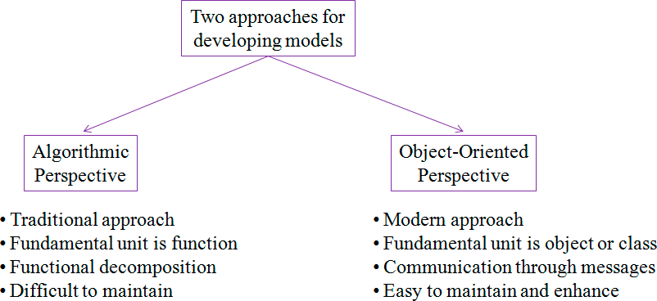

Conceptual Model of the UML
To understand the UML, we need to form a conceptual model of the language, and this requires learning three major elements: the UML's basic building blocks, the rules that dictate how those building blocks may be put together, and some common mechanisms that apply throughout the UML.
Building Blocks of the UML
The vocabulary of the UML encompasses three kinds of building blocks:
- Things 2. Relationships 3. Diagrams
Things are the abstractions that are first-class citizens in a model; relationships tie these things together; diagrams group interesting collections of things.
Things in the UML
There are four kinds of things in the UML:
1. Structural things 2. Behavioral things 3. Grouping things 4. Annotational things
These things are the basic object-oriented building blocks of the UML. We use them to write well- formed models.
Structural Things
Structural things are the nouns of UML models. These are the mostly static parts of a model, representing elements that are either conceptual or physical. Collectively, the structural things are called classifiers.
A class is a description of a set of objects that share the same attributes, operations, relationships, and semantics. A class implements one or more interfaces. Graphically, a class is rendered as a rectangle, usually including its name, attributes, and operations, as in Figure.
Figure. Classes
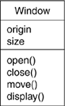
An interface is a collection of operations that specify a service of a class or component.
Figure. Interfaces
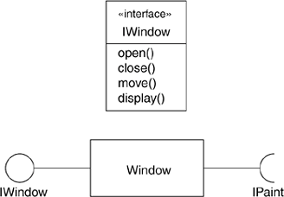

A collaboration defines an interaction and is a society of roles and other elements that work together to provide some cooperative behavior that's bigger than the sum of all the elements.
Figure . Collaborations
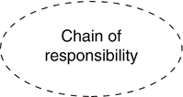

A use case is a description of sequences of actions that a system performs that yield observable results of value to a particular actor.
Figure. Use Cases
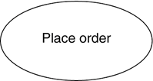

An active class is a class whose objects own one or more processes or threads and therefore can initiate control activity.
Figure. Active Classes
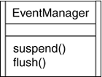
A component is a modular part of the system design that hides its implementation behind a set of external interfaces.
Figure. Components
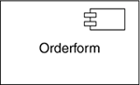
The remaining two elements artifacts and nodes are also different. They represent physical things, whereas the previous five things represent conceptual or logical things.
An artifact is a physical and replaceable part of a system that contains physical information ("bits").
Figure. Artifacts
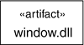
A node is a physical element that exists at run time and represents a computational resource, generally having at least some memory and, often, processing capability.
Figure. Nodes
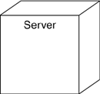

Behavioral Things
Behavioral things are the dynamic parts of UML models..
First, an interaction is a behavior that comprises a set of messages exchanged among a set of objects or roles within a particular context to accomplish a specific purpose.
Figure. Messages

Second, a state machine is a behavior that specifies the sequences of states an object or an interaction goes through during its lifetime in response to events, together with its responses to those events.

In an interaction, the focus is on the set of objects that interact. In a state machine, the focus is on the life cycle of one object at a time. In an activity, the focus is on the flows among steps without regard to which object performs each step. A step of an activity is called an action. Graphically, an action is rendered as a rounded rectangle with a name indicating its purpose. States and actions are distinguished by their different contexts.
Figure. Actions
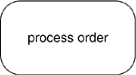
Grouping Things
Grouping things are the organizational parts of UML models. These are the boxes into which a model can be decomposed. There is one primary kind of grouping thing, namely, packages.
A package is a general-purpose mechanism for organizing the design itself, as opposed to classes, which organize implementation constructs. Structural things, behavioral things, and even other grouping things may be placed in a package.
Figure. Packages
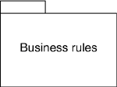
Annotational Things
Annotational things are the explanatory parts of UML models. These are the comments we may apply to describe, illuminate, and remark about any element in a model. There is one primary kind of annotational thing, called a note. A note is simply a symbol for rendering constraints and comments attached to an element or a collection of elements. Graphically, a note is rendered as a rectangle with a dog-eared corner, together with a textual or graphical comment, as in Figure.
Figure. Notes
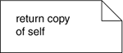

Relationships in the UML
There are four kinds of relationships in the UML:
1. Dependency 2. Association 3. Generalization 4. Realization
These relationships are the basic relational building blocks of the UML. We use them to write well- formed models.
First, a dependency is a semantic relationship between two model elements in which a change to one element (the independent one) may affect the semantics of the other element (the dependent one).
Graphically, a dependency is rendered as a dashed line, possibly directed, and occasionally including a label, as in Figure.
Figure. Dependencies
Second, an association is a structural relationship among classes that describes a set of links, a link being a connection among objects that are instances of the classes. Aggregation is a special kind of association, representing a structural relationship between a whole and its parts. Graphically, an association is rendered as a solid line, possibly directed, occasionally including a label, and often containing other adornments, such as multiplicity and end names, as in Figure
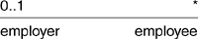
Figure. Associations
Third, a generalization is a specialization/generalization relationship in which the specialized element (the child) builds on the specification of the generalized element (the parent). The child shares the structure and the behavior of the parent. Graphically, a generalization relationship is rendered as a solid line with a hollow arrowhead pointing to the parent, as in Figure.
Figure. Generalizations
Fourth, a realization is a semantic relationship between classifiers, wherein one classifier specifies a contract that another classifier guarantees to carry out. We'll encounter realization relationships in two places: between interfaces and the classes or components that realize them, and between use cases and the collaborations that realize them. Graphically, a realization relationship is rendered as a cross between a generalization and a dependency relationship, as in Figure.
Figure. Realizations
These four elements are the basic relational things we may include in a UML model. There are also variations on these four, such as refinement, trace, include, and extend.
Diagrams in the UML
A diagram is the graphical presentation of a set of elements, most often rendered as a connected graph of vertices (things) and paths (relationships). We draw diagrams to visualize a system from different perspectives, so a diagram is a projection into a system.

For all but the most trivial systems, a diagram represents an elided view of the elements that make up a system. The same element may appear in all diagrams, only a few diagrams (the most common case), or in no diagrams at all (a very rare case). In theory, a diagram may contain any combination of things and relationships. In practice, however, a small number of common combinations arise, which are consistent with the five most useful views that comprise the architecture of a software-intensive system. For this reason, the UML includes thirteen kinds of diagrams:
1. Class diagram 2. Object diagram 3. Component diagram 4. Composite structure diagram
5. Use case diagram 6. Sequence diagram 7. Communication diagram 8. State diagram
9. Activity diagram 10. Deployment diagram 11. Package diagram 12. Timing diagram
12. Interaction overview diagram
A class diagram shows a set of classes, interfaces, and collaborations and their relationships. These diagrams are the most common diagram found in modeling object-oriented systems. Class diagrams address the static design view of a system. Class diagrams that include active classes address the static process view of a system. Component diagrams are variants of class diagrams.
An object diagram shows a set of objects and their relationships. Object diagrams represent static snapshots of instances of the things found in class diagrams. These diagrams address the static design view or static process view of a system as do class diagrams, but from the perspective of real or prototypical cases.

A component diagram is shows an encapsulated class and its interfaces, ports, and internal structure consisting of nested components and connectors. Component diagrams address the static design implementation view of a system. They are important for building large systems from smaller parts. (UML distinguishes a composite structure diagram, applicable to any class, from a component diagram, but we combine the discussion because the distinction between a component and a structured class is unnecessarily subtle.

A use case diagram shows a set of use cases and actors (a special kind of class) and their relationships. Use case diagrams address the static use case view of a system. These diagrams are especially important in organizing and modeling the behaviors of a system.

Both sequence diagrams and communication diagrams are kinds of interaction diagrams. An interaction diagram shows an interaction, consisting of a set of objects or roles, including the messages that may be dispatched among them.

Interaction diagrams address the dynamic view of a system. A sequence diagram is an interaction diagram that emphasizes the time-ordering of messages; a communication diagram is an interaction diagram that emphasizes the structural organization of the objects or roles that send and receive messages. Sequence diagrams and communication diagrams represent similar basic concepts, but each diagram emphasizes a different view of the concepts. Sequence diagrams emphasize temporal ordering, and communication diagrams emphasize the data structure through which messages flow.

A timing diagram (not covered in this book) shows the actual times at which messages are exchanged.

A state diagram shows a state machine, consisting of states, transitions, events, and activities. A state diagrams shows the dynamic view of an object. They are especially important in modeling the behavior of an interface, class, or collaboration and emphasize the event-ordered behavior of an object, which is especially useful in modeling reactive systems

An activity diagram shows the structure of a process or other computation as the flow of control and data from step to step within the computation. Activity diagrams address the dynamic view of a system. They are especially important in modeling the function of a system and emphasize the flow of control among objects.

A deployment diagram shows the configuration of run-time processing nodes and the components that live on them. Deployment diagrams address the static deployment view of an architecture. A node typically hosts one or more artifacts.
An artifact diagram shows the physical constituents of a system on the computer. Artifacts include files, databases, and similar physical collections of bits. Artifacts are often used in conjunction with deployment diagrams. Artifacts also show the classes and components that they implement. (UML treats artifact diagrams as a variety of deployment diagram, but we discuss them separately.)
A package diagram shows the decomposition of the model itself into organization units and their dependencies.

A timing diagram is an interaction diagram that shows actual times across different objects or roles, as opposed to just relative sequences of messages. An interaction overview diagram is a hybrid of an activity diagram and a sequence diagram. These diagrams have specialized uses and so are not discussed in this book. See the UML Reference Manual for more details.
This is not a closed list of diagrams. Tools may use the UML to provide other kinds of diagrams, although these are the most common ones that we will encounter in practice.
Rules of the UML
The UML's building blocks can't simply be thrown together in a random fashion. Like any language, the UML has a number of rules that specify what a well-formed model should look like. A well- formed model is one that is semantically self-consistent and in harmony with all its related models.
The UML has syntactic and semantic rules for
Names What we can call things, relationships, and diagrams Scope The context that gives specific meaning to a name
Visibility How those names can be seen and used by others
Integrity How things properly and consistently relate to one another Execution What it means to run or simulate a dynamic model
Models built during the development of a software-intensive system tend to evolve and may be viewed
by many stakeholders in different ways and at different times. For this reason, it is common for the development team to not only build models that are well-formed, but also to build models that are
Elided Certain elements are hidden to simplify the view Incomplete Certain elements may be missing
Inconsistent The integrity of the model is not guaranteed
These less-than-well-formed models are unavoidable as the details of a system unfold and churn during the software development life cycle. The rules of the UML encourage us but do not force us to address the most important analysis, design, and implementation questions that push such models to become well-formed over time.
Common Mechanisms in the UML
A building is made simpler and more harmonious by the conformance to a pattern of common features. A house may be built in the Victorian or French country style largely by using certain architectural patterns that define those styles. The same is true of the UML. It is made simpler by the presence of four common mechanisms that apply consistently throughout the language.
1. Specifications 2. Adornments 3. Common divisions 4. Extensibility mechanisms
Specifications
The UML is more than just a graphical language. Rather, behind every part of its graphical notation there is a specification that provides a textual statement of the syntax and semantics of that building block. For example, behind a class icon is a specification that provides the full set of attributes, operations (including their full signatures), and behaviors that the class embodies; visually, that class icon might only show a small part of this specification. Furthermore, there might be another view of that class that presents a completely different set of parts yet is still consistent with the class's underlying specification. We use the UML's graphical notation to visualize a system; we use the UML's specification to state the system's details. Given this split, it's possible to build up a model incrementally by drawing diagrams and then adding semantics to the model's specifications, or directly by creating a specification, perhaps by reverse engineering an existing system, and then creating diagrams that are projections into those specifications.
The UML's specifications provide a semantic backplane that contains all the parts of all the models of a system, each part related to one another in a consistent fashion. The UML's diagrams are thus simply visual projections into that backplane, each diagram revealing a specific interesting aspect of the system.
Adornments
Most elements in the UML have a unique and direct graphical notation that provides a visual representation of the most important aspects of the element. For example, the notation for a class is intentionally designed to be easy to draw, because classes are the most common element found in modeling object-oriented systems. The class notation also exposes the most important aspects of a class, namely its name, attributes, and operations.
A class's specification may include other details, such as whether it is abstract or the visibility of its attributes and operations. Many of these details can be rendered as graphical or textual adornments to the class's basic rectangular notation. For example, Figure shows a class, adorned to indicate that it is an abstract class with two public, one protected, and one private operation.
Figure. Adornments
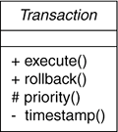
Every element in the UML's notation starts with a basic symbol, to which can be added a variety of adornments specific to that symbol.
Common Divisions
In modeling object-oriented systems, the world often gets divided in several ways.
First, there is the division of class and object. A class is an abstraction; an object is one concrete manifestation of that abstraction. In the UML, we can model classes as well as objects, as shown in Figure. Graphically, the UML distinguishes an object by using the same symbol as its class and then simply underlying the object's name.
Figure. Classes and Objects
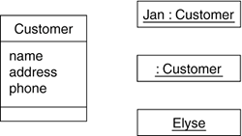
In this figure, there is one class, named Customer, together with three objects: Jan (which is marked explicitly as being a Customer object), :Customer (an anonymous Customer object), and Elyse (which in its specification is marked as being a kind of Customer object, although it's not shown explicitly here).
Almost every building block in the UML has this same kind of class/object dichotomy. For example, we can have use cases and use case executions, components and component instances, nodes and node instances, and so on.
Second, there is the separation of interface and implementation. An interface declares a contract, and an implementation represents one concrete realization of that contract, responsible for faithfully carrying out the interface's complete semantics. In the UML, we can model both interfaces and their implementations, as shown in Figure.
Figure. Interfaces and Implementations
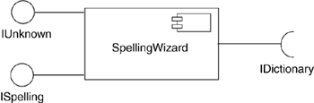
In this figure, there is one component named SpellingWizard.dll that provides (implements) two interfaces, IUnknown and ISpelling. It also requires an interface, IDictionary, that must be provided by another component.
Almost every building block in the UML has this same kind of interface/implementation dichotomy. For example, we can have use cases and the collaborations that realize them, as well as operations and the methods that implement them.
Third, there is the separation of type and role. The type declares the class of an entity, such as an object, an attribute, or a parameter. A role describes the meaning of an entity within its context, such as a class, component, or collaboration. Any entity that forms part of the structure of another entity, such as an attribute, has both characteristics: It derives some of its meaning from its inherent type and some of its meaning from its role within its context (Figure).
Figure. Part with role and type
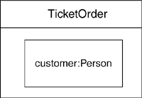
Extensibility Mechanisms
The UML provides a standard language for writing software blueprints, but it is not possible for one closed language to ever be sufficient to express all possible nuances of all models across all domains across all time. For this reason, the UML is opened-ended, making it possible for us to extend the language in controlled ways. The UML's extensibility mechanisms include
- Stereotypes
- Tagged values
- Constraints
A stereotype extends the vocabulary of the UML, allowing we to create new kinds of building blocks that are derived from existing ones but that are specific to our problem. For example, if we are working in a programming language, such as Java or C++, we will often want to model exceptions. In these languages, exceptions are just classes, although they are treated in very special ways. Typically, we only want to allow them to be thrown and caught, nothing else. We can make exceptions first-class citizens in our models meaning that they are treated like basic building blocks by marking them with an appropriate stereotype, as for the class Overflow in Figure.
A tagged value extends the properties of a UML stereotype, allowing us to create new information in the stereotype's specification. For example, if we are working on a shrink-wrapped product that undergoes many releases over time, we often want to track the version and author of certain critical abstractions. Version and author are not primitive UML concepts. They can be added to any building block, such as a class, by introducing new tagged values to that building block. In Figure, for example, the class EventQueue is extended by marking its version and author explicitly.
A constraint extends the semantics of a UML building block, allowing us to add new rules or modify
existing ones. For example, we might want to constrain the EventQueue class so that all additions are done in order. As Figure shows, we can add a constraint that explicitly marks these for the operation add.
Figure. Extensibility Mechanisms
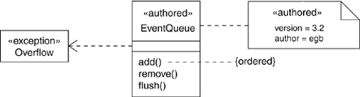
Collectively, these three extensibility mechanisms allow us to shape and grow the UML to our project's needs. These mechanisms also let the UML adapt to new software technology, such as the likely emergence of more powerful distributed programming languages. We can add new building blocks, modify the specification of existing ones, and even change their semantics. Naturally, it's important that we do so in controlled ways so that through these extensions, we remain true to the UML's purpose the communication of information.

Architecture
A model is a simplified representation of the system. To visualize a system, we will build various models. The subset of these models is a view. Architecture is the collection of several views.
The stakeholders (end users, analysts, developers, system integrators, testers, technical writers and project managers) of a project will be interested in different views.
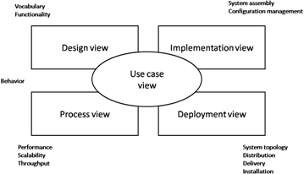
Architecture can be best represented as a collection five views: 1) Use case view, 2) Design/logical view, 3) Implementation/development view, 4) Process view and 5) Deployment/physical view.
Developed by Philippe Kruchten

Software architecture involves the high level structure of software system abstraction, by using decomposition and composition, with architectural style and quality attributes. A software architecture design must conform to the major functionality and performance requirements of the system, as well as satisfy the non-functional requirements such as reliability, scalability, portability, and availability.
The five views can be summarized as shown in the below table:
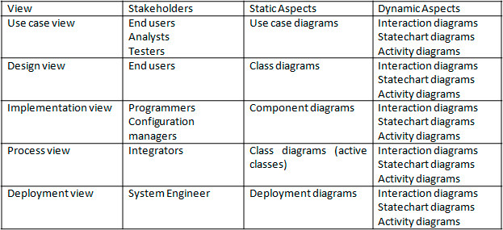
A software architecture must describe its group of components, their connections, interactions among them and deployment configuration of all components.
A software architecture can be defined in many ways −
- UML (Unified Modeling Language) − UML is one of object-oriented solutions used in software modeling and design.
- Architecture View Model (4+1 view model) − Architecture view model represents the
functional and non-functional requirements of software application.
- ADL (Architecture Description Language) − ADL defines the software architecture
formally and semantically.

UML
UML stands for Unified Modeling Language. It is a pictorial language used to make software blueprints. UML was created by Object Management Group (OMG). The UML 1.0 specification draft was proposed to the OMG in January 1997. It serves as a standard for software requirement analysis and design documents which are the basis for developing a software.
UML can be described as a general purpose visual modeling language to visualize, specify, construct, and document a software system. Although UML is generally used to model software system, it is not limited within this boundary. It is also used to model non software systems such as process flows in a manufacturing unit.
The elements are like components which can be associated in different ways to make a complete UML picture, which is known as a diagram. So, it is very important to understand the different diagrams to implement the knowledge in real-life systems. We have two broad categories of diagrams and they are further divided into sub-categories i.e. Structural Diagrams and Behavioral Diagrams. Structural Diagrams
Structural diagrams represent the static aspects of a system. These static aspects represent those parts of a diagram which forms the main structure and is therefore stable.
These static parts are represented by classes, interfaces, objects, components and nodes. Structural diagrams can be sub-divided as follows −
- Class diagram
- Object diagram
- Component diagram
- Deployment diagram
- Package diagram
- Composite structure
The following table provides a brief description of these diagrams −
Sr.No. | Diagram & Description
1 | Class  Represents the object orientation of a system. Shows how classes are statically related.
2 | Object  Represents a set of objects and their relationships at runtime and also represent the static view of the system.
3 | Component  Describes all the components, their interrelationship, interactions and interface of the system.
4 | Composite structure  Describes inner structure of component including all classes, interfaces of the component, etc.
5 | Package  Describes the package structure and organization. Covers classes in the package and packages within another package.
6 | Deployment  Deployment diagrams are a set of nodes and their relationships. These nodes are physical entities where the components are deployed.
Behavioral Diagrams
Behavioral diagrams basically capture the dynamic aspect of a system. Dynamic aspects are basically
the changing/moving parts of a system. UML has the following types of behavioral diagrams −
- Use case diagram
- Sequence diagram
- Communication diagram
- State chart diagram
- Activity diagram
- Interaction overview
- Time sequence diagram
The following table provides a brief description of these diagram −
Sr.No. | Diagram & Description
1 | Use case  Describes the relationships among the functionalities and their internal/external controllers. These controllers are known as actors.

2 | Activity  Describes the flow of control in a system. It consists of activities and links. The flow can be sequential, concurrent, or branched.
3 | State Machine/state chart  Represents the event driven state change of a system. It basically describes the state change of a class, interface, etc. Used to visualize the reaction of a system by internal/external factors.
4 | Sequence  Visualizes the sequence of calls in a system to perform a specific functionality.
5 | Interaction Overview  Combines activity and sequence diagrams to provide a control flow overview of system and business process.
6 | Communication  Same as sequence diagram, except that it focuses on the object’s role. Each communication is associated with a sequence order, number plus the past messages.
7 | Time Sequenced  Describes the changes by messages in state, condition and events.

Architecture View Model
A model is a complete, basic, and simplified description of software architecture which is composed of multiple views from a particular perspective or viewpoint.
A view is a representation of an entire system from the perspective of a related set of concerns. It is used to describe the system from the viewpoint of different stakeholders such as end-users, developers, project managers, and testers.
4+1 View Model
The 4+1 View Model was designed by Philippe Kruchten to describe the architecture of a software– intensive system based on the use of multiple and concurrent views. It is a multiple view model that addresses different features and concerns of the system. It standardizes the software design documents and makes the design easy to understand by all stakeholders.
It is an architecture verification method for studying and documenting software architecture design and covers all the aspects of software architecture for all stakeholders. It provides four essential views
−
- The logical view or conceptual view − It describes the object model of the design.
- The process view − It describes the activities of the system, captures the concurrency and
synchronization aspects of the design.
- The physical view − It describes the mapping of software onto hardware and reflects its
distributed aspect.
- The development view − It describes the static organization or structure of the software in its
development of environment.
This view model can be extended by adding one more view called scenario view or use case view for end-users or customers of software systems. It is coherent with other four views and are utilized to illustrate the architecture serving as “plus one” view, (4+1) view model. The following figure describes the software architecture using five concurrent views (4+1) model.
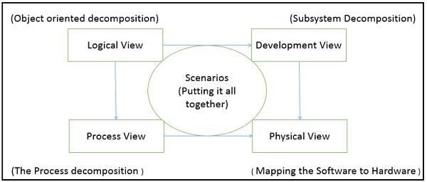

Reason for calling it 4+1 instead of 5 is:
The use case view has a special significance as it details the high level requirement of a system while other views details — how those requirements are realized. When all other four views are completed, it’s effectively redundant. However, all other views would not be possible without it. The following image and table shows the 4+1 view in detail −
 | Logical | Process | Development | Physical | Scenario
Description | Shows the | Shows the | Gives | Shows the | Shows the
 | component | processes / | building block | installation, | design is
 | (Object) of | Workflow | views of | configuration | complete
 | system as well | rules of | system and | And | by
 | as their | system and | describe static | deployment | performing
 | interaction | how those | organization | of software | validation
 |  | processes | of the system | application | and
 |  | communicate | modules |  | illustration
 |  | , focuses on
 |  | dynamic
 |  | view of
 |  | system
Viewer / | End-User, | Integrators & | Programmer | System | All the
Stake | Analysts and | developers | and software | engineer, | views of
holder | Designer |  | project | operators, | their views
 |  |  | managers | System | and
 |  |  |  | administrator | evaluators
 |  |  |  | s and system
 |  |  |  | installers
Consider | Functional | Non | Software | Nonfunction | System

 | requirements | Functional Requirements | Module organization (Software management reuse, constraint of tools) | Al requirement regarding to underlying hardware | Consistenc y and validity
UML – | Class, State, | Activity | Component, | Deployment | Use case
Diagram | Object, | Diagram | Package | diagram | diagram
 | sequence, |  | diagram
 | Communicatio
 | n Diagram

Architecture Description Languages (ADLs)
An ADL is a language that provides syntax and semantics for defining a software architecture. It is a notation specification which provides features for modeling a software system’s conceptual architecture, distinguished from the system’s implementation.
ADLs must support the architecture components, their connections, interfaces, and configurations which are the building block of architecture description. It is a form of expression for use in architecture descriptions and provides the ability to decompose components, combine the components, and define the interfaces of components.
An architecture description language is a formal specification language, which describes the software features such as processes, threads, data, and sub-programs as well as hardware component such as processors, devices, buses, and memory.
It is hard to classify or differentiate an ADL and a programming language or a modeling language.
However, there are following requirements for a language to be classified as an ADL −
- It should be appropriate for communicating the architecture to all concerned parties.
- It should be suitable for tasks of architecture creation, refinement, and validation.
- It should provide a basis for further implementation, so it must be able to add information to the ADL specification to enable the final system specification to be derived from the ADL.
- It should have the ability to represent most of the common architectural styles.
- It should support analytical capabilities or provide quick generating prototype implementations.

Software Development Life Cycle
UML is a software development life cycle or process independent language. But to get most out of UML, the software development process should have the following properties:
- Use case driven
- Architecture centric
- Iterative and Incremental
Rational Unified Process (RUP) is a software development process framework developed by Rational Corporation which satisfies the above three properties. The overall software development life cycle can be visualized as shown below:
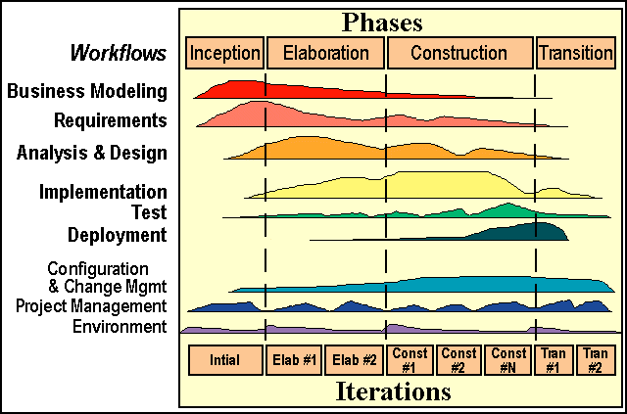

Critical activities in each phase:
Inception:
- Business case is established
- 20% of the critical use cases are identified
Elaboration:
- Develop the architecture
- Analyze the problem domain (80% of use cases are identified)
Construction:
- Source code
- User manual
- Verification and validation of code
Transition:
- Deployment of software
- New releases
- Training

