- SIMPLE CALCULATOR

//Calc.java
import java.awt.*;
import java.awt.event.*;
import java.applet.*;
/*
<applet code="calc" width=300 height=300>
</applet>
*/
public class calc extends Applet implements ActionListener
{
String msg="";
int v1,v2,result;
TextField t1;
Button b[]=new Button[10];
Button add,sub,mul,div,clear,mod,equal,Exit;
char OP;
public void init()
{
Color k=new Color(120,89,90);
setBackground(k);
t1=new TextField("0");
GridLayout g1=new GridLayout(4,5);
setLayout(g1);
for(inti=0;i<10;i++)
{
b[i]=new Button (""+i);
}
add=new Button("+");
sub=new Button("-");
mul=new Button("*");
div=new Button("/");
mod=new Button("%");
clear=new Button("clear");
equal=new Button("=");
add(t1);
for(inti=0;i<10;i++)
{
add(b[i]);
}
add.setActionCommand("add");
add(add);
sub.setActionCommand("sub");
add(sub);
mul.setActionCommand("mul");
add(mul);
div.setActionCommand("div");
add(div);
mod.setActionCommand("mod");
add(mod);
add(clear);
equal.setActionCommand("equal");
add(equal);
for(inti=0;i<10;i++)
{
b[i].addActionListener(this);
}
add.addActionListener(this);
sub.addActionListener(this);
mul.addActionListener(this);
div.addActionListener(this);
mod.addActionListener(this);
clear.addActionListener(this);
equal.addActionListener(this);
}
public void actionPerformed(ActionEvent ae)
{
String str=ae.getActionCommand();
char ch=str.charAt(0);
if(Character.isDigit(ch))
t1.setText(t1.getText()+str);
else if(str.equals("add"))
{
v1=Integer.parseInt(t1.getText());
OP='+';
t1.setText("");
}
else if(str.equals("sub"))
{
v1=Integer.parseInt(t1.getText());
OP='-';
t1.setText("");
}
else if(str.equals("mul"))
{
v1=Integer.parseInt(t1.getText());
OP='*';
t1.setText("");
}
else if(str.equals("div"))
{
v1=Integer.parseInt(t1.getText());
OP='/';
t1.setText("");
}
else if(str.equals("mod"))
{
v1=Integer.parseInt(t1.getText());
OP='%';
t1.setText("");
}
else if(str.equals("equal"))
{
v2=Integer.parseInt(t1.getText());
if(OP=='+')
result=v1+v2;
else if(OP=='-')
result=v1-v2;
else if(OP=='*')
result=v1*v2;
else if(OP=='/')
result=v1/v2;
else if(OP=='%')
result=v1%v2;
t1.setText(""+result);
}
else if(str.equals("clear"))
{
t1.setText("");
}
}
}

OUTPUT :

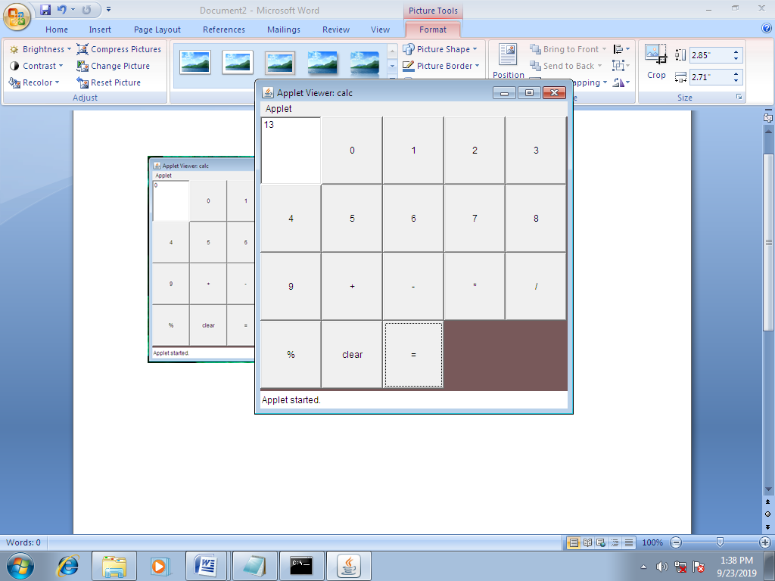

- A SIMPLE JAPPLET USING SWING CONTROLS

import java.awt.*;
import java.awt.event.*;
import javax.swing.*;
/*
<applet code="Frm" width=680 height=250>
</applet>
*/
public class Frm extends JApplet implements ActionListener,ItemListener
{
JLabel jl1,jl2,jl3,jl4,jl5;
JTextField jtf1,jtf2;
JCheckBox jcb1,jcb2,jcb3;
JRadioButton jrb1,jrb2,jrb3;
JButton jb1,jb2;
public void init()
{
Container cp=getContentPane();
cp.setLayout(new BorderLayout());
JPaneljp=new JPanel();
jp.setLayout (new GridLayout (5,2,50,10));
JPanel p1=new JPanel (new FlowLayout(FlowLayout.LEFT,30,0));
JPanel p2=new JPanel (new FlowLayout(FlowLayout.LEFT,30,0));
JPanel p3=new JPanel (new FlowLayout(FlowLayout.CENTER));
jl1=new JLabel ("Enter your Name",JLabel.RIGHT);
jl2=new JLabel("Enter your age",JLabel.RIGHT);
jl5=new JLabel("",JLabel.CENTER);
jtf1=new JTextField();
jtf2=new JTextField();
jl3=new JLabel ("Select your software ",JLabel.RIGHT);
jcb1=new JCheckBox("Oracle");
jcb2=new JCheckBox("Visual Studio");
jcb3=new JCheckBox("JAVA");
jl4=new JLabel ("Select your city",JLabel.RIGHT);
jrb1=new JRadioButton("Chenai");
jrb2=new JRadioButton("Delhi");
jrb3=new JRadioButton("Mumbai");
ButtonGroupbg=new ButtonGroup();
bg.add(jrb1);
bg.add(jrb2);
bg.add(jrb3);
jb1=new JButton("Submit");
jb2=new JButton("Reset");
jp.add(jl1);
jp.add(jtf1);
jp.add(jl2);
jp.add(jtf2);
jp.add(jl5);
jp.add(jl3);
p1.add(jcb1);
p1.add(jcb2);
p1.add(jcb3);
jp.add(p1);
jp.add(jl4);
p2.add(jrb1);
p2.add(jrb2);
p2.add(jrb3);
jp.add(p2);
p3.add(jb1);
p3.add(jb2);
cp.add(jp,BorderLayout.NORTH);
cp.add(p3,BorderLayout.SOUTH);
cp.add(jl5,BorderLayout.CENTER);
jb1.addActionListener(this);
jb2.addActionListener(this);
jrb1.addActionListener(this);
jrb2.addActionListener(this);
jrb3.addActionListener(this);
jcb1.addActionListener(this);
jcb2.addActionListener(this);
jcb3.addActionListener(this);
}
public void actionPerformed(ActionEvent ae)
{
String s=ae.getActionCommand();
if(s.equals("submit"))
{
jl5.setText(jtf1.getText()+""+jtf2.getText()+"Submitted Successfully");
}
else if(s.equals("Reset"))
{
jtf1.setText("");
jtf2.setText("");
jl5.setText("");
}
else
{
jl5.setText("You are selected"+s);
}
}
public void itemStateChanged(ItemEventie)
{
JCheckBox c=(JCheckBox)ie.getItem();
jl5.setText("You are selected "+c.getText());
}
}

OUTPUT :

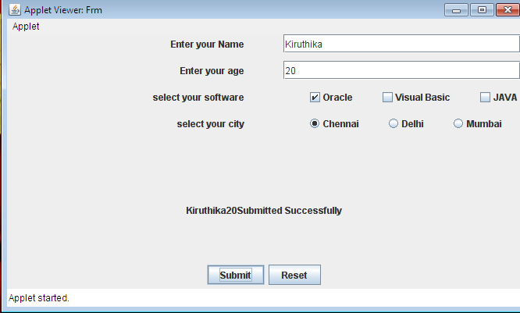
- TABLE CREATION USING JDBC

import java.io.*;
import java.sql.*;
class jdbc
{
public static void main(String a[])throws IOException
{
BufferedReaderbr=new BufferedReader (new InputStreamReader(System.in));
int x;
Connection con;
Statement st;
String name,pass;
do
{
System.out.println("\n1.Insert \n2.Retrieve \n3.Update \n4.Delete \n5.Exit\n");
System.out.println("Enter your choice:");
x=Integer.parseInt(br.readLine());
switch(x)
{
case 1:
System.out.println("\nEnter your name");
name=br.readLine();
System.out.println("\n Enter your password");
pass=br.readLine();
try
{
Class.forName("sun.jdbc.odbc.JdbcOdbcDriver");
con=DriverManager.getConnection("Jdbc:Odbc:p3");
st=con.createStatement();
st.executeQuery("insert into your login values('"+name+"','"+pass+"')");
st.close();
con.close();
}
catch(Exception ex)
{
}
break;
case 2:
inti=1;
try
{
Class.forName("sun.jdbc.odbc.jdbcodbcDriver");
con=DriverManager.getConnection("Jdbc:Odbc:p3");
st=con.createStatement();
ResultSetrs=st.executeQuery("Select * from login");
if(i==1)
{
while(rs.next());
{
System.out.println(rs.getString(1));
System.out.println(rs.getString(2));
}
}
rs.close();
st.close();
con.close();
}
catch(Exception ex)
{
}
break;
case 3:
System.out.println("\n Enter your Name to update");
name=br.readLine();
System.out.println("\n Enter your new Name");
String name1=br.readLine();
System.out.println("\n Enterf the new password");
String pass1=br.readLine();
try
{
Class.forName("sun.jdbc.odbc.JdbcOdbcDriver");
con=DriverManager.getConnection("Jdbc:Odbc:p3");
st=con.createStatement();
st.executeQuery("Update login set name='"+name1+"',pass='"+pass1+"' where name='"+name+"'");
st.close();
con.close();
}
catch(Exception ex)
{
}
break;
case 4:
System.out.println("\n Enter the name");
name=br.readLine();
try
{
Class.forName("sun.jdbc.odbc.jdbcodbcDriver");
con=DriverManager.getConnection("Jdbc:Odbc:p3");
st=con.createStatement();
st.executeQuery("delete from login where name='"+name+"'");
st.close();
con.close();
}
catch(Exception ex)
{
}
break;
}
}
while(x!=5);
}
}

OUTPUT :

- Insert
- Retrieve
- Update
- Delete
- Exit
Enter your choice :2
Anu
111
Sindhu
333
Enter your choice :1
Enter your name: Deepa
Enter your password: 222
Enter your choice:2
Anu
111
Sindhu
333
Deepa
222
Enter your choice: 3
Enter the name to update: Anu
Enter the new name: Kavi
Enter the new password: 444
Enter your choice :2
Kavi
444
Sindhu
333
Deepa
222
Enter your choice: 4
Enter the name:Sindhu
Enter your choice :2
Kavi
444
Deepa
222
Enter your choice :5

- CLIENT SERVER APPLICATION USING RMI

//ADDSERVER INTERFACE

import java.rmi.*;
public interface AddServerIntf extends Remote
{
double add(double d1,double d2)throws RemoteException;
}

//ADDSERVER IMPLEMENTATION

import java.rmi.*;
import java.rmi.server.*;
public class AddServerImp extends UnicastRemoteObject implements AddServerIntf
{
public AddServerImp()throws RemoteException
{
}
public double add(double d1,double d2)throws RemoteException
{
return(d1+d2);
}
}

//ADDSERVER

import java.rmi.*;
import java.rmi.server.*;
public class AddServer
{
public static void main(String a[])
{
try
{
AddServerImpobimp=new AddServerImp();
Naming.rebind("AddServer",obimp);
}
catch(Exception e)
{
System.out.println("Exception:"+e.getMessage());
}
}
}
//ADDCLIENT

import java.rmi.*;
public class AddClient
{
public static void main(String a[])
{
try
{
String addServerURL="rmi://"+a[0]+"/AddServer";
AddServerIntfobintf=(AddServerIntf)Naming.lookup(addServerURL);
System.out.println("The first number is:"+a[1]);
double d1=Double.valueOf(a[1]).doubleValue();
System.out.println("The second number is:"+a[2]);
double d2=Double.valueOf(a[2]).doubleValue();
System.out.println("The sum is: "+obintf.add(d1,d2));
}
catch(Exception e)
{
System.out.println("Exception "+e.getMessage());
}
}
}

OUTPUT :

E:\server>start rmiregistry
E:\server>java AddServer

F:\client>java AddClient 127.0.0.1 12 14
The first number is :12
The second number is :14
The sum is:26.0

- COOKIE and its EXPIRY TIME PROGRAM

//index.html
<html>
<head>
<title>Cookie program</title>
</head>
<body bgcolor=pink>
<center><h1><font face="Camberia">Setting Cookie&its expiry time</h1></center>
<form name="Form1" method="POST" action="http://localhost/p5/servlet/AddCookieServlet>
<table border=1 cellspacing=0 cellpadding=8>
<tr><td> Enter a name for cookie</td>
<td><input type=textbox name="name" size=25 value=""></td></tr>
<tr><td>Enter a value for cookie</td>
<td><input type=textbox name=val size=25 value=""></td></tr>
<tr><td colspan=2 align=center><input type=submit value="Submit"></td></tr>
</table>
</form>
</body>
</html>

//ADDING COOKIE

import java.io.*;
import javax.servlet.*;
import javax.servlet.http.*;
public class AddCookieServlet extends HttpServlet
{
public void doPost(HttpServletRequest request, HttpServletResponse response)throws ServletException, IOException
{
String name=request.getParameter("name");
String value=request.getParameter("val");
Cookie cookie=new Cookie(name,value);
cookie.setMaxAge(7200);
response.addCookie(cookie);
response.setContentType("text/html");
PrintWriter pw=response.getWriter();
pw.println("<center>");
pw.println("<b>"+name+"has been set to");
pw.println(value);
pw.println("<br><a href=http://localhost/P5-Cookie/servlet/GetCookieServlet>Click here to See the Cookie</a>");
pw.close();
}
}

//GETTING COOKIE

import java.io.*;
import javax.servlet.*;
import javax.servlet.http.*;
public class GetCookiesServlet extends HttpServlet
{
public void doGet (HttpServletRequest request, HttpServletResponseresponse)throwsServletException,IOException
{
Cookie[] cookies=request.getCookies();
response.setContentType("text/html");
PrintWriter pw=response.getWriter();
pw.println("<left><b>");
for(inti=0;i<cookies.length;i++)
{
String name=cookies[i].getName();
String value=cookies[i].getValue();
long age=cookies[i].getMaxAge();
pw.println("<br>Name="+name);
pw.println("<br>Value="+value);
pw.println("<br>Age="+age);
pw.println("<br>----------------------");
}
pw.close();
}
}

OUTPUT :

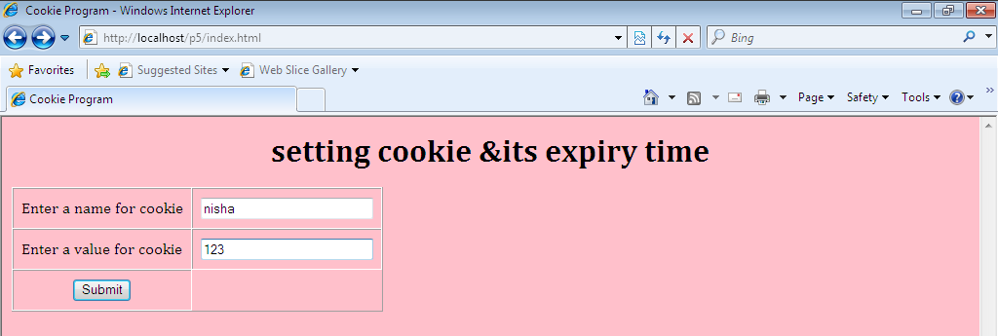

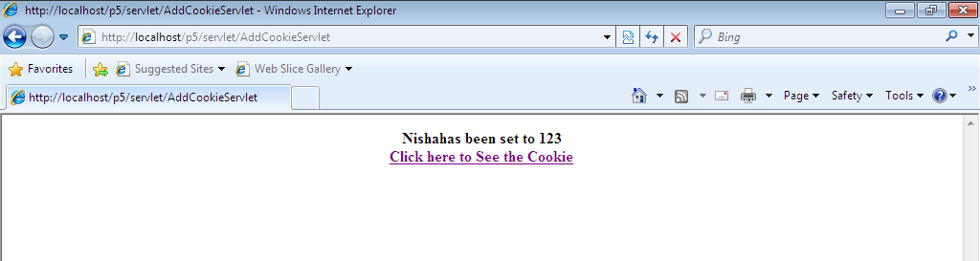

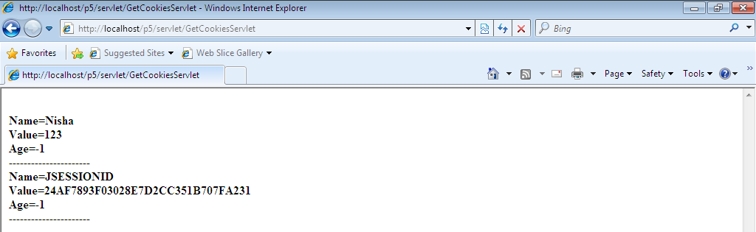

- WEB PAGE HIT COUNTER
//index.html
<html>
<body align="center">
<form method="get" action="http://localhost/p7/servlet/PageHitCounter">
<b>Servlet Program to count the number of visitors of a Web Page</b>
<p><input type="submit" value="Submit"></p>
</form>
</body>
</html>

//PAGE HIT COUNTER

import java.io.*;
import javax.servlet.*;
import javax.servlet.http.*;
public class PageHitCounter extends HttpServlet
{
private int hits;
public void init()
{
hits=0;
}
public void doGet(HttpServletRequestrequest,HttpServletResponse response)throws ServletException,IOException
{
hits++;
PrintWriter out=response.getWriter();
String title="Total Number of Hits";
out.println("<html>\n"+
"<head><title>"+title+"</title></head>\n"+
"<bodybgcolor=\"#f0f0f0\">\n"+
"<h1 align=\"center\">"+title+"</h1>\n"+
"<h2 align=\"center\">"+hits+"</h2>\n"+
"</body></html>");
}
}

OUTPUT :

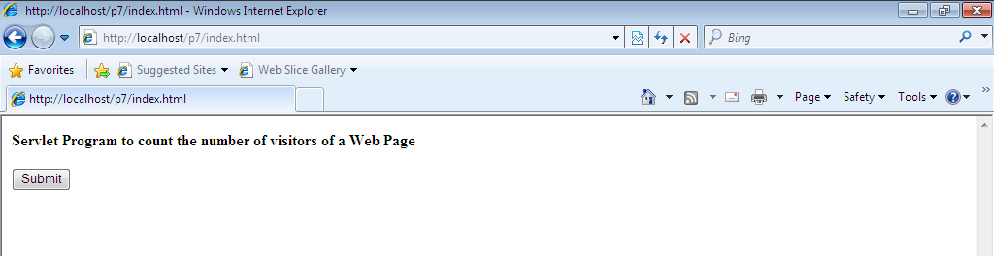

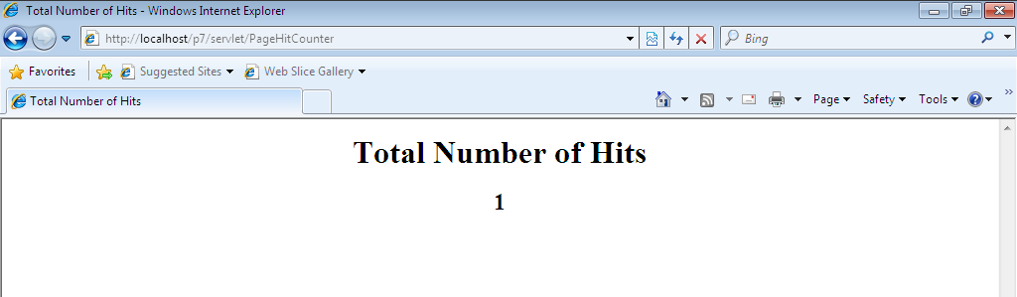

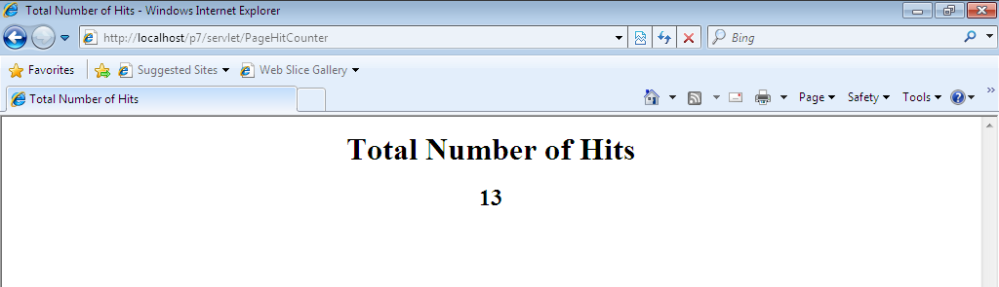

- USER VALIDATION USING SERVLET

//index.html
<html>
<head>
<title>User Validation Page</title>
</head>
<body>
<form method="POST" action="http://localhost/:P7_Login/servlet/Log">
<center>
<table border="1">
<tr><td colspan="2" align="center">Login Here</td></tr>
<tr><tdalign="right" UserName</td>
<tdalign="center">
<input type="text" name="T1"></td></tr>
<tr><tdalign="right">Password</td><td align="center">
<input type="password" name="T2"></td></tr>
<tr><td colspan="2" align="center">
<input type="submit" value="signIn">
<input type=reset" value="cancel"></td></tr>
</table>
</center>
</form>
</body></html>
//Empty.html
<html>
<head>
<title>Empty Entries</title>
</head>
<body align="center"><b>
Entries needed!!! You should give both the entries
<a href="javascript:history.back(1)"><p>TRY AGAIN</p></a>
</body>
</html>
//Invalid User.html
<html>
<head>
<title>Invalid User</title>
</head><body>
You are not a valid user.!!!
<a href="javascript:history.back(1)"<p>Try Again</p></a>
</body>
</html>
//Success.html
<html>
<head>
<title>Success Page</title>
</head>
<body align="center">
Successful Login
</body></html>
//Log.java
import javax.servlet.*;
import javax.servlet.http.*;
import java.sql.*;
import java.io.*;
public class Log extends HttpServlet
{
public void doPost(HttpServletRequestrequest,HttpServletResponse response)throws ServletException,IOException
{
String uname=request.getParameter("T1");
String pword=request.getParameter("T2");
String u="";
String p="";
PrintWriter pw=response.getWriter();
if((!uname.equals(""))||(!pword.equals("")))
{
try
{
Class.forName("sun.jdbc.odbc.JdbcOdbcDriver");
Connection con=DriverManager.getConnection("jdbc:odbc:P7");
Statement stmt=con.createStatement();
ResultSetrs=stmt.executeQuery("select UName,PWord from Login where UName='"+uname+"'");
while(rs.next())
{
u=rs.getString(1);
p=rs.getString(2);
}
if(uname.equals(u))
{
if(pword.equals(p))
{
response.sendRedirect("http://localhost/P7-Login/Success.html");
}
else
{
response.sendRedirect("http://localhost/P7-Login/Err.html");
}
}
else
{
response.sendRedirect("http://localhost/P7-Login/InvalidUser.html");
}
stmt.close();
con.close();
}
catch(Exception e)
{
pw.println("<h2 align=center>Sorry"+e+"</h2>");
}
}
else
{
response.sendRedirect("http://localhost/P7-Login/Empty.html");
}
pw.close();
}
}

OUTPUT :

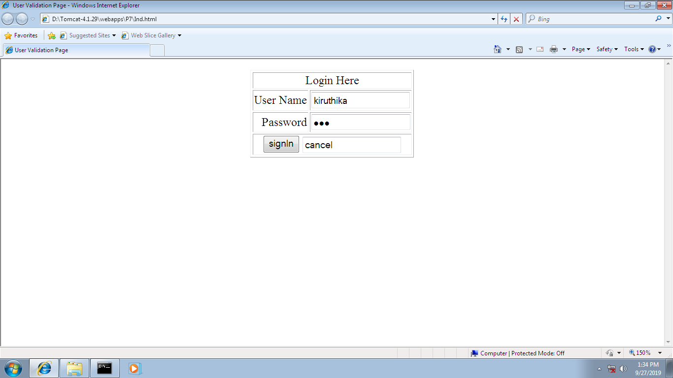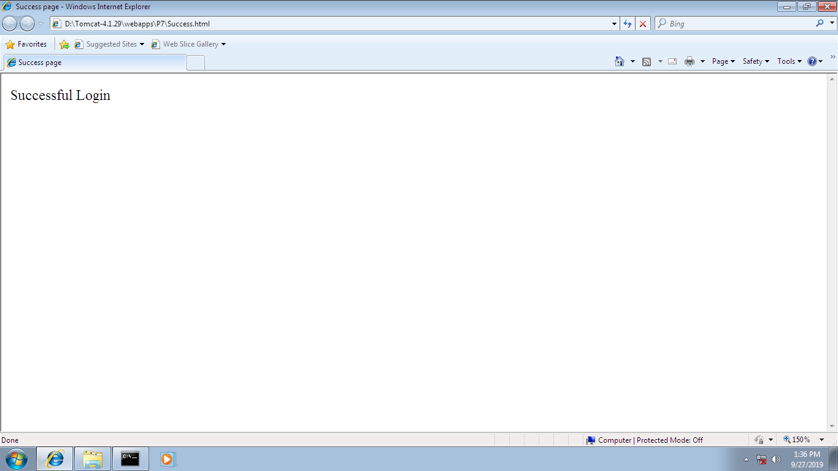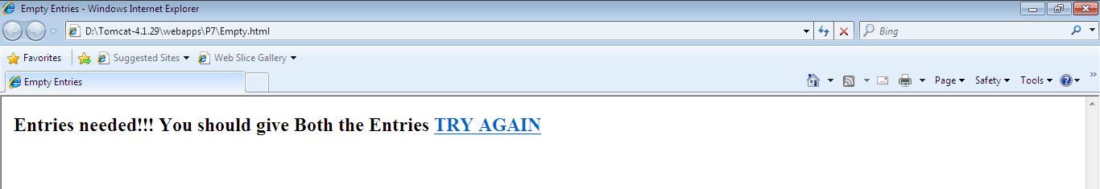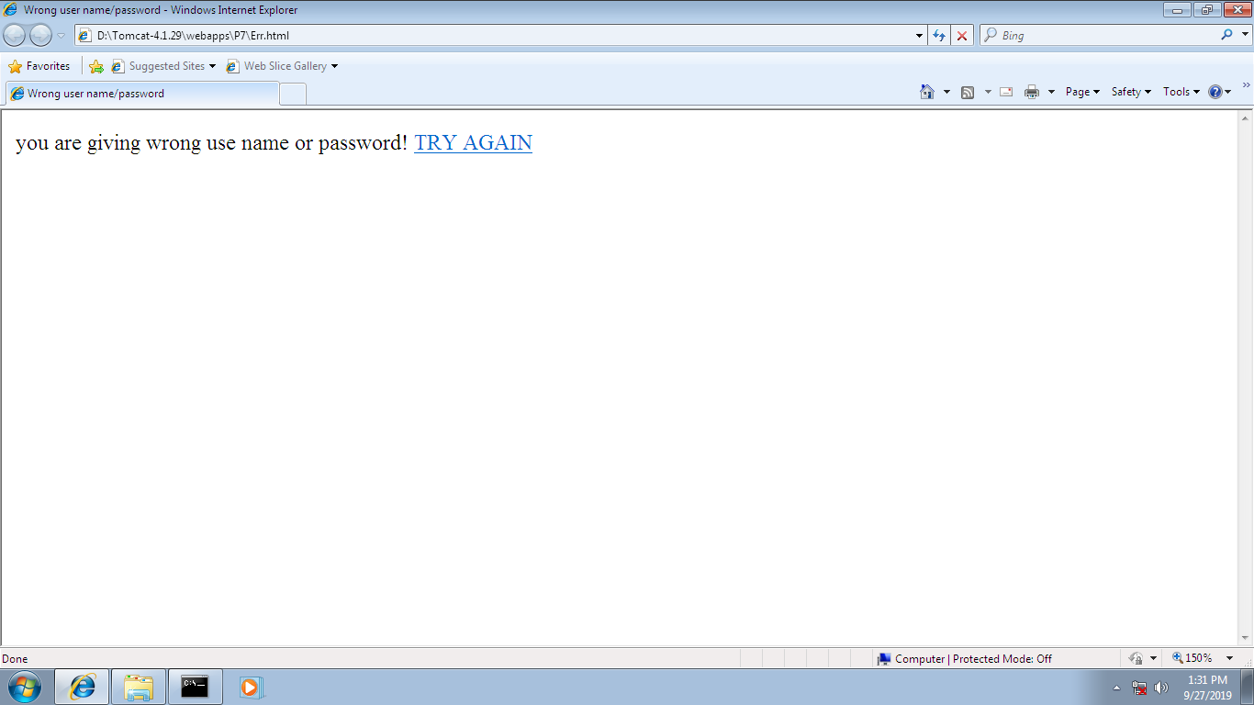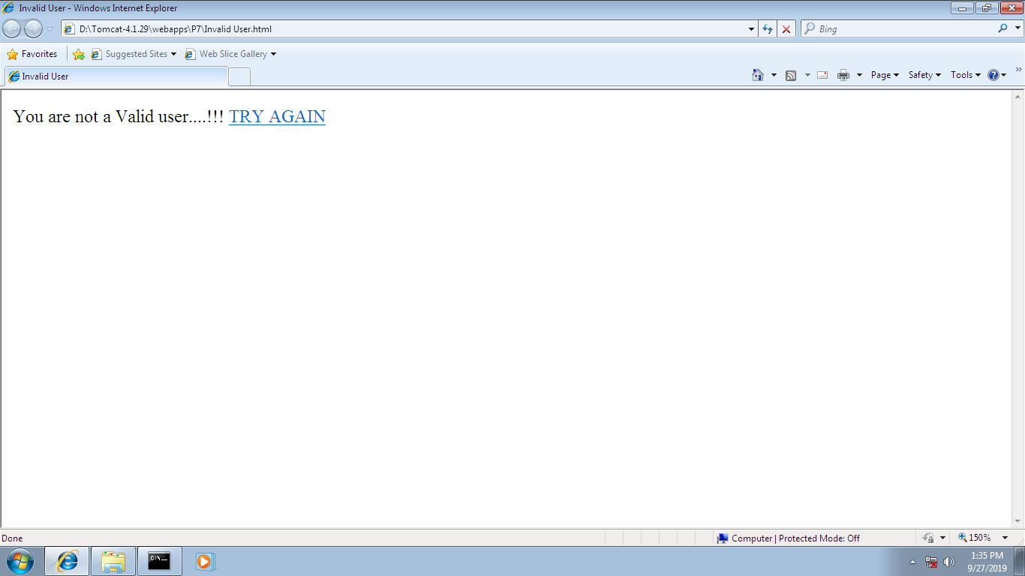
- A SIMPLE JAVA BEAN

import java.awt.*;
import java.io.*;
import java.util.*;
public class SimpleBean extends Canvas implements Serializable
{
private String msg;
public SimpleBean()
{
msg="Hello World!";
setSize(200,50);
setBackground(Color.blue);
}
public void setMsg(String msg)
{
this.msg=msg;
}
public String getMsg()
{
return msg;
}
public void paint(Graphics g)
{
g.drawString(msg,10,10);
}
}

OUTPUT :

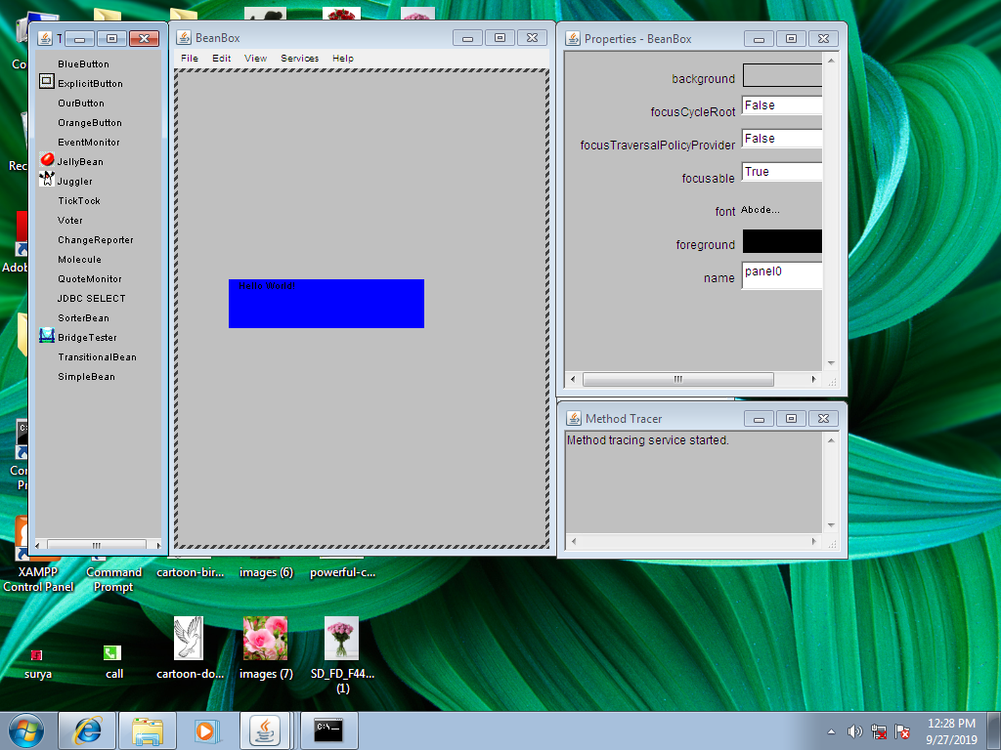
9. RGB TO GRAYSCALE IMAGE

import java.awt.*;
import java.awt.image.BufferedImage;
import java.io.*;
import javax.imageio.ImageIO;
import javax.swing.JFrame;
public class GrayScale
{
BufferedImage image;
int width;
int height;
public GrayScale()
{
try
{
File input=new File("Desert.jpg");
image=ImageIO.read(input);
width=image.getWidth();
height=image.getHeight();
for(inti=0;i<height;i++)
{
for(int j=0;j<width;j++)
{
Color c=new Color(image.getRGB(j,i));
int red=(int)(c.getRed()*0.299);
int green=(int)(c.getGreen()*0.587);
int blue=(int)(c.getBlue()*0.114);
Color newColor=new Color(red+green+blue,red+green+blue,red+green+blue);
image.setRGB(j,i,newColor.getRGB());
}
}
File output=new File("GrayScaleImage.jpg");
ImageIO.write(image,"jpg",output);
}
catch(Exception e)
{
}
}
public static void main(String args[])throws Exception
{
GrayScaleobj=new GrayScale();
}
}

OUTPUT :

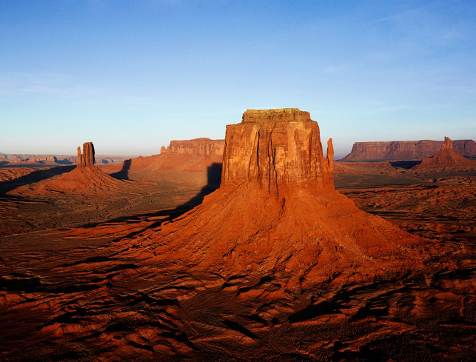

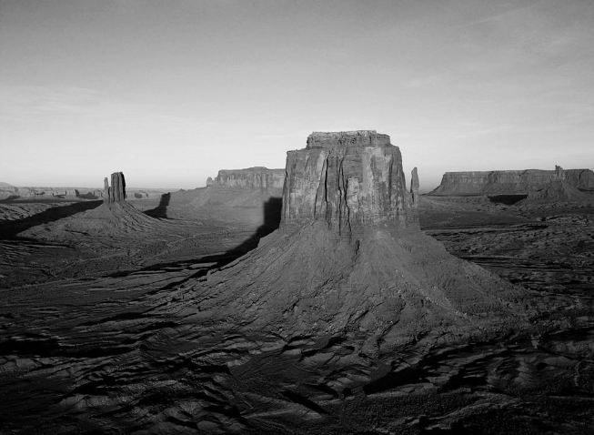

10. CHAT - SERVER

//CLIENT

import java.io.*;
import java.net.*;
public class Client
{
public static void main(String args[])throws IOException
{
String q;
Socket so;
PrintStreamps;
DataInputStream dip;
System.out.println("I am ready");
while(true)
{
so=new Socket(InetAddress.getLocalHost(),98);
ps=new PrintStream(so.getOutputStream());
dip=new DataInputStream(so.getInputStream());
System.out.println("From Server"+dip.readLine());
BufferedReaderbr=new BufferedReader(new InputStreamReader(System.in));
q=br.readLine();
if(q.equals("end"))
{
ps.println("Over Talk");
so.close();
System.exit(0);
}
ps.println(q);
so.close();
}
}
}

//SERVER
import java.io.*;
import java.net.*;
public class Server
{
public static void main(String args[])throws IOException
{
int p=98;
Socket so;
System.out.println("I am ready");
String q="Hai How are you";
ServerSocketss=new ServerSocket(p);
PrintStreamot;
DataInputStream da;
while(true)
{
so=ss.accept();
ot=new PrintStream(so.getOutputStream());
da=new DataInputStream(so.getInputStream());
ot.println();
q=da.readLine();
System.out.println("From client "+q);
BufferedReaderbr=new BufferedReader(new InputStreamReader(System.in));
q=br.readLine();
if(q.equals("end"))
{
so.close();
System.exit(0);
}
ot.println(q);
so.close();
}
}
}

OUTPUT

