UNIT I - OVERVIEW OF C

History of C

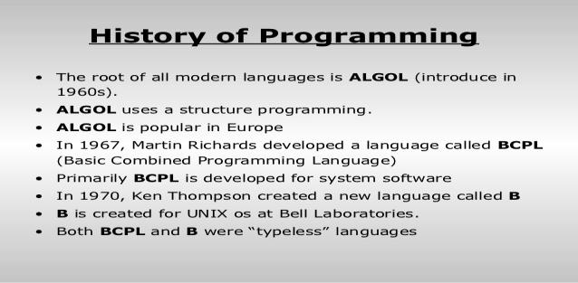

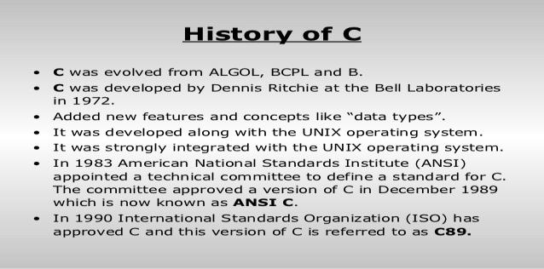

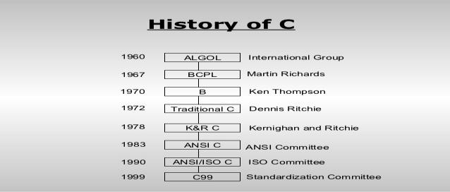
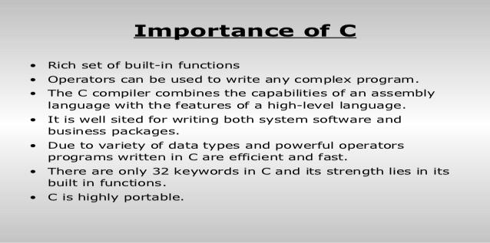
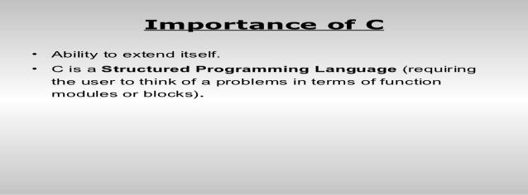
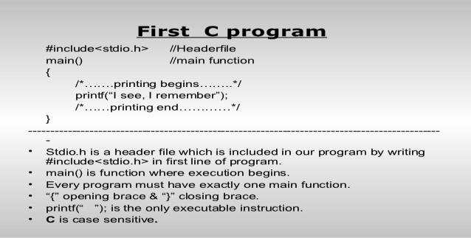

/*program to add two numbers*/
#include<stdio.h>
#define PI 3.14
Int a;
Void main()
{
Int a=10;
Float b,c;
Printf(“ENTER THE VALUE OF A:”)
scanf(“%d”,&a);
Printf(“enter the value of b:);
Scanf(“%f”,&b);
C=a+b;
Printf(“output=%f”,c);
}

Ctrl+f9

Enter the value of A:
67

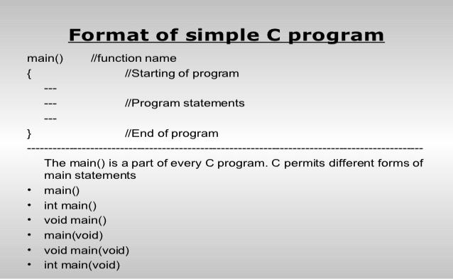

/*program to subtraction of two numbers*/
#include<stdio.h>
Void main()
{
Int a,b,c;
Printf(“ENTER THE VALUE OF A:\n”)
scanf(“%d”,&a);
Printf(“enter the value of b:\n”);
Scanf(“%f”,&b);
C=a-b;
Printf(“output=%f”,c);
}

Ctrl+f9
Basic structure of c program

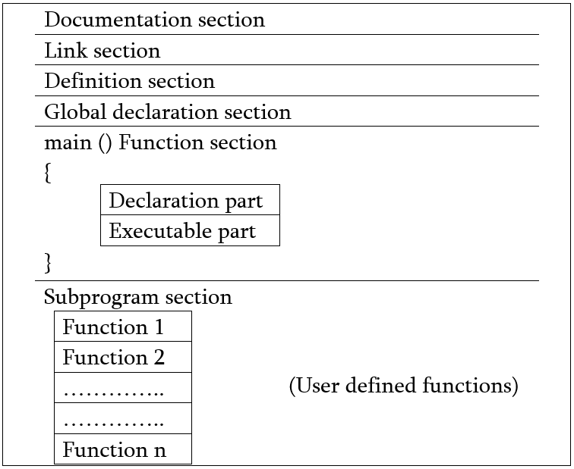
- Documentation section:
The documentation section consists of a set of comment lines giving the name of the program, the author and other details, which the programmer would like to use later. These information give the program an identity and basic authority.
- Link section: The link section provides instruction to the compiler to link or include the required in-built functions from the system library such as using the #include directive. This is important, because if we need to use any in-built system function we must first include the library in which the function has been defined.
- Definition section: The definition section defines all symbolic constants using the #define directive. Having the constants being defined here, we can use them elsewhere in code.
- Global declaration section: There are some variables that are used in more than one function; these variables are called global variables and are declared in this global declaration section which is outside the definition of any function This section also declares all the user-defined functions. As this global scope, these functions and variables can be used from definition of other functions.
- main () function section: A C program must have one main function section in its structure. This section contains two parts; declaration part and executable part. However, the content of these two parts can be mixed.
  - Declaration part: The declaration part declares all the variables used in the executable part.
  - Executable part: There is at least one statement in the executable part. These two parts must appear between the opening and closing braces of the main function. The program execution begins at the opening brace and ends at the closing brace. The closing brace of the main function is the logical end of the program. All statements in the declaration and executable part end with a semicolon.
- Subprogram section: If the program is a multi-function program then the subprogram section contains definition of all the user-defined functions which were declared earlier in the Definition Section. User-defined functions are generally placed immediately after the main () function, although they may appear in any order.
Programming style:
C programs are written in lowercase.uppercase are used only for symbolic constants
C is a free form language,we can group statements in one line.
a=b;
x=y+1;
z=a+x;
_{can be written in oneline} a=b;x=y+1;z=a+x;
_{the program main()}
{
_{printf(“hello c);}
} may be written as main(){printf(“hello c”)};
_{EXECUTING A C PROGRAM}
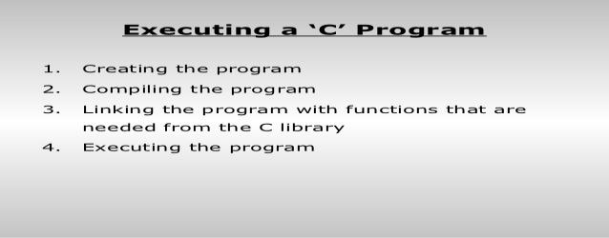

Constants,variables and data types

Character Set

Letters, Digits,Special Characters,White spaces

Letters :
C language comprises the following set of letters to form a standard program. They are:
A to Z in Capital letters.
a to z in Small letters.
In C programming, small latter and caps latter are distinct.

Digits : C language comprises the following sequence of numbers to associate the letters. 0 to 9 digits.

Special characters:
Symbol | Meaning
~ | Tilde
! | Exclamation mark
# | Number sign
$ | Dollar sign
% | Percent sign
^ | Caret
& | Ampersand
* | Asterisk
( | Lest parenthesis
) | Right parenthesis
_ | Underscore
+ | Plus sign
| | Vertical bar
\ | Backslash
` | Apostrophe
- | Minus sign
= | Equal to sign
{ | Left brace
} | Right brace
[ | Left bracket
] | Right bracket
: | Colon
" | Quotation mark
; | Semicolon
< | Opening angle bracket
> | Closing angle bracket
? | Question mark
, | Comma
. | Period
/ | Slash

White spaces: blank space,horizontal tab,carriage return.new line,form feed
Trigraph sequence:c introduces the concept of “trigraph” sequence to provide a way to enter certain characters that are not available in some keywords:
For ex:if the keyboard does not support square bracket we can still use them in a program
As trigraph??
Trigraph sequence
??= #number sign
??( [ left bracket
??) ]right bracket
??< {left brace
??> }right brace
C tokens
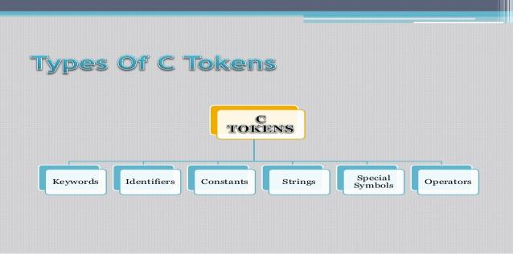
Keywords:float,while
Identifier:main,amount
Constants:-15.5
Strings:”ABC”
Special symbols:[],{}
operators:

keywords and identifiers
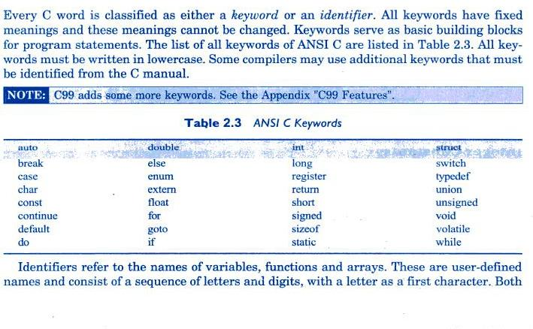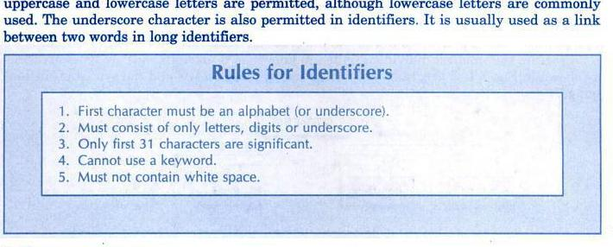

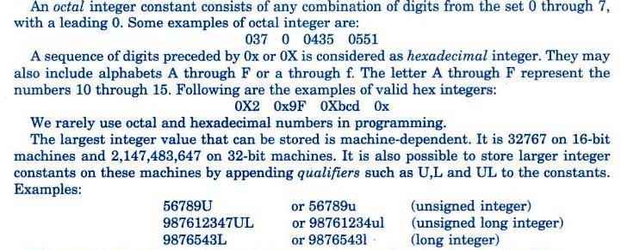
_{float b;}
_{b=6.78; .78 -8,.90}

_{CONSTANTS}
Constants in C refer to fixed values that do not change during the execution of program.C supports different types of constants
_{Constants}

Numeric constant Character constant

Integer Real Single _{String}
constant constant character constant constant
_{Integer constant:}
Integer constants refer to sequence of digits.there are 3 types of integer namely
decimal integer,octal integer,hexadecimal integer
_{for ex: 123,-45,+79}
_{octal integer example 037,551}
hexadecimal integer example: 0X2,0x9F

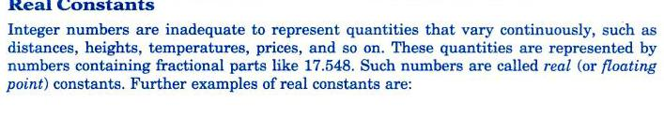
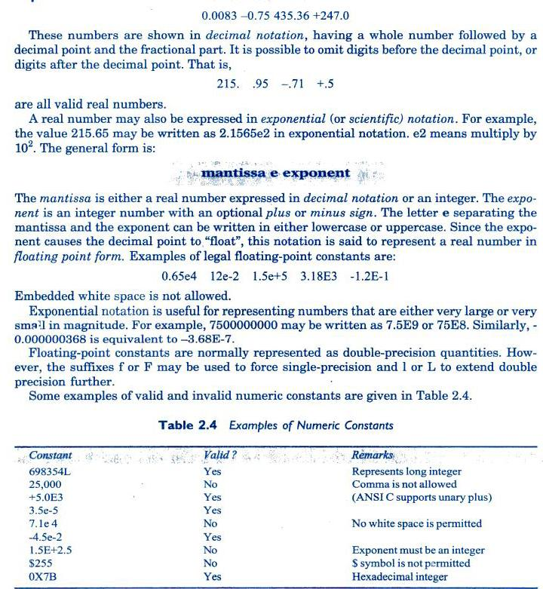
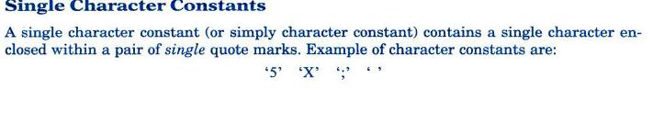
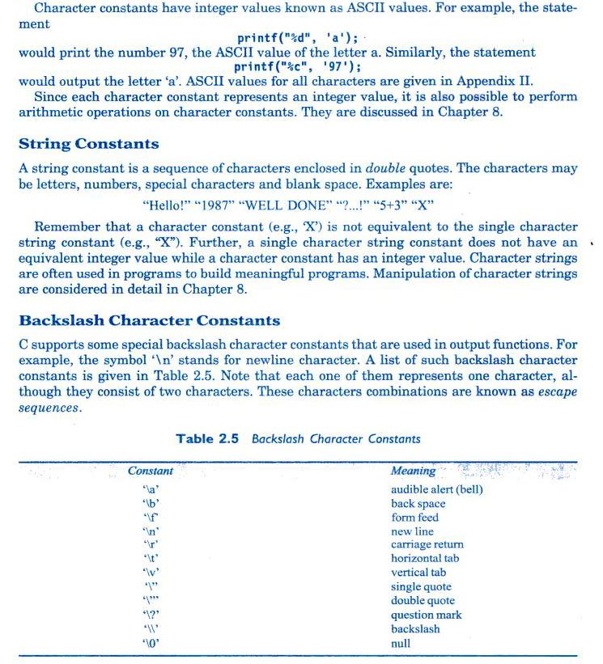
printf(“Output of this A is%d\t\\”,a); a/b
printf(“Output of this B is%d”,b);
₆
_{int A;}
_{int i6;}
int a,b,total,averagefgmnfmgnmfngmfngmfngmfngnfmngfmgnfmn;
_{int} 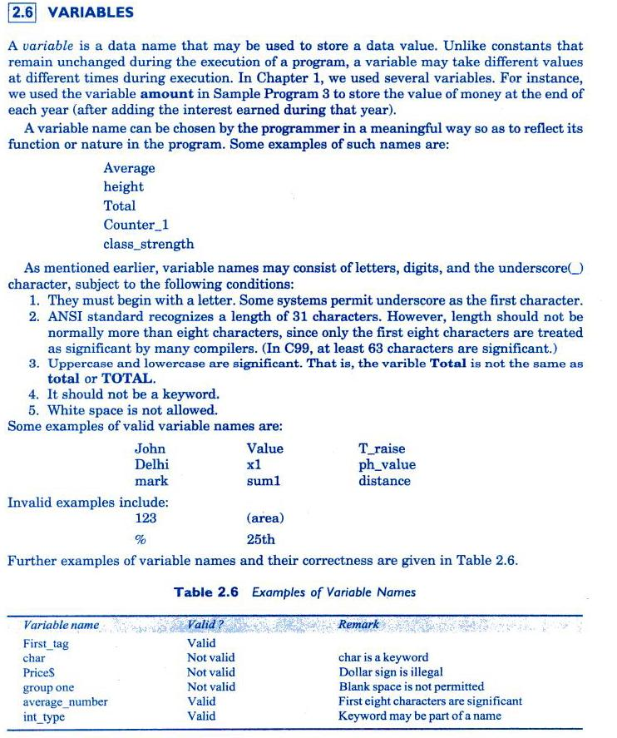
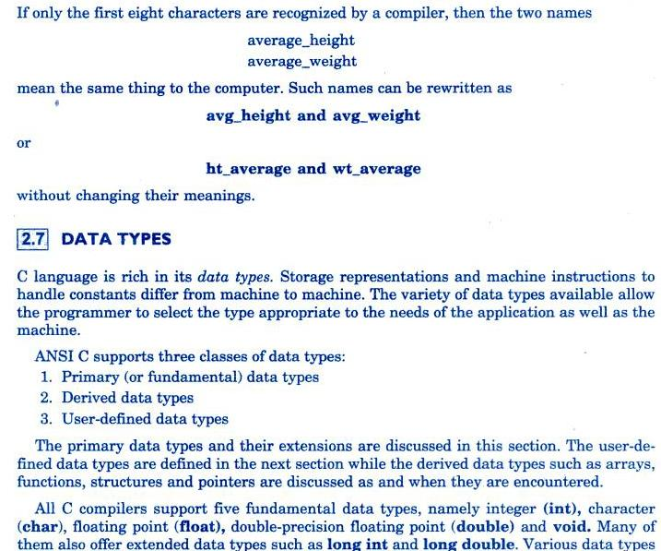

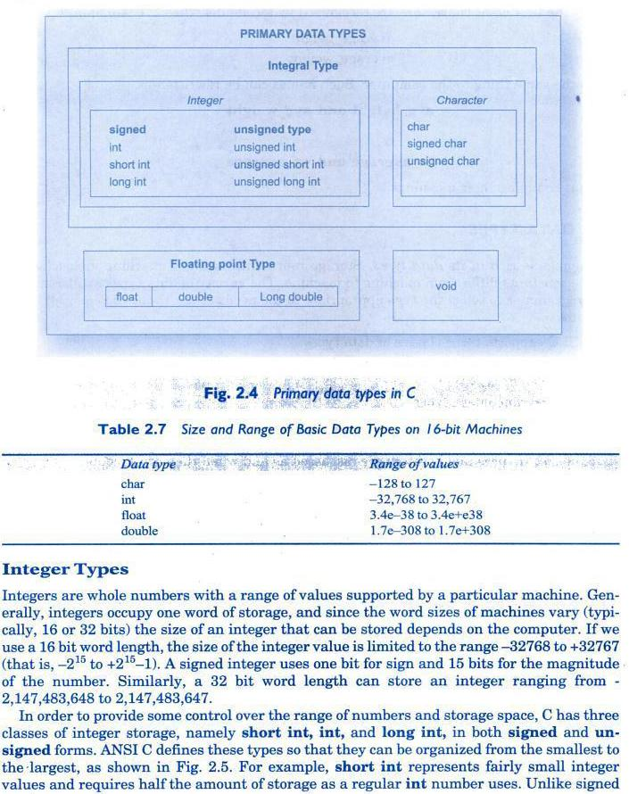
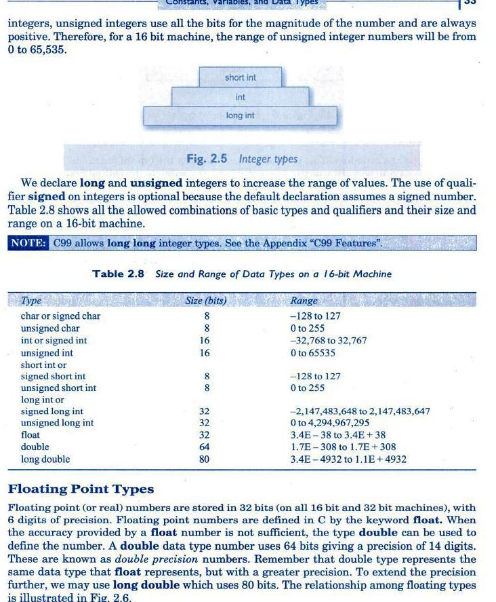
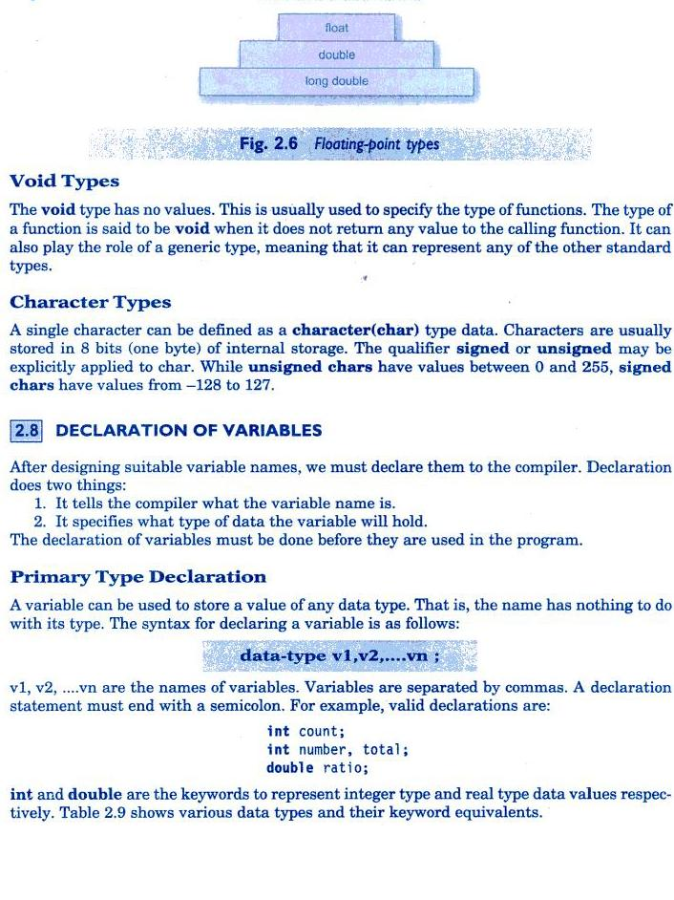
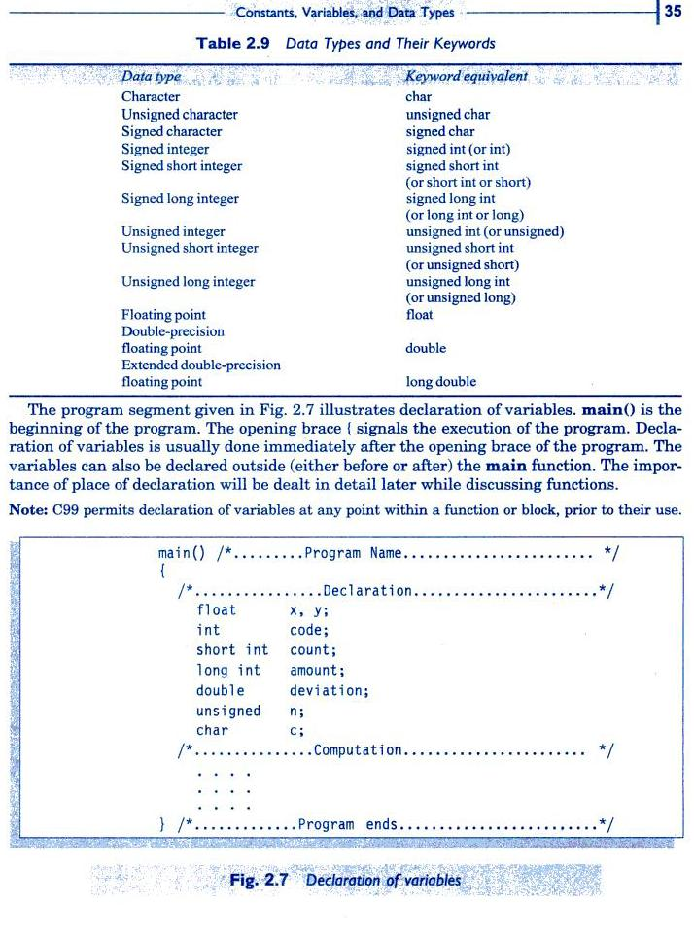
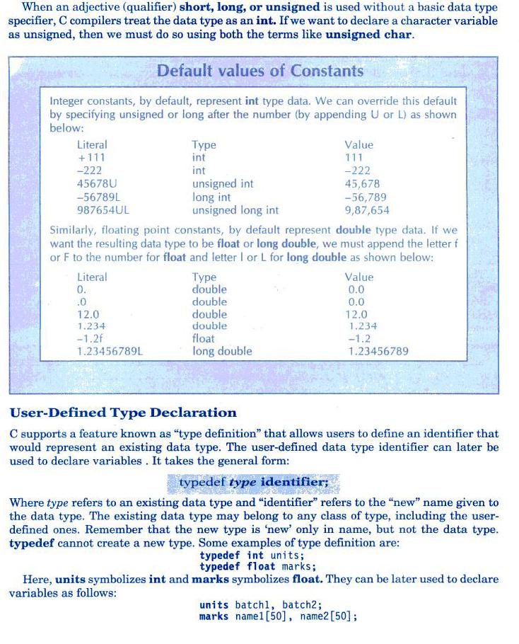
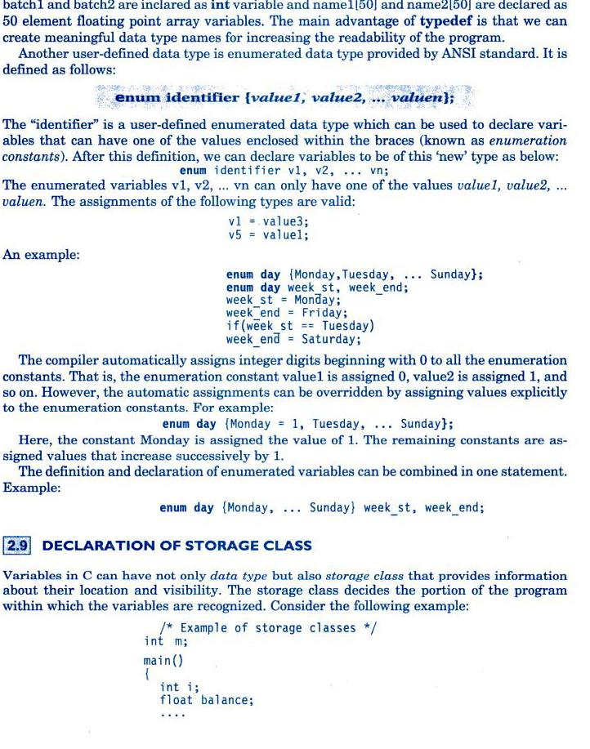
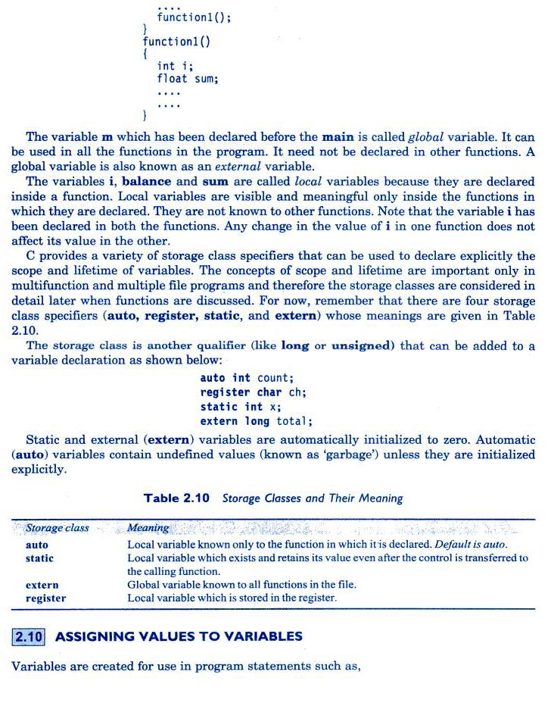
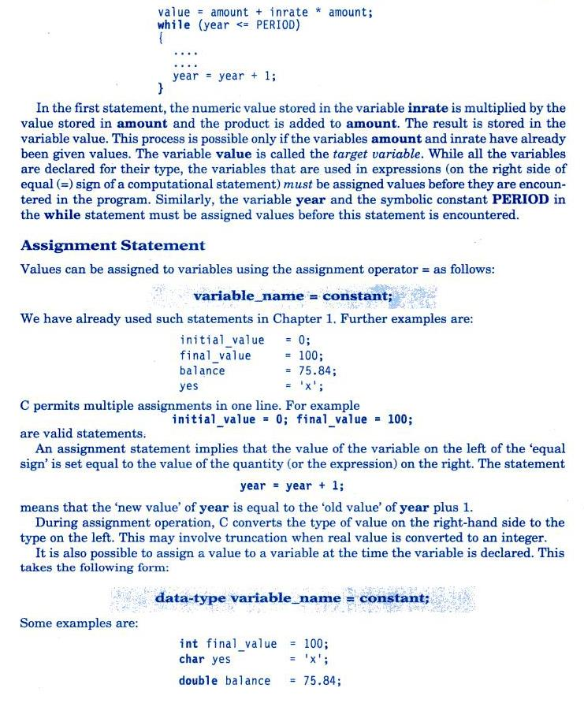
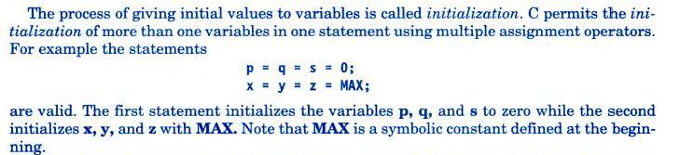
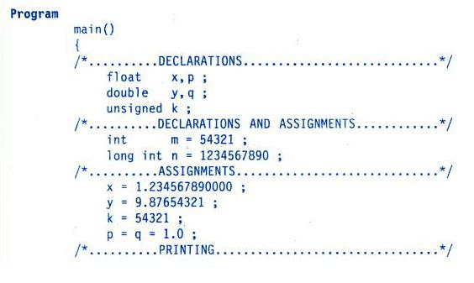
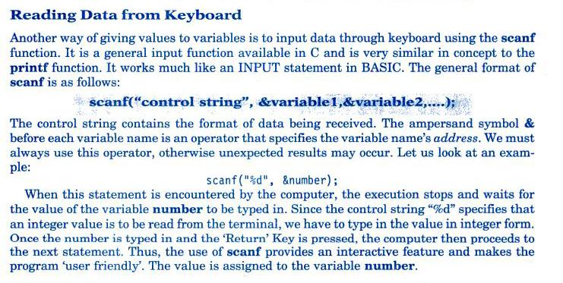
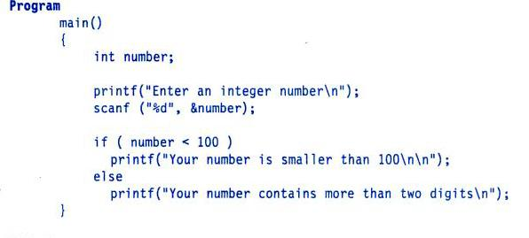
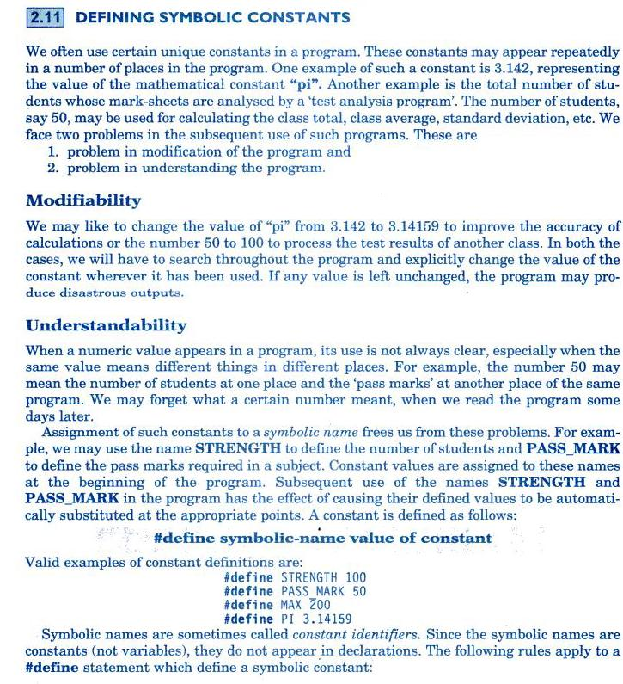

_{const int a=10,b=5;}

_{a=a+b;}
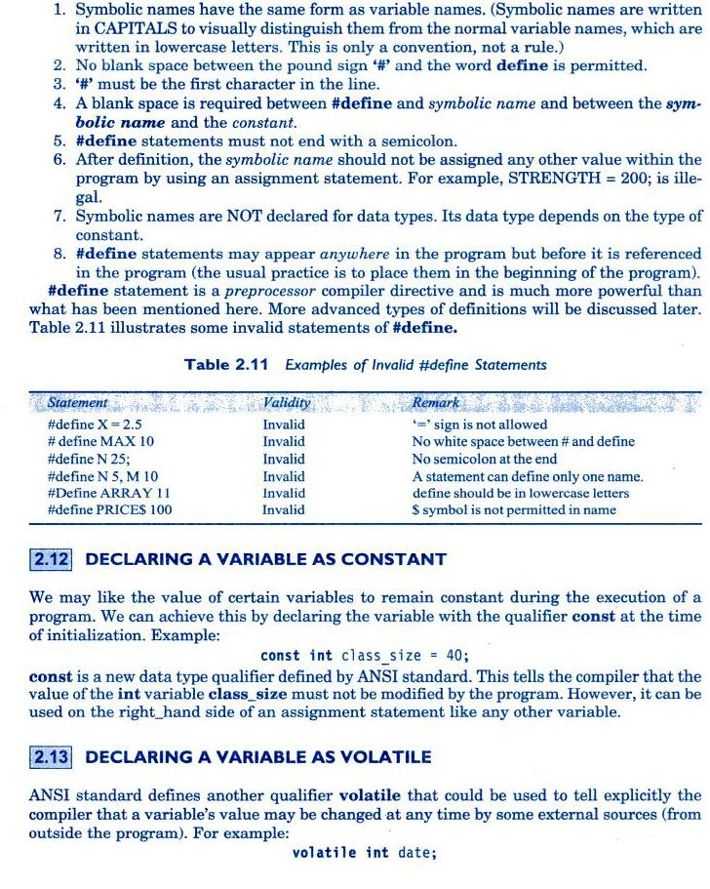
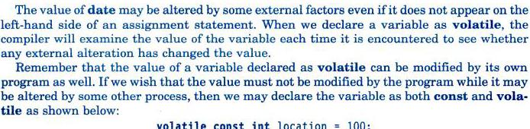
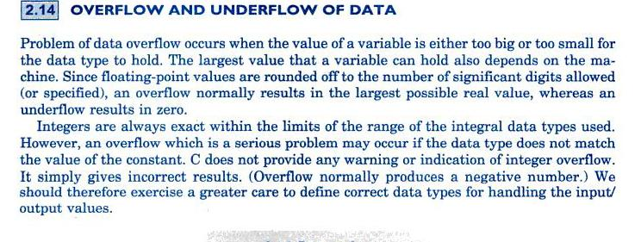

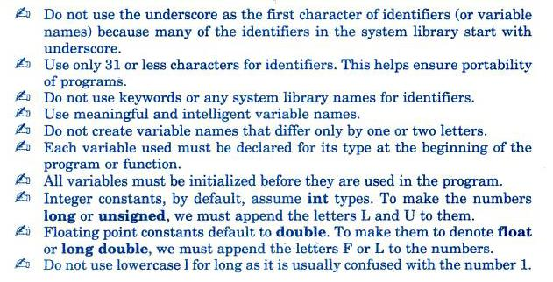
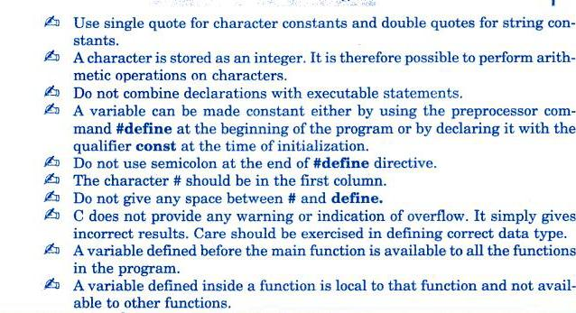

_{operators and expressions}
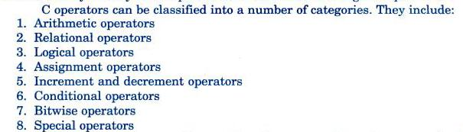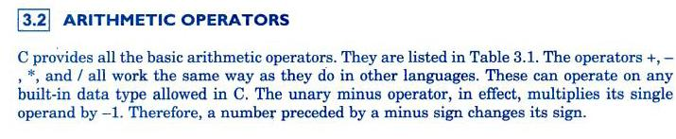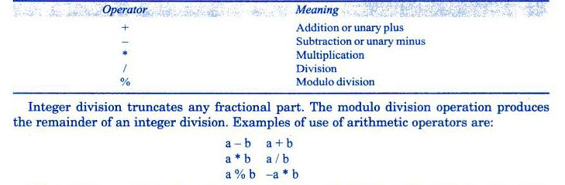
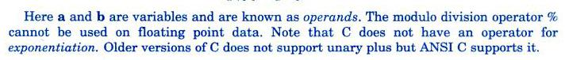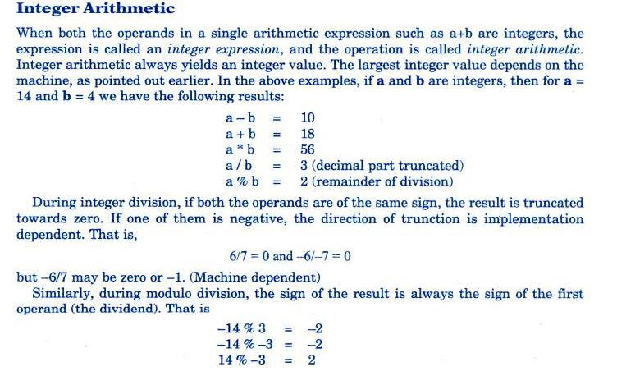

_{a=4;}
_{b=5;}
_{a==b}

_{AND (&&)}
_{OR(||) PIPE SYMBOL}
_{NOT !}
_{A B A AND B A OR B}
- ₀ ₀ ₀
- ₁ ₀ ₁
- ₀ ₀ ₁
₁ ₁ ₁ ₁

_{A NOT}
- ₁
- ₀
_{a=2 ,b=3,x=10,c=1,d=4}
_{!a+b}
_{if(a>b&&x==10)}
_{printf(“value is correct”);}
_{else}
printf(“value is not correct”);
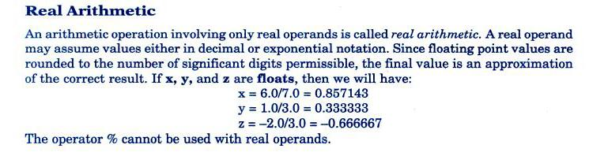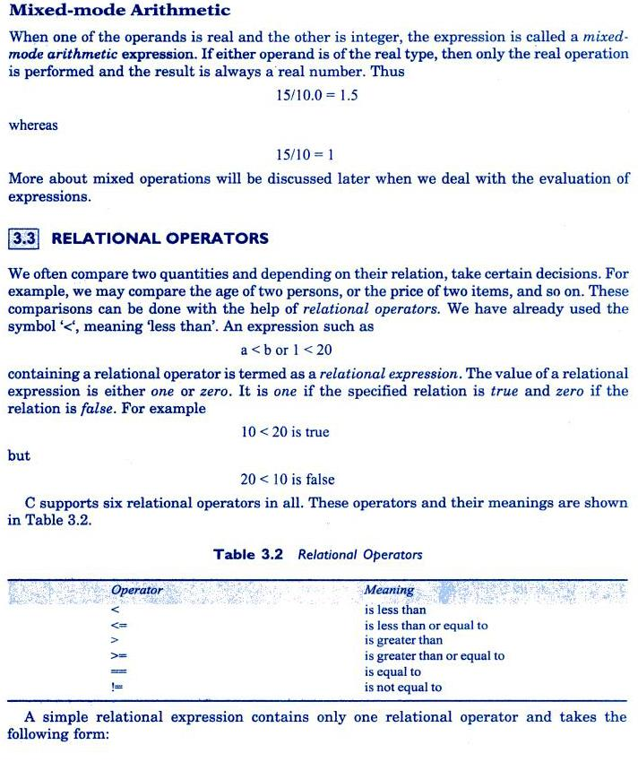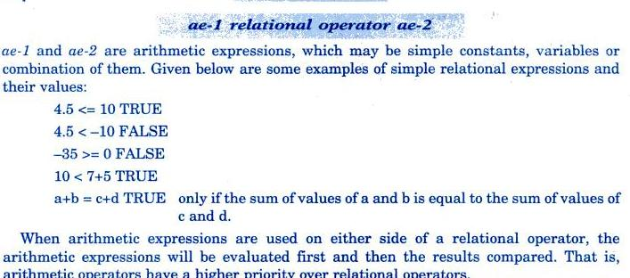

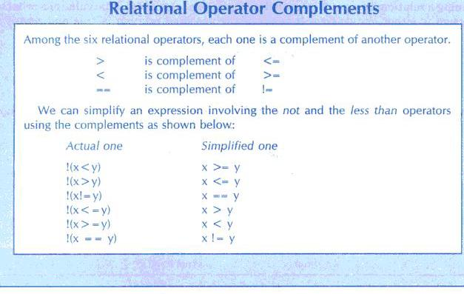
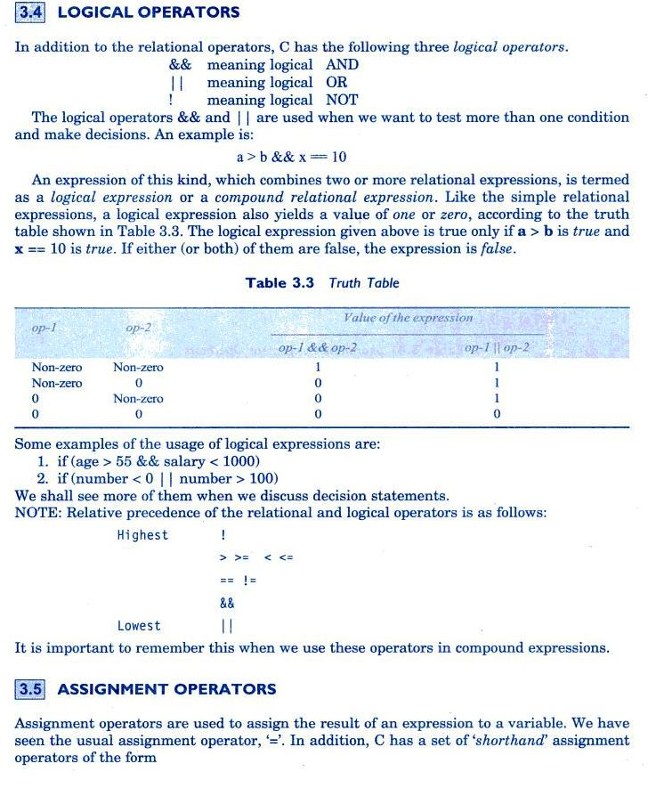
_{v op= exp; int a=10; b=b-4;}

_{b-=4;}
v-variable,exp=expression we can assign

v=v op(exp),x=x+(y+1)the shortant operator+= can also be used.

X+=3 i.e x=x+3

y-=7
The shorthand operator has many advantages:
1.what appears in left hand side need not be repeated.
2.statement is more concise and easier to read.
3.statement is more efficient.
a=5; c=4
a=a+1; c=c-1

a= 1 0 1 1
b=1 1 0 1
a&b= 1 0 0 1 bitwise and
a|b=1 1 1 1 bitwise OR
a^b=0 1 1 0 bitwise Ex-OR

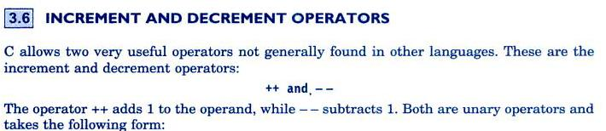
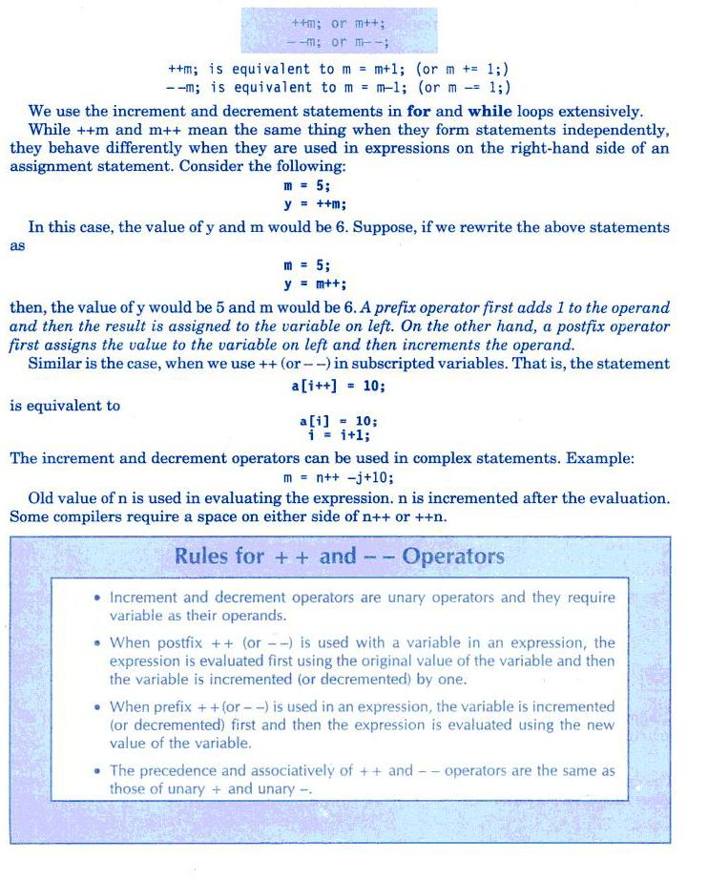
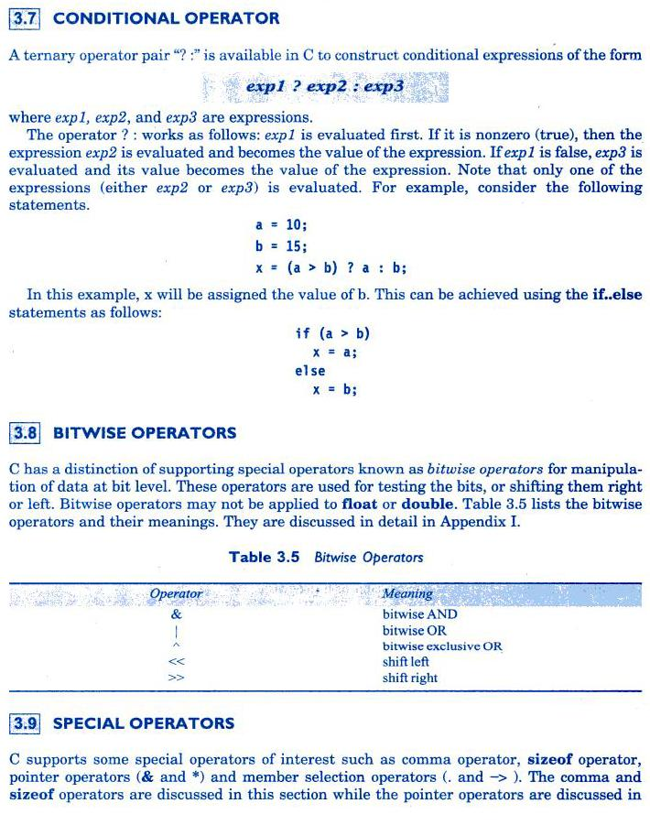

_{int a=1000,b=5.78,c=90;}
_{float c,g,h,y;}
_{x=sizeof(a);}
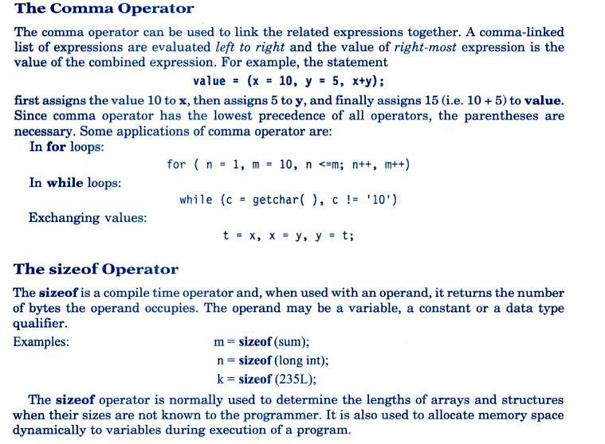
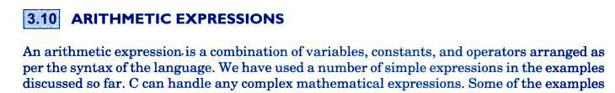
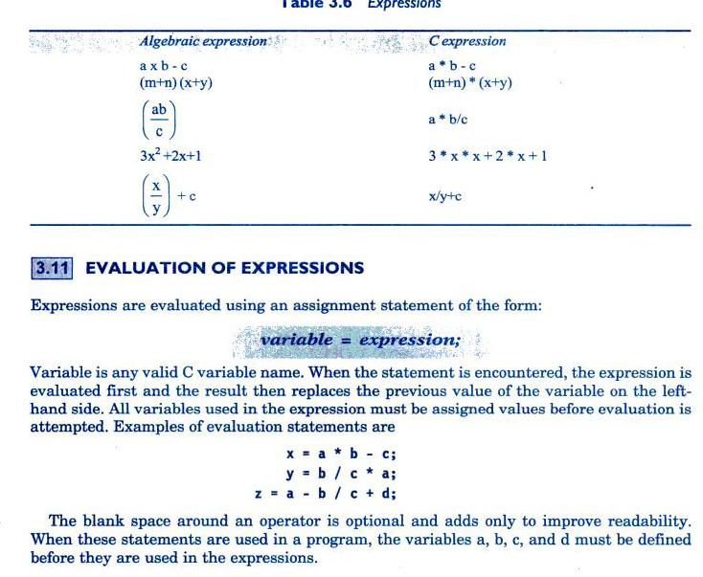
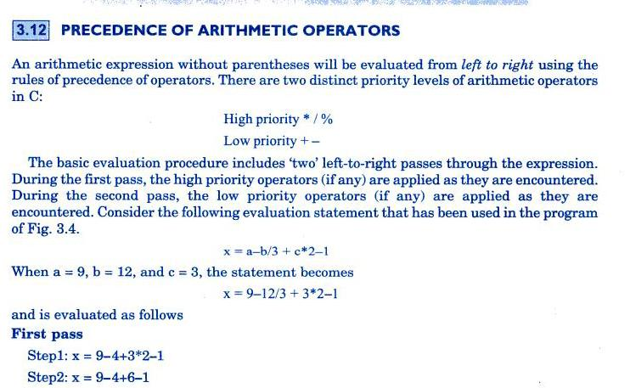
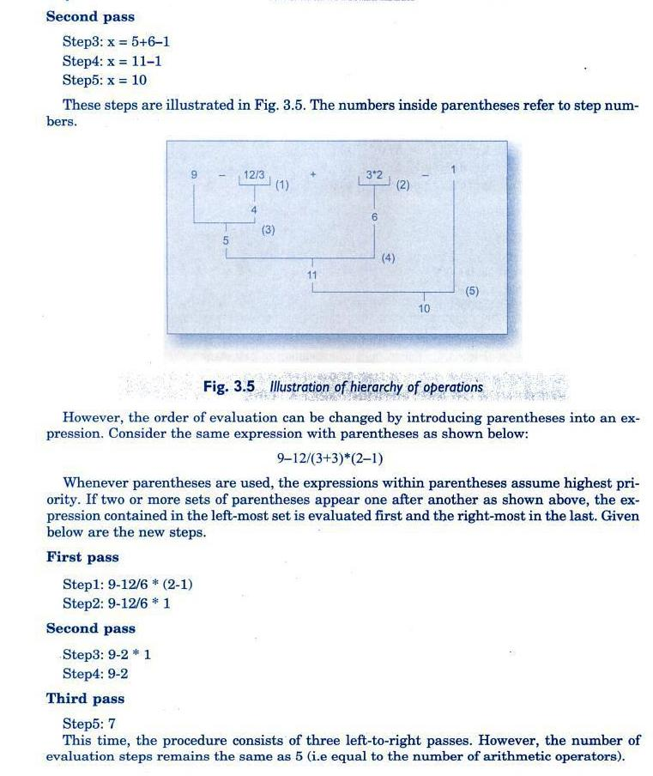
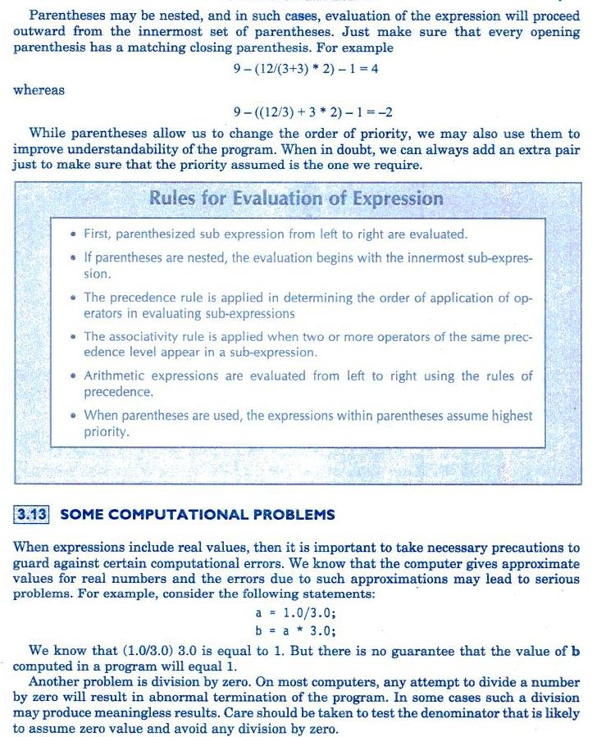
The third problem is to avoid overflow or underflow errors.it is our responsibility to guarantee that operands are of the correct type and range,and the result may not produce any overflow or underflow.
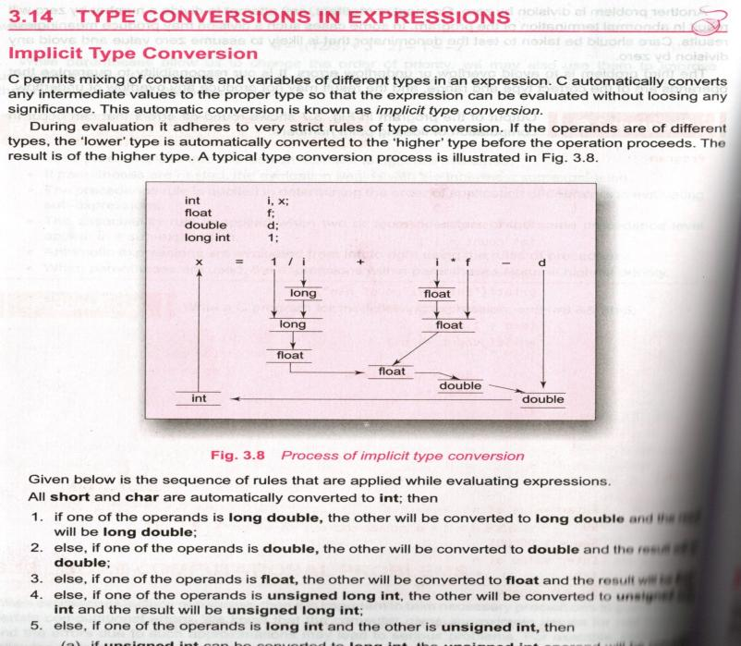
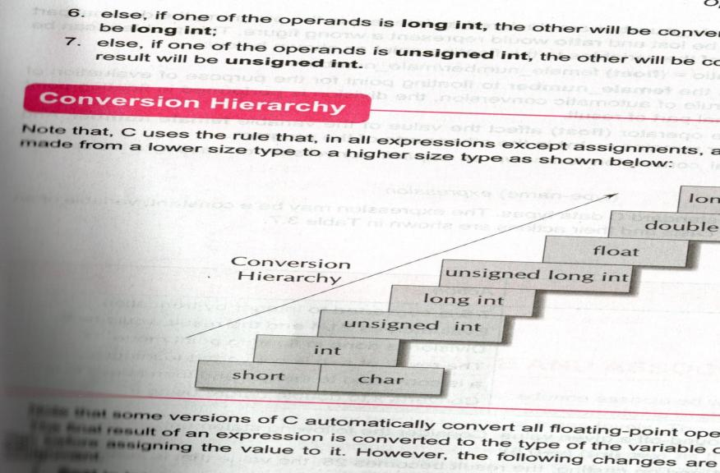

float to int truncates the fractional part
double to float causes rounding of digits
long int to int causes dropping of excess higher order bits.

_{Explicit conversion:}
we want to force a type conversion ina way that is different from automatic conversion

for ex:ratio=female-number/male-number.
both female-number and male-number is declared as integers.the decimal of theresult

oFthe divisionwould be lostand ratio would represent a wrong figure.the problem could be solved by

ratio-(float)female-number/male-number

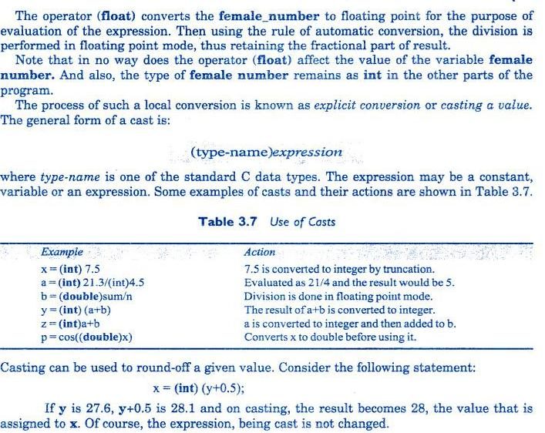

operator precedence and associativity

c has a precedence associated with it.there are distinct levels of precedence.the operators at higher level of precedence are evaluated first.the operators at same precedence are evaluated either from lfet to right or right to left.
For ex: if(x==10+15&&y<10)
The precedence rules say addition operator has highest priority and a logical operator (&&)and the relational operator(==and<)therefore the addition of 10 and 15 is executed first.this is equivalent to
If(x==25&&y=10) x=20 y=5
Then X==25 is false Y<10 is true < has higher precedence than == y<10 is tested first then x==25 If(false&&true) One condition is false,the complex condition os false.
Mathematical functions
Mathematical functions such as cos,sqrt,log are frequently used in analysis of real –life problems,it is implemented by compiler using math functions.
Math functions
acos(x),asin(x), atan(x),cosh(x),floor(x),log(x),pow(x,y).

