Core Paper II – I semester- Practical I PROGRAMMING IN C LAB

1. Simple Interest
2. Reverse a given five digit number.
3. Income Tax calculation using nested IF.
4. Prime number checking.
5. Sum of digits of a given number.
6. Printing Pascal Triangle.
7. Solution of a Quadratic Equation (all cases).
8. Sum of Series (Sine, Cosine, e (Pow) x).
9. Palindrome checking.
10. Ascending and descending order of numbers using Arrays(Use it to find Largest and Smallest Numbers)
11. Sorting of names in Alphabetical order.
12. Matrix Operations(Addition, Subtraction, Multiplication – use Functions)
13. Finding factorial, generating Fibonacci Numbers using recursive function.
14. String manipulations without using string functions (String length, String Comparison, String Copy, Palindrome checking, Counting words and lines in strings – use function pointers).
15. Calculate no.of positive , no.of negative and zero number in an array.
16. Swap two values using function pointers.
17. Number sorting using pointers.
18. Printing maximum marks in each subject along with the name of the student by using structure. 19. Pay bill calculation using file.
20. Counting no.of words, lines and characters using files.
21. Adding given numbers using command line arguments. 22. Graphics programs (Fill style, Olympic logo,Doordarshan )

Program 1

/*PROGRAM FOR SIMPLE INTEREST CALCULATION*/
#include<stdio.h>
#include<conio.h>
void main()
{
float p,n,r;
float si;
clrscr();
printf("enter the principle amount \n");
scanf("%f",&p);
printf("enter the number of year \n");
scanf("%f",&n);
printf("enter the rate of interest \n");
scanf("%f",&r);
si=(p*n*r)/100;
printf("simple interest value %f",si);
getch();
}

OUTPUT:
~~~~~~
enter the principle amount 3000
enter the number of years 2
enter the rate of interest 2
simple interest value is 120.000

Program 2
/* PROGRAM TO REVERSE A NUMBER*/
#include<stdio.h>
#include<conio.h>
void main()
{
int rem,sum=0,num;
clrscr();
printf("enter number:\n");
scanf("%d",&num);
while(num>0)
{
rem=num%10;
sum=(sum*10)+rem;
num=num/10;
}
printf("\n reversed number is:%d",sum);
getch();
}
OUTPUT:
~~~~~~
enter number:2223
reversed number:3222

program 3:
/*PROGRAM FOR NESTED IF*/
#include<stdio.h>
#include<conio.h>
main()
{
float income,tax;
clrscr();
printf("enter the basic income:\n");
scanf("%f",&income);
if(income<=22000)
tax=0;
else if(income<=30000)
tax=(income-22000)*0.20;
else if(income<=50000)
tax=(income-30000)*0.30;
else if(income<=100000)
tax=(income-50000)*0.40;
else
tax=(income-100000)*0.50;
printf("tax amount %8.2f",tax);
getch();
}
OUTPUT:
enter the basic income:30000
tax amount:1600

Program 4

/*PROGRAM TO CHECK WHETHER IT IS PRIME OR NOT*/
#include<stdio.h>
#include<conio.h>
main()
{
int n,c;
clrscr();
printf("enter a number to check if it is prime :\n");
scanf("%d",&n);
for(c=2;c<=n-1;c++)
{
if(n%c==0)
{
printf("%d is not prime \n",n);
break;
}
}
if(c == n)
{
printf("%d is prime \n",n);
}
getch();
}
output:
enter a number to check if it is prime : 5
5 is prime

Program 5
/*PROGRAM FOR SUM OF DIGITS*/
#include<stdio.h>
#include<conio.h>
void main()
{
int rem,sum=0,num;
clrscr();
printf("enter any number:\n");
scanf("%d",&num);
while(num>0)
{
rem=num%10;
sum=sum+rem;
num=num/10;
}
printf("the sum of digits is %d",sum);
getch();
}
output:
enter any number: 123
the sum of sigits is 6

Program 6

/*PROGRAM USING PASCAL TRIANGLE*/
#include<stdio.h>
#include<conio.h>
void main()
{
int b,p,q,r,x;
clrscr();
b=1;
q=0;
printf("enter the number of rows:");
scanf("%d",&p);
printf("\n pascal's triangle is:\n\n");
while(q<p)
{
for(r=40-3*q;r>0;--r)
printf(" ");
for(x=0;x<=q;++x)
{
if((x==0)||(q==0))
b=1;
else
b=(b*(q-x+1))/x;
printf("%6d",b);
}
printf("\n\n");
++q;
}
getch();
}

OUTPUT:
~~~~~~
enter the number of rows:3
pascal's triangle is
1
1 1
1 2 1

Program 7
/* program for quadractic equation */
#include<stdio.h>
#include<conio.h>
#include<math.h>
void main()
{
int a,b,c;
float d,x,y;
printf("\n\t\t\t quadratic equation\n");
printf("\n\t\t\tenter the value of a:");
scanf("%d",&a);
printf("\n\t\t\tenter the value of b:");
scanf("%d",&b);
printf("\n\t\t\t enter the value of c:");
scanf("%d",&c);
d=(b*b)-(4*a*c);
if(d>0)
{
x=(-b+sqrt(d))/(2*a);
y=(-b-sqrt(d))/(2*a);
printf("\n\t\t\t roots are real and unequal");
printf("\n\t\t\t value of x:%f",x);
printf("\n\t\t\t value of y:%f",y);
}
else if(d==0)
{
x=(-b)/(2*a);
y=(-b)/(2*a);
printf("\n\t\t\t roots are real and equal");
printf("\n\t\t\t value of x:%f",x);
printf("\n\t\t\t value of y:%f",y);
}
else
{
x=(-b)/(2*a);
y=(sqrt(-d))/(2*a);
printf("\n\t\t\t roots are imaginary");
printf("\n\t\t\t value of x:%f",x);
printf("\n\t\t\t value of y:%f",y);
}
getch();
}
output:
~~~~~~
quadratic equation
enter value of a:1
enter value of b:2
enter value of c:2
roots are imaginery
value of x:-1.000 value of y: 1.000

Program 8a

/* program for sine series*/
#include<stdio.h>
#include<math.h>
#include<conio.h>
main()
{
float x,n,i,j,k,f,s;
clrscr();
printf("\n\t\t\t sum of sine series");
printf("\n\t\t\t enter x value");
scanf("%f",&x);
printf("\n\t\t\t enter n value");
scanf("%f",&n);
s=0.0;
f=1.0;
k=1.0;
for(i=1.0;i<=n;i=i+2)
{
for(j=1.0;j<=i;j++)
{
f=f*j;
}
s=s+(pow(x,i)/f)*k;
k=k*(-1.0);
}
printf("\n\t\t\t value of x= %f",x);
printf("\n\t\t\t value of y=%f",n);
printf("\n\t\t\t sin series=%f",s);
getch();
}

output
~~~~~~

sum of sin series
enter x value:2
enter n value:3
sum of series:0.66667

Program 8b
/*program for cosine series */
#include<stdio.h>
#include<conio.h>
#include<math.h>
main()
{
float x,n,i,j,k,f,s;
clrscr();
printf("\n\t\t\t sum of cosine series");
printf("\n\t\t\t enter x value");
scanf("%f",&x);
printf("\n\t\t\t enter n value");
scanf("%f",&n);
s=0.0;
f=1.0;
k=1.0;
for(i=0.0;i<=n;i=i+2)
{
for(j=1.0;j<=i;j++)
{
f=f*j;
}
s=s+(pow(x,i)/f)*k;
k=k*(-1);
}
printf("\n\t\t\t value of x=%f",x);
printf("\n\t\t\t value of y=%f",n);
printf("\n\t\t\t cos series=%f",s);
getch();
}

output
~~~~~~
sum of cosine series

enter x value:1
enter n value:4

value of x=1.00
value of y=4.00
sin series=0.520833

Program 8c
/* program for exponential series*/
#include<stdio.h>
#include<math.h>
#include<conio.h>
main()
{
float x,n,i,j,k,f,s;
clrscr();
printf("\n\t\t\t sum of exponential series");
printf("\n\t\t\t enter x value");
scanf("%f",&x);
printf("\n\t\t\t enter n value");
scanf("%f",&n);
s=1.0;
f=1.0;
for(i=1.0;i<=n;i++)
{
for(j=1.0;j<=i;j++)
{
f=f*j;
}
s=s+(pow(x,i)/f);
}
printf("\n\t\t\t value of x= %f",x);
printf("\n\t\t\t value of y=%f",n);
printf("\n\t\t\t exponential series=%f",s);
getch();
}

output:
~~~~~~
sum of exponential series

enter x value:1
enter n value:2

value of x=1.00
value of y=2.00
exponential series=2.5000

Program 9
/* program for palindrome checking */
#include<stdio.h>
#include<conio.h>
#include<string.h>
main()
{
char str1[20],str2[20];
clrscr();
printf("\n\t\t\tEnter the string:");
scanf("%s",str1);
strcpy(str2,str1);
strrev(str1);
if(strcmp(str1,str2)==0)
printf("\n\t\t\t %s is a palindrome",str1);
else
printf("\n\t\t\t %s is not a palindrome",str2);
getch();
}

output:
~~~~~~
Enter the string : madam
madam is a palindrome

Program 10
/* sorting of numbers*/
#include<stdio.h>
#include<conio.h>
main()
{
int i,j,n,a[10],b[10],t;
clrscr();
printf("sorting of numbers");
printf("\n\n enter the value of n");
scanf("%d",&n);
printf("\n enter numbers");
for(i=1;i<=n;i++)
{
scanf("%d",&a[i]);
b[i]=a[i];
}
for(i=1;i<=n;i++)
{
for(j=i+1;j<=n;j++)
{
if(a[i]>a[j])
{
t=a[i];
a[i]=a[j];
a[j]=t;
}
}
}
printf("\ngiven order\tascendingorder\t\t\tdescending order");
printf("\n***********\t**************\t\t\t**************\n");
for(i=1;i<=n;i++)
{
j=n-i+1;
printf("%7d %15d %17d\n",b[i],a[i],a[j]);
}
printf("\n smallestnumber\tbiggest number");
printf("\n *************\t**************\n");
printf("%7d %14d",a[1],a[n]);
getch();
}

output
~~~~~~
sorting of numbers
enter value of n 4
enter numbers
2
3
55
1

given order ascending order descending order
2 1 55
3 2 3
55 3 2
1 55 1

smallest number biggest number
1 55

Program 11

/* sorting of names */
#include<stdio.h>
#include<conio.h>
main()
{
int i,j,n;
char a[10][10],b[10][10],t[10];
clrscr();
printf("\n\t\t\t alphabetical order");
printf("\n\t\t\t ******************");
printf("\n enter n");
scanf("%d",&n);
printf("enter names\n");
for(i=1;i<=n;i++)
{
scanf("%s",a[i]);
strcpy(b[i],a[i]);
}
for(i=1;i<=n;i++)
{
for(j=i+1;j<=n;j++)
{
if(strcmp(a[i],a[j])>0)
{
strcpy(t,a[i]);
strcpy(a[i],a[j]);
strcpy(a[j],t);
}
}
}
printf("\n given order\t sorted order");
printf("\n -----------\t ------------\n");
for(i=1;i<=n;i++)
{
printf("%12s\t%8s\n",b[i],a[i]);
}
getch();
}

output
~~~~~~
enter n : 2
enter names
sam
anu

given order sorted order
sam anu
anu sam

Program 12a
/*Matrix Operations-Matrix Addition*/
#include<stdio.h>
#include<conio.h>
void main()
{
int m,n,i,j,a[10][10],b[10][10],c[10][10];
clrscr();
printf("enter row value for 1 matrix");
scanf("%d",&m);
printf("enter column value for 1 matrix");
scanf("%d",&n);
printf("enter value of 1 matrix");
for(i=0;i<m;i++)
{
for(j=0;j<n;j++)
{
scanf("%d",&a[i][j]);
}
}
printf("enter value of 2 matrix");
for(i=0;i<m;i++)
{
for(j=0;j<n;j++)
{
scanf("%d",&b[i][j]);
}
}
for(i=0;i<m;i++)
{
for(j=0;j<n;j++)
{
c[i][j]=a[i][j]+b[i][j];
}
}
printf("Matrix Addition \n");

for(i=0;i<m;i++)
{
for(j=0;j<n;j++)
{
printf("\t%d",c[i][j]);
}
printf("\n");
}
getch();
}

Input/Output:
***********
Enter row value for 1 matrix 2
Enter column value for 1 matrix 2
Enter value of 1 matrix2
2
2
2
Enter value of 2 matrix2
2
2
2
Matrix Addition
4 4
4 4

Program 12b
/*Matrix Subtraction*/
#include<stdio.h>
#include<conio.h>
void main()
{
int m,n,i,j,a[10][10],b[10][10],d[10][10];
clrscr();
printf("enter row value for 1 matrix");
scanf("%d",&m);
printf("enter the column value for 1 matrix");
scanf("%d",&n);
printf("enter value of 1 matrix");
for(i=0;i<m;i++)
{
for(j=0;j<n;j++)
{
scanf("%d",&a[i][j]);
}
}
printf("enter value of 2 matrix");
for(i=0;i<m;i++)
{
for(j=0;j<n;j++)
{
scanf("%d",&b[i][j]);
}
}
for(i=0;i<m;i++)
{
for(j=0;j<n;j++)
{
d[i][j]=a[i][j]-b[i][j];
}
}
printf("subracted matrix \n");
for(i=0;i<m;i++)
{
for(j=0;j<n;j++)
{
printf("\t%d",d[i][j]);
}

printf("\n");
}
getch();
}
Input/Output:
***********
Enter row value for 1 matrix 2
Enter the column value for 1 matrix 2
Enter value of 1 matrix
2
2
2
2
Enter value of 2 matrix
2
2
2
2
Subracted matrix
0 0
0 0

Program 12c
/*Matrix Multiplication*/
#include<stdio.h>
#include<conio.h>
void main()
{
int m,n,i,j,k,a[10][10],b[10][10],e[10][10];
clrscr();
printf("enter row value for 1 matrix");
scanf("%d",&m);
printf("enter column value for 2 matrix");
scanf("%d",&n);
printf("enter value of 1 matrix");
for(i=0;i<m;i++)
{
for(j=0;j<n;j++)
{
scanf("%d",&a[i][j]);
}
}
printf("enter value of 2 matrix");
for(i=0;i<m;i++)
{
for(j=0;j<n;j++)
{
scanf("%d",&b[i][j]);
}
}
for(i=0;i<m;i++)
{
for(j=0;j<n;j++)
{
e[i][j]=0;
for(k=0;k<m;k++)
{
e[i][j]=e[i][j]+a[i][j]*b[k][j];
}
}
}
printf("multiplied matrix \n");
for(i=0;i<m;i++)
{
for(j=0;j<n;j++)
{
printf("\t%d",e[i][j]);
}
printf("\n");
}
getch();
}

Input/Output:
***********
Enter row value for 1 matrix 2
Enter the column value for 1 matrix 2
Enter value of 1 matrix 2
2
2
2
Enter value of 2 matrix 2
2
2
2
multiplied matrix
8 8
8 8

Program 13a

/*factorial using recursive functions*/
#include<stdio.h>
#include<conio.h>
#include<math.h>
int fact(int n);
void main()
{
int a,n;
clrscr();
printf("Finding factorial\n");
printf("Enter x value:");
scanf("%d",&n);
a=fact(n);
printf("\n\tFactorial value:%d\n",a);
getch();
}
int fact(int n)
{
if(n==1)
{
return(1);

}
else
{
return(n*fact(n-1));
}
}

Output:
Finding Factorial
Enter x value:3
Factorial Value:6

Program 13b
/*fibonacci using recursive functions*/

#include<stdio.h>
#include<conio.h>
#include<math.h>
int f(int n);
main()
{
int n,i=0,c;
clrscr();
printf("Enter the Number:\t");
scanf("%d",&n);
for(c=1;c<=n;c++)
{
printf("%d\n",f(i));
i++;
}
getch();
return(0);
}
int f(int n)
{
if(n==0||n==1)
return n;
else
return(f(n-1)+f(n-2));
}

Output
Enter the Number:3
0
1
1

Program 14a

/* string length without using strlen()*/
#include<stdio.h>
#include<stdlib.h>
int len(char *s)
{
int count=0;
while(s[count]!='\0')
{
++count;
}
return count;
}
void main()
{
char *str=(char *)malloc(1000*sizeof(char));
clrscr();
printf("enter the string\n");
gets(str);
printf("\n length of the string %d",len(str));
getch();
}

output
enter the string welcome
length of the string 7

program 14b

/* program for string comparison*/
#include<stdio.h>
#include<conio.h>
int compare(char *,char *);
void main()
{
char f[100];
char s[100],result;
clrscr();
printf("enter the first string:\n");
gets(f);
printf("enter the second string:\n");
gets(s);
result=compare(f,s);

if(result==0)
{
printf("\n strings are same");
}
else
{
printf("\n strings are not same");
}
getch();
}
int compare(char *f,char *s)
{
while(*f==*s)
{
if(*f=='\0'||*s=='\0')
break;
f++;
s++;
}
if(*f=='\0'&& *s=='\0')
return 0;
else
return 1;
}

output

enter the first string
welcome
enter the second string
welcome

strings are same

program 14c

/*program for string copy*/
#include<stdio.h>
#include<conio.h>
void copy(char *,char *);
void main()
{
char s[100];
char t[100];
clrscr();
printf("enter the string to copy:\n");
gets(s);
copy(t,s);
printf("copied string:%s",t);
getch();
}
void copy(char *t,char *s)
{
while(*s)
{
*t=*s;
s++;
t++;
}
*t='\0';
getch();
}

output
enter the string to copy: welcome
copied string : welcome

Program 14d

/* program for palindrome*/

#include<stdio.h>
#include<conio.h>
#include<string.h>
int palin(char *str)
{
int i,len;
len=strlen(str);
for(i=0;i<len/2;i++)
{
if(*(str+i)!=*(str+len-i-1))
return 0;
}
return 1;
}
void main()
{
char string[100]=" ";
clrscr();
printf("enter the string\n");
gets(string);
if (palin(string))
printf("given string is palindrome");
else
printf("given string is not palindrome");
getch();
}

output:

enter the string
good
given string is not palindrome

Program 14e

/*Counting words,lines in string using function pointers*/
#include<stdio.h>
#include<conio.h>
void main()
{
char str[200];
int i, line, word, ch;
line=word=ch=0;
printf("Enter a string in multiple lines terminated with ~ :\n");
scanf("%[^~]", str);

for(i=0; str[i]!='\0'; i++)
{
if(str[i]=='\n')
{
line++;
word++;
}
else
{
if(str[i]==' '||str[i]=='\t')
{
word++;
ch++;
}
else ch++;
}
}

printf("\nCharacter counts = %d\n",ch);
printf("Word counts = %d\n",word);
printf("Line counts = %d\n",line);
getch();
}

Output:-

Enter a string in multiple lines terminated with ~ :
Hello, how are you?
Welcome to the programming world.
Programming is fun.
~

Character counts = 71
Word counts = 12
Line counts = 3

Program 15
/* Positive and Negative Numbers*/
#include<stdio.h>
#include<conio.h>
void main()
{
int a[10],n,i,neg=0,pos=0,zro=0;
clrscr();
printf("How many elements");
scanf("%d",&n);
printf("Enter elements\n");
for(i=0;i<n;i++)
scanf("%d",&a[i]);
for(i=0;i<n;i++)
{
if(a[i]>0)
pos++;
if(a[i]<0)
neg++;
if(a[i]==0)
zro++;
}
printf("Number of positive elements:%d\n",pos);
printf("Number of negative elements:%d\n",neg);
printf("Number of zero elements:%d\n",zro);
getch();
}

Input/Output:
***********
how many elements: 4
Enter elements
3
4
0
-4
Number of positive elements:2
Number of negative elements:1
Number of zero elements:1

Program 16
/*program for swapping two values using function pointers*/

#include<stdio.h>
#include<conio.h>
void swap(float *d1, float *d2)
{
float temp;
temp=*d1;
*d1=*d2;
*d2=temp;
}
void main()
{
float a,b;
clrscr();
printf("enter value of a");
scanf("%f",&a);
printf("enter value of b");
scanf("%f",&b);
swap(&a,&b);
printf("value of a%f",a);
printf("value of b%f",b);
getch();
}

output
~~~~~~

enter value of a 3
enter value of b 4
value of a 4.000
value of b 3.000

Program 17

/* Number Sorting using Pointers */
#include<stdio.h>
#include<conio.h>
void main()
{
int a[15],*p,n,i,j,t;
clrscr();
p=&a[0];
printf("Enter number of elements");
scanf("%d",&n);
printf("Enter the values one by one");
for(i=0;i<n;i++)
scanf("%d",&a[i]);
for(i=0;i<=n;i++)
{
for(j=i+1;j<n;j++)
{
if(*(p+i)>*(p+j))
{
t=*(p+i);
*(p+i)=*(p+j);
*(p+j)=t;
}
}
}
printf("sorted number\n");
for(i=0;i<n;i++)
printf("%d\n",a[i]);
getch();
}

Input/Output:
***********
Enter number of elements: 4
Enter value one by one
3
5
1
4
Sorted Numbers are
1
3
4
5

Program 18
/*Program for Students Details using Structures*/
#include<stdio.h>
#include<conio.h>
struct student
{
int eng;
int tam;
int major;
};
void main()
{
struct student s[3];
int i,total=0;
clrscr();
for(i=0;i<=2;i++)
{
printf("enter marks for 3 students\n");
printf("Enter eng marks\n");
scanf("%d",&s[i].eng);
printf("Enter tam marks\n");
scanf("%d",&s[i].tam);
printf("Enter major marks\n");
scanf("%d",&s[i].major);
total=s[i].eng+s[i].tam+s[i].major;
printf("total marks to s[%d] student=%d",i,total);
getch();
}
}

Input/Output:
***********
Enter marks for 3 students:
Enter eng marks 56
Enter tam marks 67
Enter major marks 95
Total marks to s[0] student=218
enter marks for 3 students
Enter eng marks 78
Enter tam marks 98
Enter major marks 90
Total marks to s[1] student=266
enter marks for 3 students
Enter eng marks 98
Enter tam marks 87
Enter major marks 67
Total marks to s[2] student=252

Program 19
/*Pay bill calculation using File*/
#include<stdio.h>
#include<conio.h>
void main()
{
FILE *fp;
int deduc,quantity,i;
float price,value,basic,allow,tot,net;
char empname[30],filename[10];
clrscr();
printf(" Enter input file name\n");
scanf("%s",filename);
fp=fopen(filename,"w");
printf("Employee name,Basic,Allowances, Deductions\n");
for(i=1;i<=3;i++)
{
fscanf(stdin,"%s %f %f %d",empname,&basic,&allow,&deduc);
fprintf(fp,"%s %f %2f %d",empname,basic,allow,deduc);
}
fclose(fp);
fprintf(stdout,"\n\n");
fp=fopen(filename,"r");
printf("empname,basic,allow,deduc\n");
for(i=1;i<=3;i++)
{
fscanf(fp,"%s %f %f %d", empname,&basic,&allow,&deduc);
tot=basic+allow;
net=tot-deduc;
fprintf(stdout,"%s %f %f %d %11f %8f \n",empname,basic,allow,deduc,tot,net);
}
fclose(fp);
getch();
}

Output

Enter file name:s.txt

Employee name Basic Allowances Deductions
Arun 5000 400 100
Balu 6000 500 200
Kavi 7000 600 300

Employee name Basic Allowances Deductions tot net
Arun 5000 400 100 5400 4900
Balu 6000 500 200 6500 5800
Kavi 7000 600 300 7600 6700

Program 20
/*Program to count lines,words,characters using file*/

#include <stdio.h>

int main()
{
FILE *fp;
char filename[100];
char ch;
int linecount, wordcount, charcount;
linecount = 0;
wordcount = 0;
charcount = 0;
printf("Enter a filename :");
gets(filename);
fp = fopen(filename,"r");
if ( fp )
{
while ((ch=getc(fp)) != EOF) {
if (ch != ' ' && ch != '\n') { ++charcount; }

if (ch == ' ' || ch == '\n') { ++wordcount; }

if (ch == '\n') { ++linecount; }

}

if (charcount > 0) {
++linecount;
++wordcount;
}
}
else
{
printf("Failed to open the file\n");
}

printf("Lines : %d \n", linecount);
printf("Words : %d \n", wordcount);
printf("Characters : %d \n", charcount);

getchar();
return(0);
}

Output

Consider a text file named sample.txt with the following content:

Hello happy
to see you all.
With the above file as input, the program will be show the result as below

Enter a filename :sample.txt
Lines : 2
Words : 6
Characters : 25

Program 21
/* Program for Command Line Arguments */
#include<stdio.h>
#include<conio.h>
#include<stdlib.h>
void main(int argc,char *argv[])
{
int i,sum=0;
clrscr();
if(argc<3)
{
printf("\n command");
return;
}
printf("\n sum");
for(i=1;i<argc;i++)
sum=sum+atoi(argv[i]);
printf("%d",sum);
getch();
}

Input/Output:
***********
File-->DOS shell
C:\TC\BIN>filename 10 20
Sum:30

Program 22a
/*Graphics program-Fill style*/

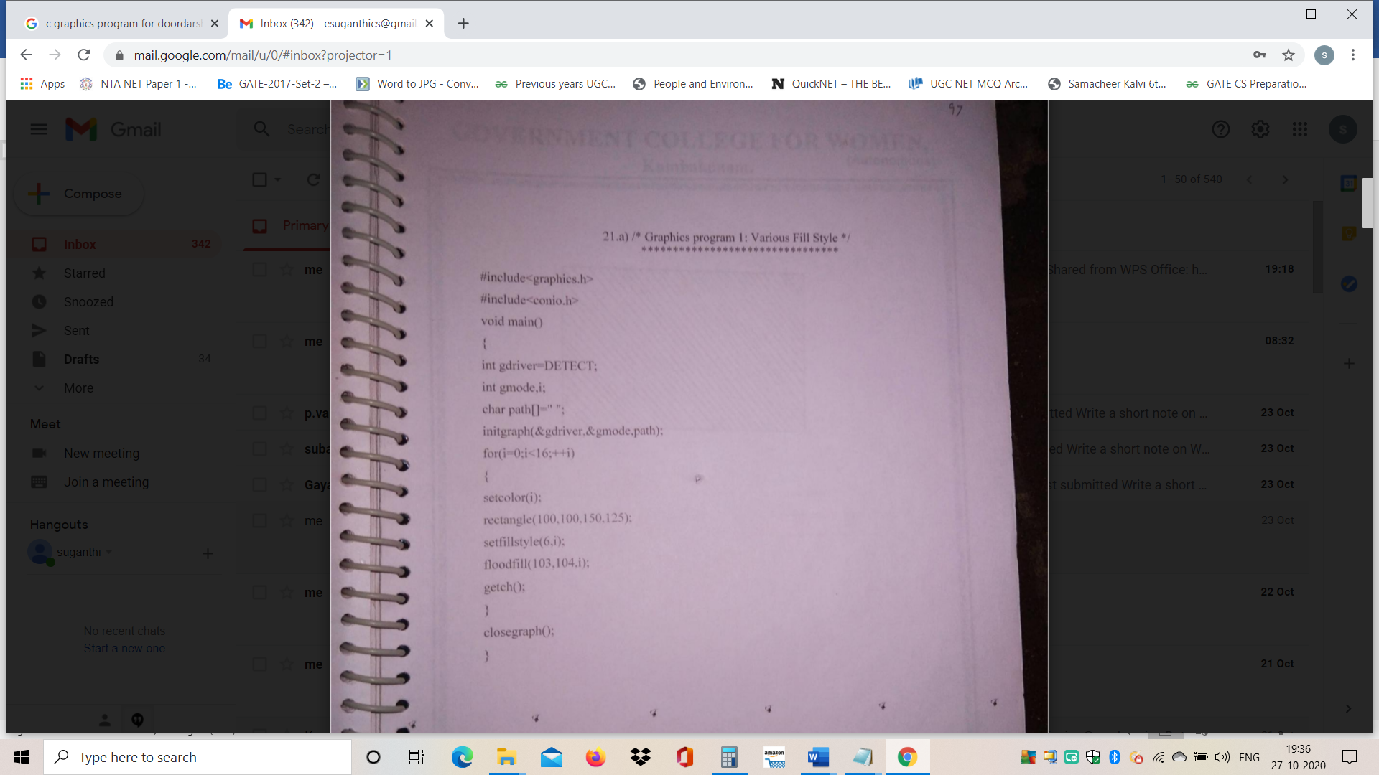

Output

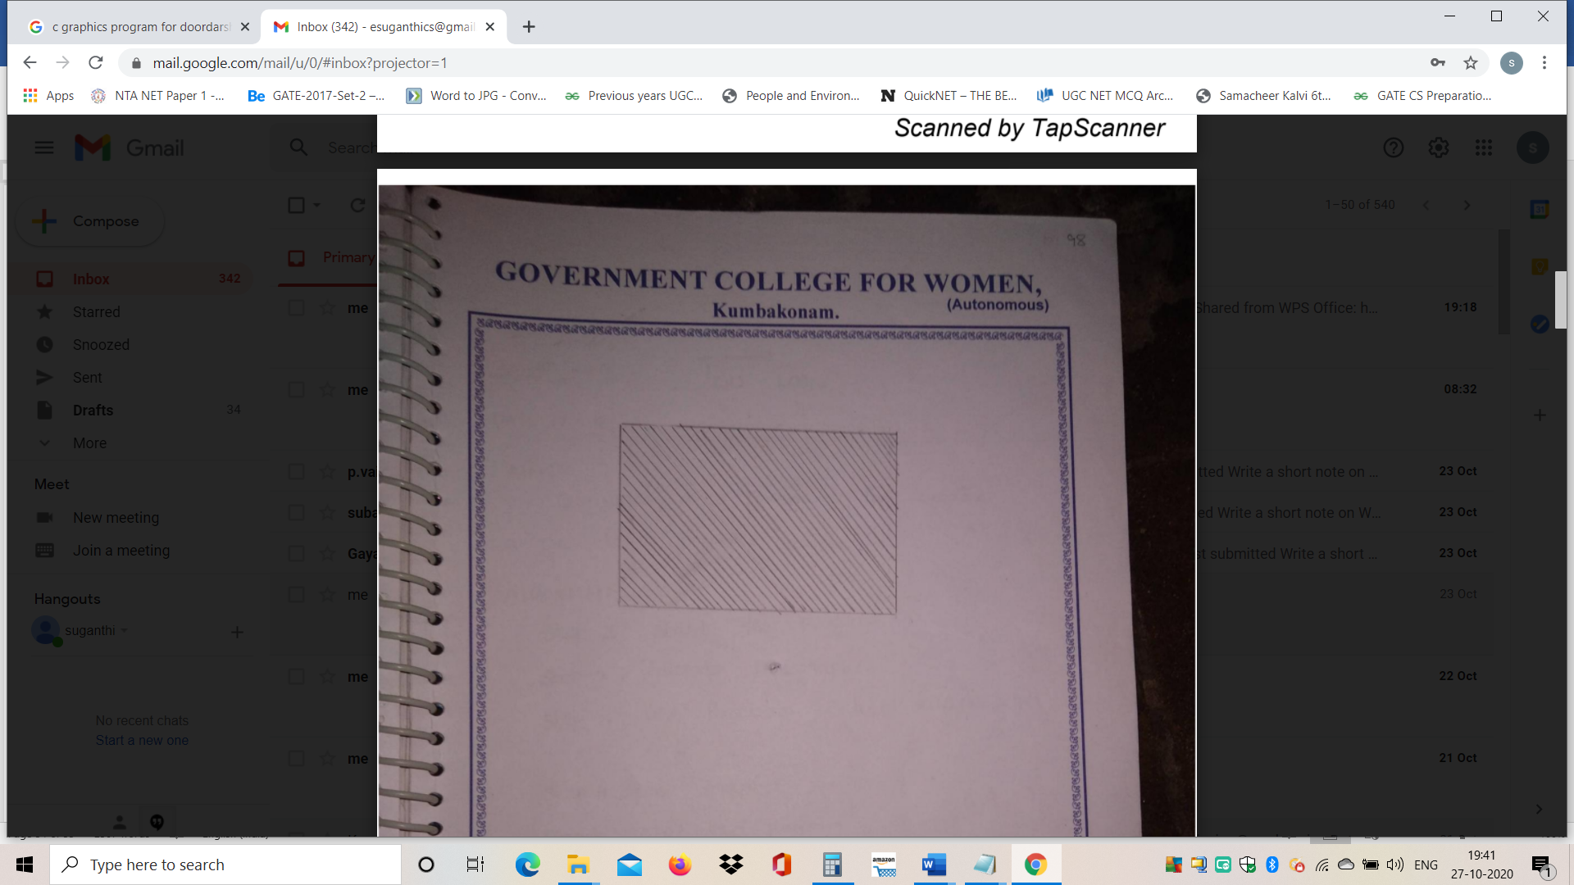

Program 22b
/*Graphics program-Olympic logo*/

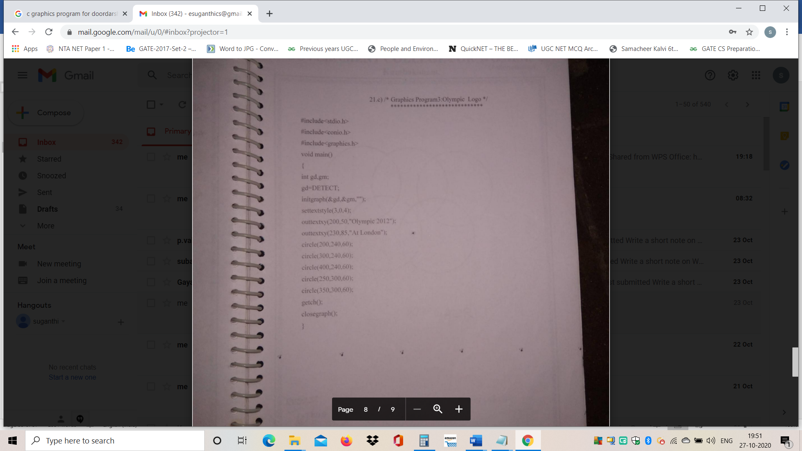

Output
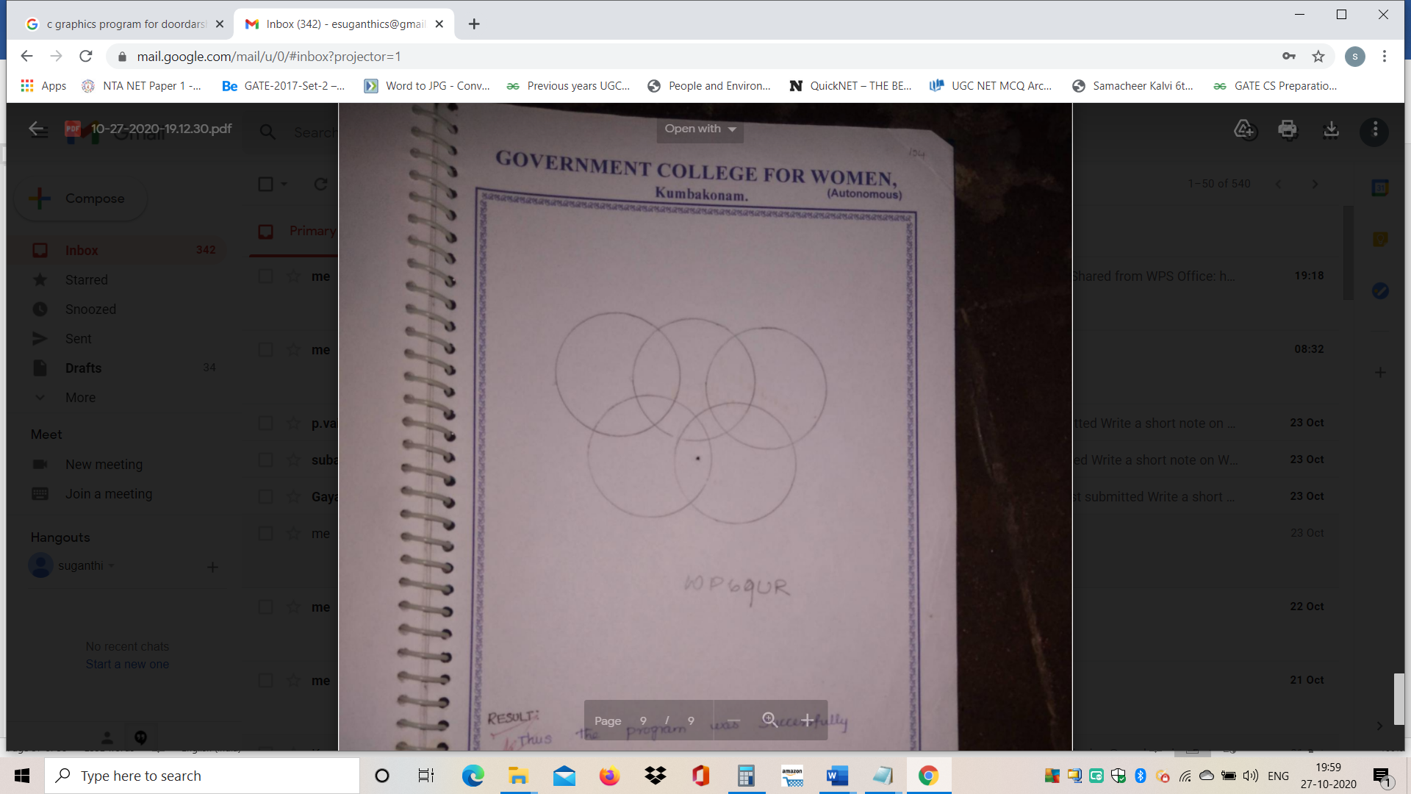

Program 22c
/*DD logo*/
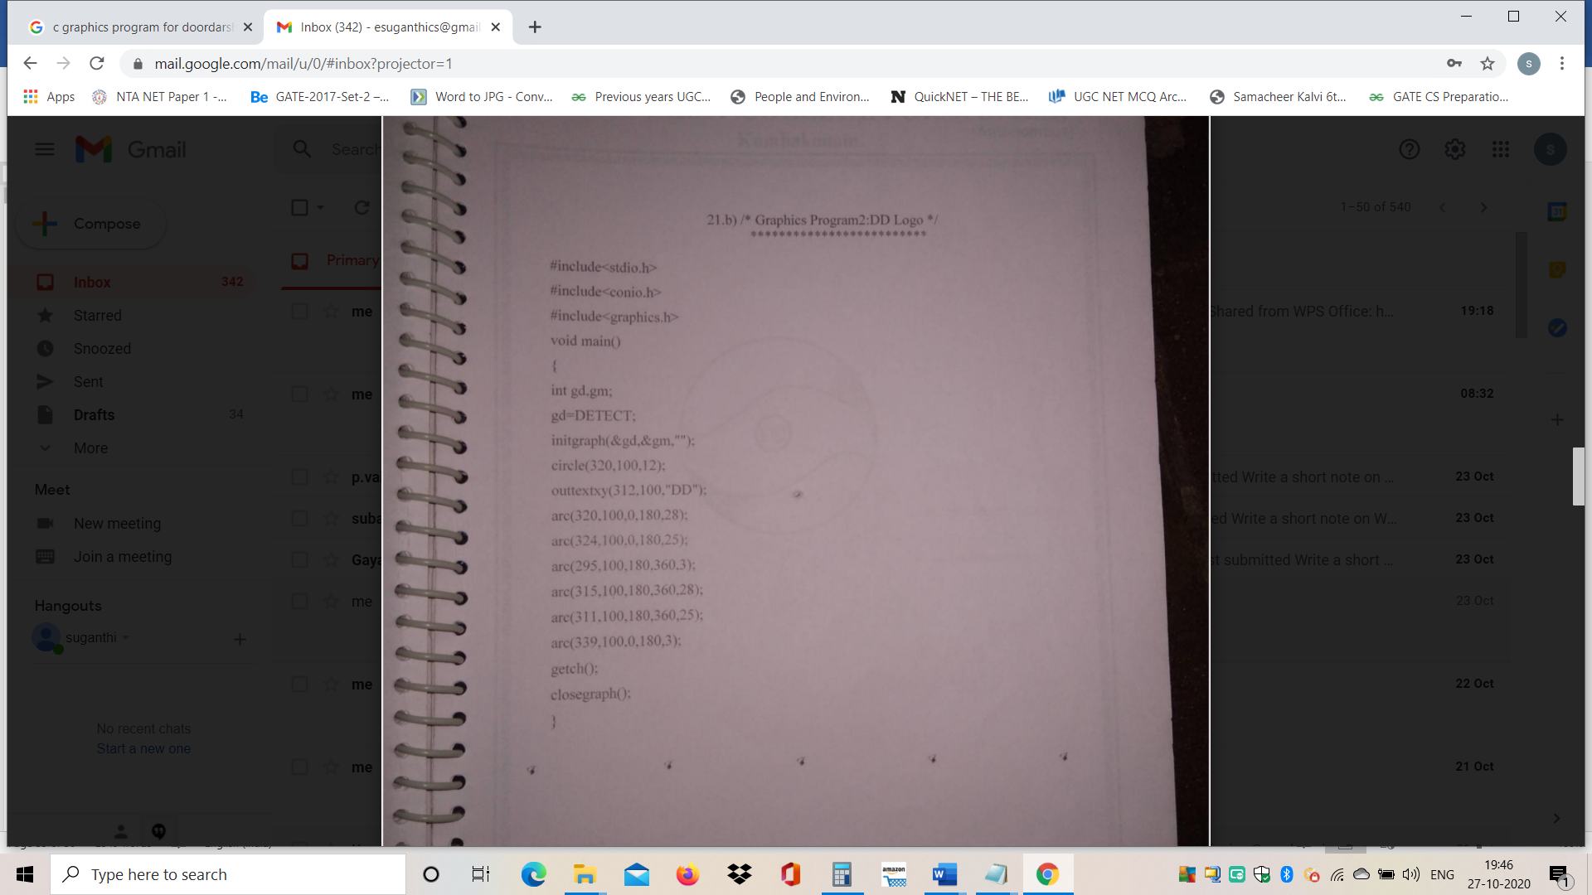

Output

