**1.A)SIMPLE TABLE**

<html>

<head>

<title>A Simple XHTML Table</title>

<body>

<caption><strong><center><font color="Red">SIMPLE TABLE</strong></center></caption><br>

<table border="2" width="40%" summary="This table provides information about the population in thanjavur" align="center">

</head>

<thead>

<tr><center><th colspan="4"><font color="Blue">Population in Thanjavur</th></center></tr>

<th><font color="Red">Place</th>

<th><font color="Red">Female</th>

<th><font color="Red">Male</th>

</thead>

<tfoot>

<tr>

<th><font color="Red">Total</th>

<th>3,27,872</th>

<th>3,12,326</th>

</tr>

</tfoot>

<tbody align="center">

<tr>

<td>Kumbakonam</td>

<td>12,695</td>

<td>12,956</td>

</tr>

<td>Papanasam</td>

<td>8,920</td>

<td>8,628</td>

</tr>

<td>Thiruvidaimaruthur</td>

<td>7,425</td>

<td>7,361</td>

</tr>

<td>Thiruvaiyaru</td>

<td>93,948</td>

<td>91,789</td>

</tr>

<td>Pattukottai</td>

<td>2,04,884</td>

<td>1,91,592</td>

</tr>

</tbody>

</table>

</body>

</html>

**Output**

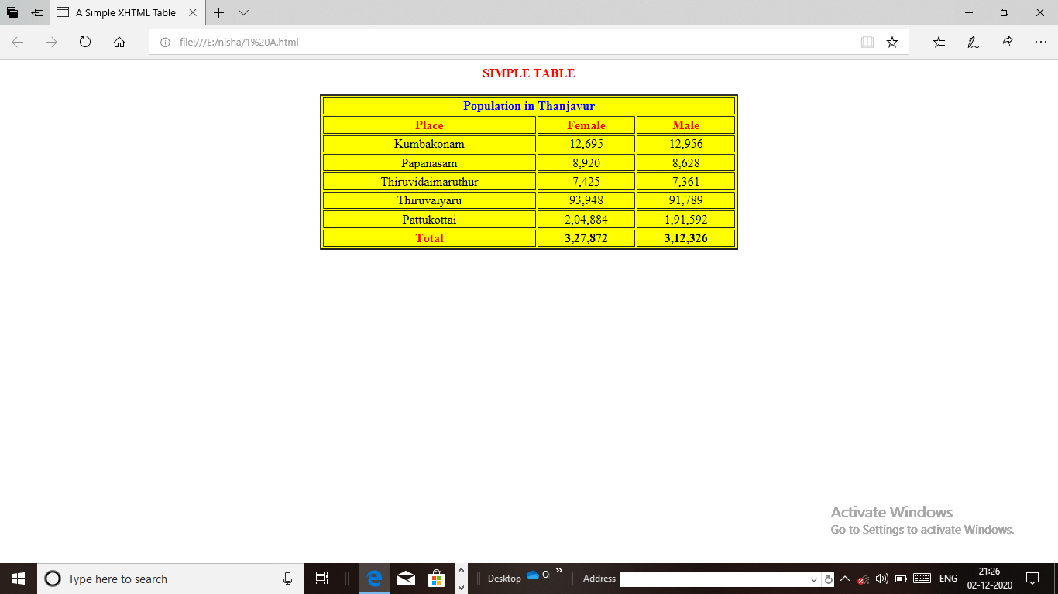

**1.B)COMPLEX TABLE**

<html>

<head>

<title>Complex Table</title>

<body>

<caption><strong><center><font color="Red">COMPLEX TABLE</strong></center></caption><br>

<center><table border="2" bgcolor="yellow">

<thead>

<tr><td colspan="6"><center><font face="stencil"><font color="Blue">JOBS AND SALARY</td></tr></center>

<tr>

<td rowspan="2"><font color="Red"><center>Job No</center></td>

<td rowspan="6"><font color="Red"><center>Job Image</center></td>

<td rowspan="2"><font color="Red"><center>Job Name</center></td>

<td rowspan="2"><font color="Red"><center>Job Salary</center></td>

<td rowspan="2"><font color="Red"><center>Job Type</center></td>

</tr>

</thead>

<tr>

<td><center>1</td></center>

<td><img src="E:\nisha\images\principal.jpg" height="40" width="60"></td>

<td>Principal</td>

<td>2,00,000</td>

<td>Permanent</td>

</tr>

<tr>

<td><center>2</td></center>

<td><img src="E:\nisha\images\engineer.jpg" height="40" width="60"></td>

<td>Engineer</td>

<td>3,00,000</td>

<td>Permanent</td>

</tr>

<tr>

<td><center>3</center></td>

<td><img src="E:\nisha\images\doctor.jpg" height="40" width="60"></td>

<td>Doctor</td>

<td>2,00,000</td>

<td>Permanent</td>

</tr>

<tr>

<td><center>4</center></td>

<td><img src="E:\nisha\images\lawyer.jpg" height="40" width="60"></img></td>

<td>Lawyer</td>

<td><center>90,000</td></center>

<td>Temporary</td>

</tr>

<tr>

<td><center>5</center></td>

<td><img src="E:\nisha\images\housekeeper.jpg" height="40" width="60"></td>

<td>House Keeper</td>

<td><center>40,000</td></center>

<td>Temporary</td>

</tr>

<tr>

<td><center>6<center></td>

<td><img src="E:\nisha\images\cookingmaster.jpg" height="40" width="60"></img></td>

<td>Cooking Master</td>

<td><center>30,000</td></center>

<td>Temporary</td>

</tr>

</center>

</table>

</body>

</html>

**Output**

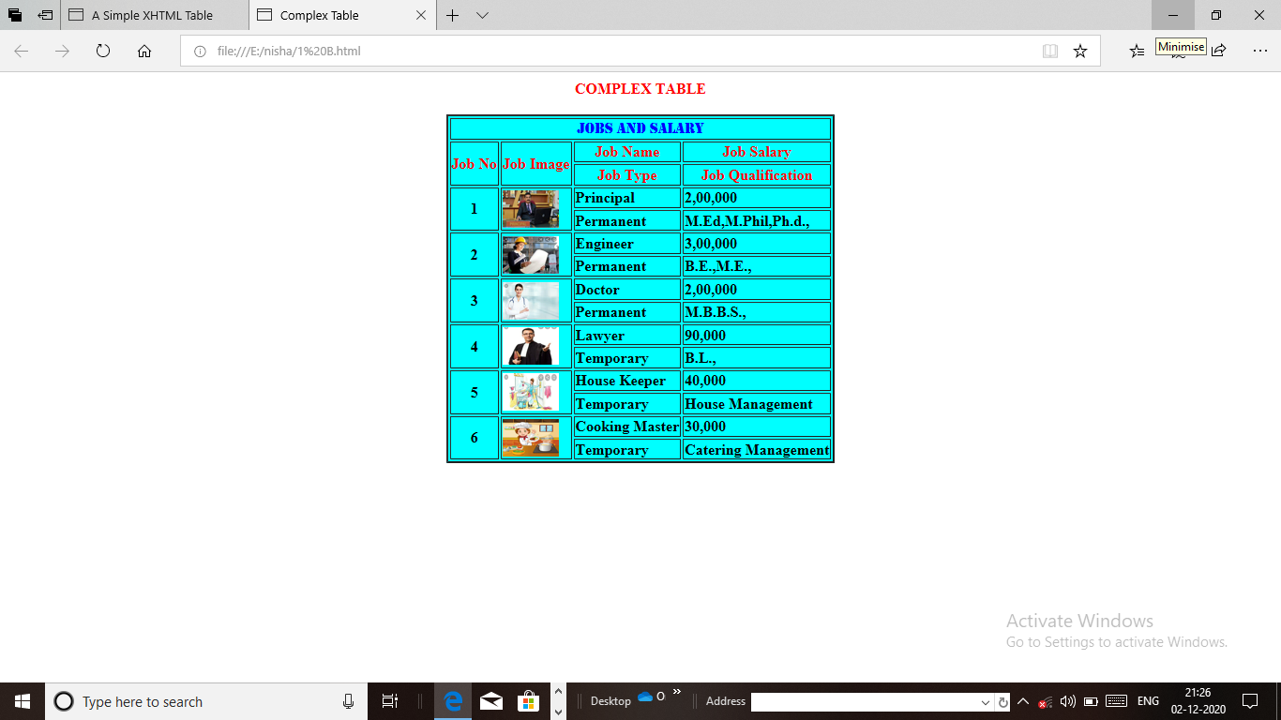

**2. FEEDBACK FORM**

<html>

<head>

<title>Feedback Form</title>

</head>

<body bgcolor="yellow">

<h1>Feedback Form</h1>

<p>Please fill out this form to help us improve my icecream stall</p>

<form method="post" action="">

<p><label>

Name:<input name="name" type="text" size=25"/>

</lable></p>

<p><lable>Comments:<br/>

<textarea name="comments" rows="4" cols="36">Enter comments here.</textarea>

</label></p>

<p><label>E-Mail Address:

<input name="email" type="password" size="25">

</label></p>

<p><strong>Flavours liked:</strong><br/>

<label>Venilla<input name="Flavours liked" type="checkbox" value="Venilla"/></label>

<label>Pistha<input name="Flavours liked" type="checkbox" value="Pistha"/></label>

<label>Chocolate<input name="Flavours liked" type="checkbox" value="Chocolate"/></label>

<label>Butter Scratch<input name="Flavours liked" type="checkbox" value="Butter Scratch"/></label>

<label>Strawberry<input name="Flavours liked" type="checkbox" value="Strawberry"/></label>

</p>

<p><strong>Favourite stall liked:</strong><br/>

<label>Ibaco<input name="Favourite stall" type="radio" value="Ibaco"/></label>

<label>Arun<input name="Favourite stall" type="radio" value="Arun"/></label>

<label>Champion<input name="Favourite stall" type="radio" value="Champion"/></label>

<label>Krazzy bytes<input name="Favourite stall" type="radio" value="Krazzy bytes"/></label>

<label>Cakes and Bakes<input name="Favourite stall" type="radio" value="Cakes and Bakes"/></label>

</p>

<p>

<label>Rate my Icecream stall:

<select name="rating">

<option selected="selected">Amazing</option>

<option selected="selected">Tasty</option>

<option selected="selected">Delicious</option>

<option selected="selected">Wonderful</option>

<option selected="selected">Nice flavour</option>

<option selected="selected">Yummy</option>

</select></lable></p>

<p>

<input type="submit" value="Submit"/>

<input type="reset" value="Clear"/>

</p></form>

</body>

</html>

**Output**

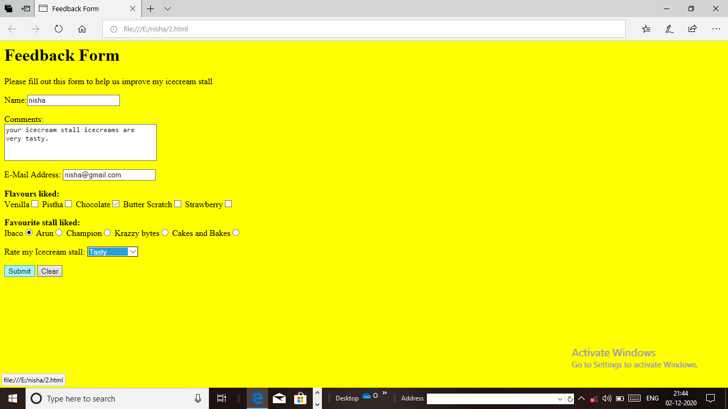

**3. INTERNAL LINKING**

<html>

<head>

<title>Internal links</title>

</head>

<body bgcolor="Pink">

<h1 id="features">Best Tourist Places in India</h1>

<p><a href="#Places">Go to <em>Favorite Tourist Place </em></a></p>

<ul>

<li> Every Person have tour for Vocation</li>

<li>Tourist places in India</li>

<ul>

<li>Ooty-TamilNadu</li>

<ul>

<li>Queen of the Nilgiris</li>

<li>Another name is Udagamandalam</li>

<li>Best time is througout the year</li>

</ul>

</li>

<li>Munnar-Kerala</li>

<ul>

<li>Tea Gardens</li>

<li>Lakes and pritty little hill-station</li>

<li>Best time is September to May</li>

</ul>

<li>Darjelling-West Bengal</li>

<ul>

<li>Queen of The Himalayas</li>

<li>Mesmerising Sunrises</li>

<li>Best time is February-March and September-December</li>

</ul>

<li>Kodaikanal-Tamil Nadu</li>

<ul>

<li>The Princess of Hill Stations</li>

<li>Beautiful Lakes and Valleys</li>

<li>Best time is September to May</li>

</ul>

</li></li>

<li>Goa is very good place for Beaches and Sunsets</li>

<li>Taj Mahal is one of the World Wonder in Agra</li>

</ul>

<!--id attribute creates an internal heperlink destination-->

<h1 id="Places">My 3 Favorite Tourist Places</h1>

<p><a href="#Features">Go to <em>Favorite Features</em></a></p>

<ol>

<li>Agra</li>

<li>Ooty</li>

<li>Munnar</li>

</ol>

</body></html>

**Output**

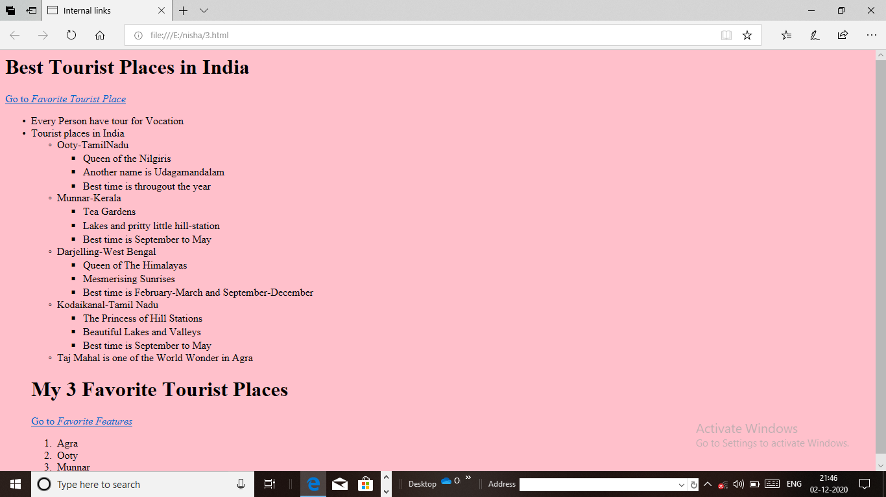

**4. FIXED BACKGROUND IMAGE WHILE SCFROLLING**

<html>

<head>

<title>Fixed Background Image</title>

<h2><center>Fixed Background Image</center></h2>

<style>

body

{

background-image:url('eiffel.jpg');

background-repeat:no-repeat;

background-attachment;fixed;

background-size:cover;

}

</style>

<p>

<pre>

<b><h3>

<center>General information</center>

Type: Observation tower, Broadcasting tower

Location: 7th arrondissement, Paris, France

Construction started: 28 January 1887

Construction completed: 15 March 1889

Opening: 31 March 1889(131 years ago)

Owner: City of Paris, France Management: Societe d Exploitation de la Tour Eiffel(SETE)

<center> Height </center>

Architectural: 300m (984 ft)

Tip: 324 m (1,063 ft) Top floor:276m (906 ft)

<center> Design and construction</center>

<font color="red">Architect: Stephen Sauvestre

Structural Engineer: Maurice Koechlin Emile Nougyier

Main Contractor: Compaign des Establissements Eiffel

Features: The tower is almost photo taken of the Paris skyline and in almost every film set in the city.

Enjoy the breath-taking views of the city with even less effort.

</p>

</body>

</html>

**Output**

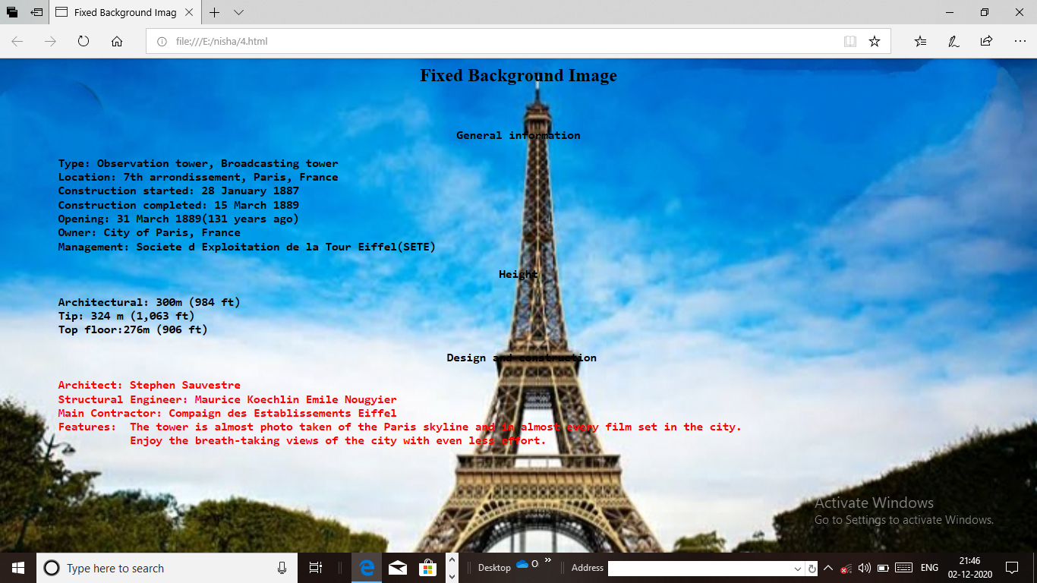

**5. DROP DOWN MENU**

<html>

<head>

<title>Drop Down Menu</title>

<style type="text/css">

body{font-family;arial,sans-serif}

div.menu{font-weight;bold; color:white; border:2px solid#225599;text-align:center; width:10em; background-color:blue}

div.menu:hover a{display:block}

div.menu a{display:none;border-top:2px solid#225599; background-color:yellow; width:10em; text-decoration:none; color:black}

div.menu a:hover{background-color:cyan}

</style>

</head>

<body bgcolor="blue">

<h1><center>Drop Down Menu</center></h1>

<center><div class="menu">Seven World Wonders

<a href=E:\123\5 Taj Mahal.html">Taj Mahal</a>

<a href=E:\123\5 Pyramid of Giza.html">Pyramid of Giza</a>

<a href=E:\123\5 Hanging Gardens of Babylons.html">Hanging Gardens of Babylons</a>

<a href=E:\123\5 Great wall of India.html">Great wall of India</a>

<a href=E:\123\5 Tower of Pisa.html">Tower of Pisa</a>

<a href=E:\123\5 Colosseum.html">Colosseum</a>

<a href=E:\123\5 Statue of Liberty.html">Statue of Liberty</a>

</center></div>

</body>

</html>

**Output**

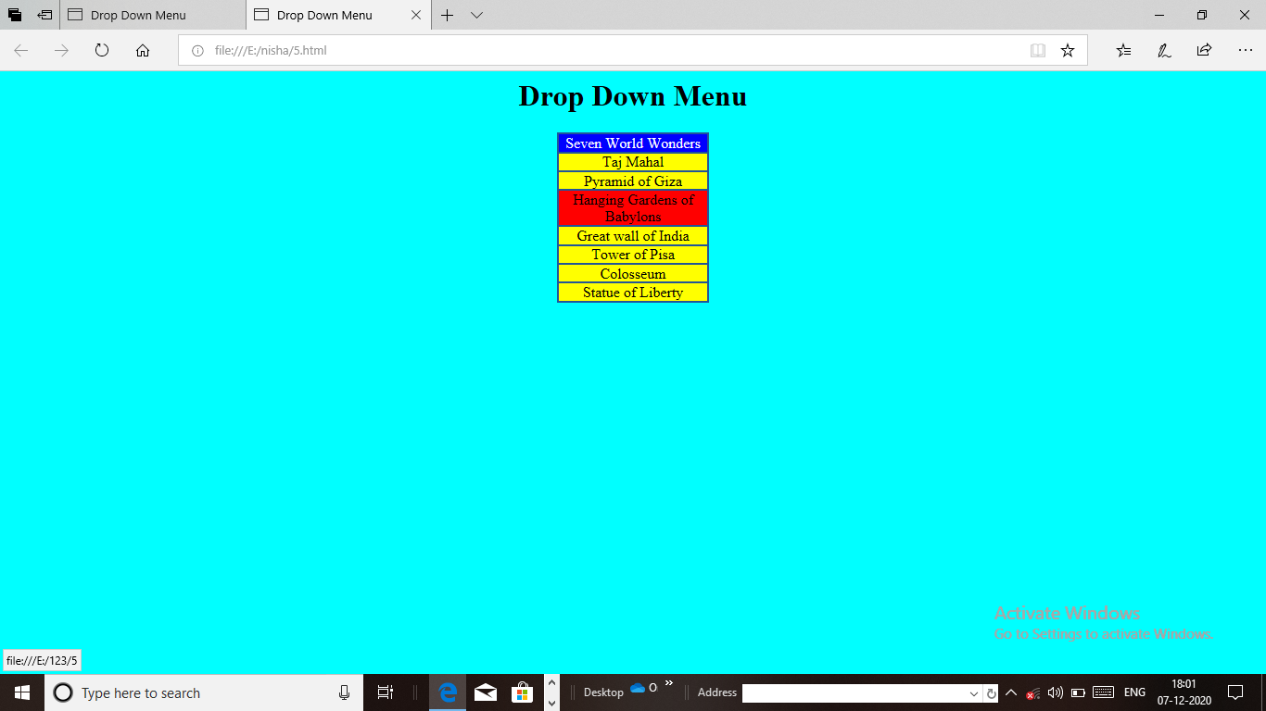

**6. Z-INDEX USING CSS**

<html xmlns="http://www.w3.org/1999/xhtml">

<head>

<title>Background image</title>

<style type="text/css">

body {

background-image: url('Taj Mahal.jpg');

background-repeat: no-repeat;

background-attachement: fixed;

background-position: center;

background-color: violet;

}

P {font-size:18pt;

color:black;

text-indent:1em;

font-family:arial,sans-serif;}

dark{font-weight:bold}

</style>

</head>

<body>

<h1><center>BACKGROUND IMAGE</center></h1>

<p>

<b>Taj mahal is the one of the world wonder. The Taj Mahal is a white marble built by Mugal emperor Shan Jahan in memory of wife, Mumtaz Mahal.

</p>

<p>

<b>The materials were transporter to the construction site by a whopping 1,000 elephants. It intricate work of art and architectural genius took 17 years to complete.

</p>

</body>

</head>

</html>

**Output**

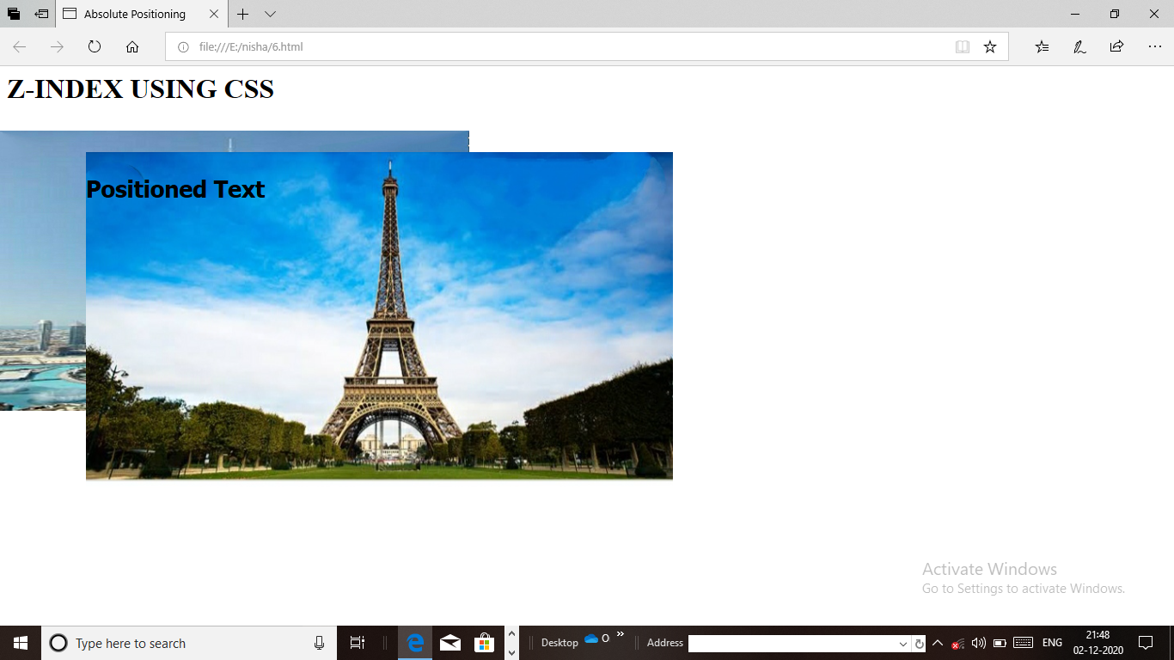

**7. BACKGROUND IMAGE & INDENTATION USING CSS**

<html>

<head>

<title>Absolute Positioning</title>

<style type="text/css">

.bgimg{position:absolute;top:75px;left:0px;z-index:1}

.fgimg{position:absolute;top:100px;left:100px;z-index:2}

.text{position:absolute;top:100px;left:100px;z-index:3;font-size:20pt;font-family:tahoma,geneva,sans-serif}

</style>

</head>

<body>

<h1>Z-INDEX USING CSS</h1><br><br>

<p><img src="E:\nisha\burji kalifa.jpg"class="bgimg"alt="First positioned image" width="40%" height="50%"/></p>

<p><img src="E:\nisha\eiffel.jpg"class="fgimg"alt="Second positioned image" width="50%" height="60%"/></p>

<p class="text"><b>Positioned Text</p>

</body>

</html>

**Output**

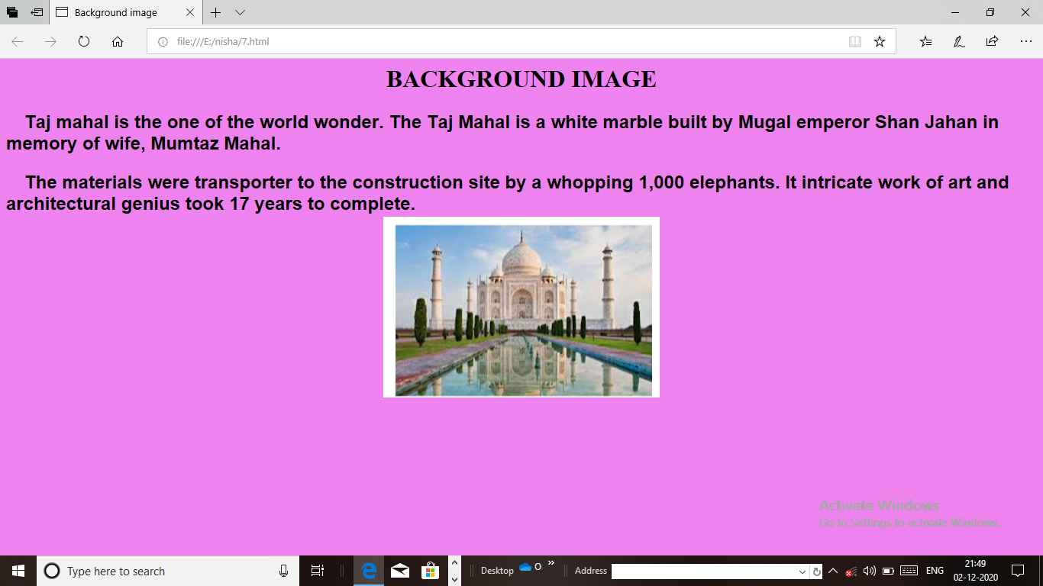

**8. A) CHECKING THE MULTIPLE OF AN INTEGER**

<html>

<head>

<title>Multiple of an Integers</title>

<script>

function check()

{

var num1,num2,check;

num1=Number(document.getElementById("first").value);

num2=Number(document.getElementById("second").value);

check=num2%num1;

if(check==0)

{

document.getElementById("answer").innerHTML="The Number " +num1+ "is a multiple of "+num2;

}

else

{

document.getElementById("answer").innerHTML="The Number " +num1+ "is a multiple of "+num2;

}

}

</script>

</head>

<body bgcolor="yellow">

<h2>Multiple of an Integers</h2>

Enter First Number:

<input id="first"/><br><br>

Enter Second Number:

<input id="second"/><br><br>

<button onClick="check()">Check</button><br><br>

<label id="answer"/>

</body>

</html>

**Output**

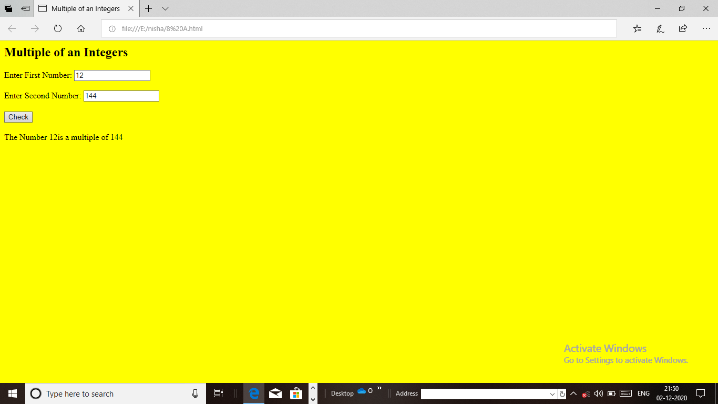

**8. B) BIGGEST AND SMALLEST OF INTEGERS**

<html>

<head>

<title>Largest and Smallest of Five Numbers</title>

<script type="text/javascript">

var v1=window.prompt("Enter first number","0");

var v2=window.prompt("Enter second number","0");

var v3=window.prompt("Enter third number","0");

var v4=window.prompt("Enter fourth number","0");

var v5=window.prompt("Enter fifth number","0");

var a1=parseFloat(v1);

var a2=parseFloat(v2);

var a3=parseFloat(v3);

var a4=parseFloat(v4);

var a5=parseFloat(v5);

var max=maximum(a1,a2,a3,a4,a5);

var min=minimum(a1,a2,a3,a4,a5);

document.writeln("<b>Largest and Smallest of Five Numbers:</b>");

document.writeln("<br/>**********************************");

document.writeln("<br/>First number:"+a1);

document.writeln("<br/>Second number:"+a2);

document.writeln("<br/>Third number:"+a3);

document.writeln("<br/>Fourth number:"+a4);

document.writeln("<br/>Fifth number:"+a5);

document.writeln("<br/><br/><b>maximum is:</b>"+max);

document.writeln("<br/><br/><b>minimum is:</b>"+min);

function maximum(a1,a2,a3,a4,a5)

{

return Math.max(Math.max(a1,a2,a3,a4,a5));

}

function minimum(a1,a2,a3,a4,a5)

{

return Math.min(Math.min(a1,a2,a3,a4,a5));

}

</script>

</head>

<body bgcolor="yellow">

<p><font color="blue">Click Refresh to run the script again</p>

</body>

</html>

**Output**

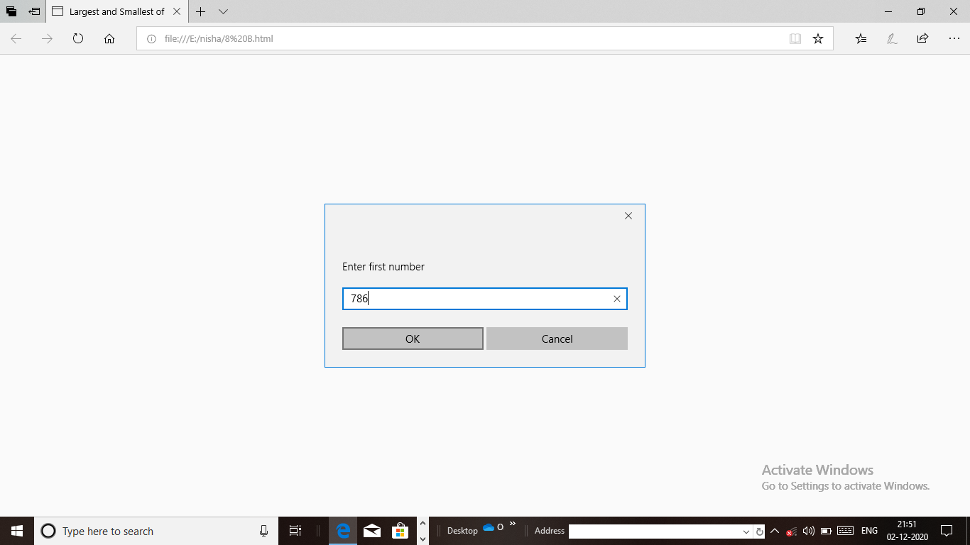

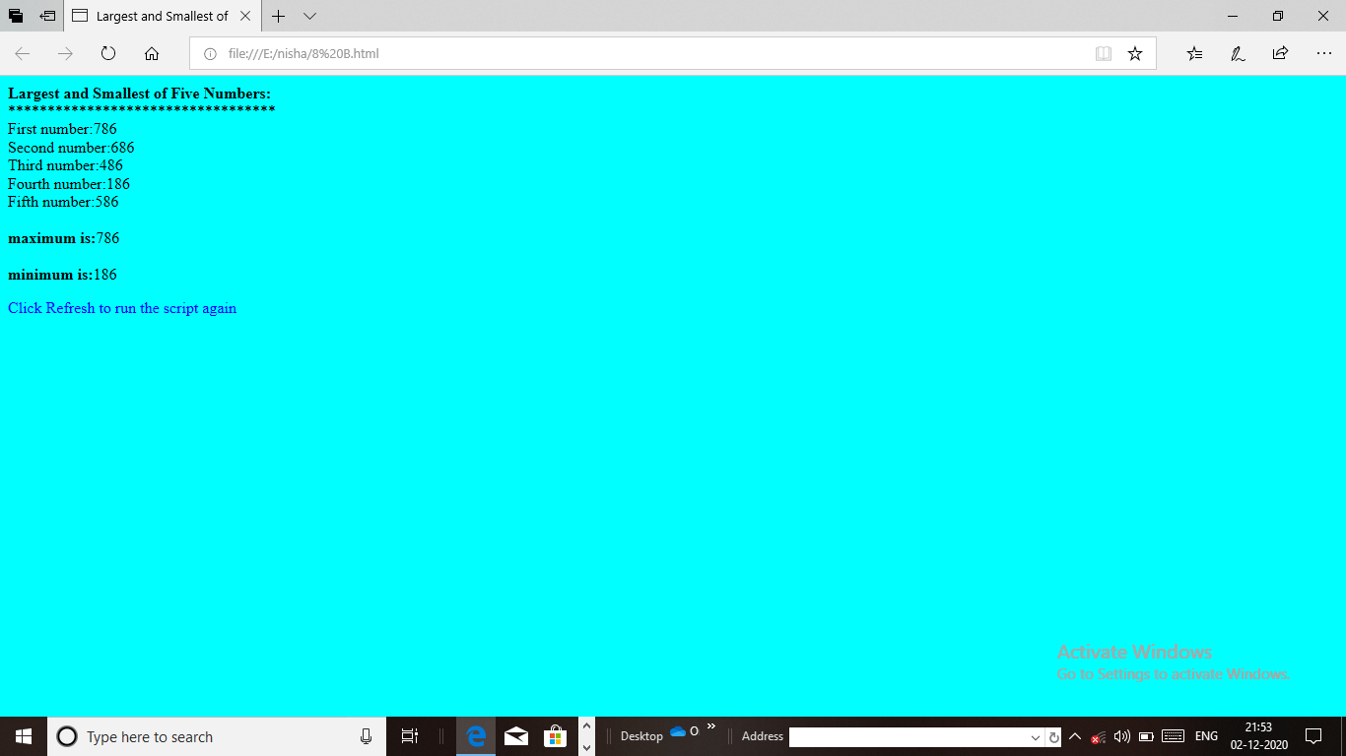

**9. USER IDENTIFICATION USING COOKIES**

<html>

<head>

<title>Using Cookies</title>

<script type="text/javascript">

var now=new Date();

var hour=now.getHours();

var name;

if(hour<12)

document.write("<h1>Good Morning...");

else

hour=hour-12;

if(hour<6)

document.write("<h1>Good Afternoon my dear students...");

else

document.write("<h1>Good Evening my dear students...");

if(document.cookie)

{

var myCookie=unescape(document.cookie);

var cookieTokens=myCookie.split("=");

name=cookieTokens[1];

}

else

{

name=window.prompt("please enter your name","nisha");

document.cookie="name="+escape(name);

}

document.writeln(name+",welcome to javascript programming!</h1>");

document.writeln("<a href='javascript:wrongPerson()'>"+

"Click here if you are not"+name+"</a>");

function wrongPerson()

{

document.cookie="name=null;"+"expires=Tue,27-oct-20 00:00:01 GMT";

location.reload();

}

</script>

</head>

<body bgcolor="pink">

<p>Click Refresh(or Reload) to run the script again</p>

</body>

</html>

**Output**

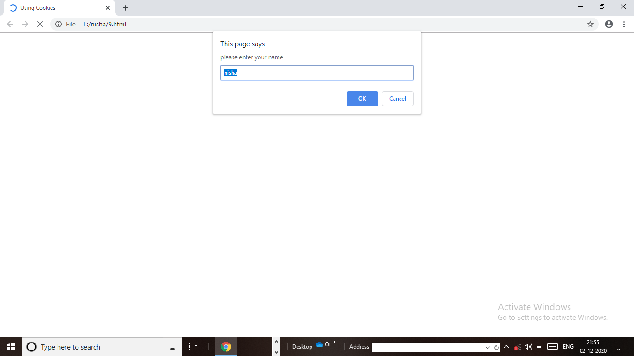

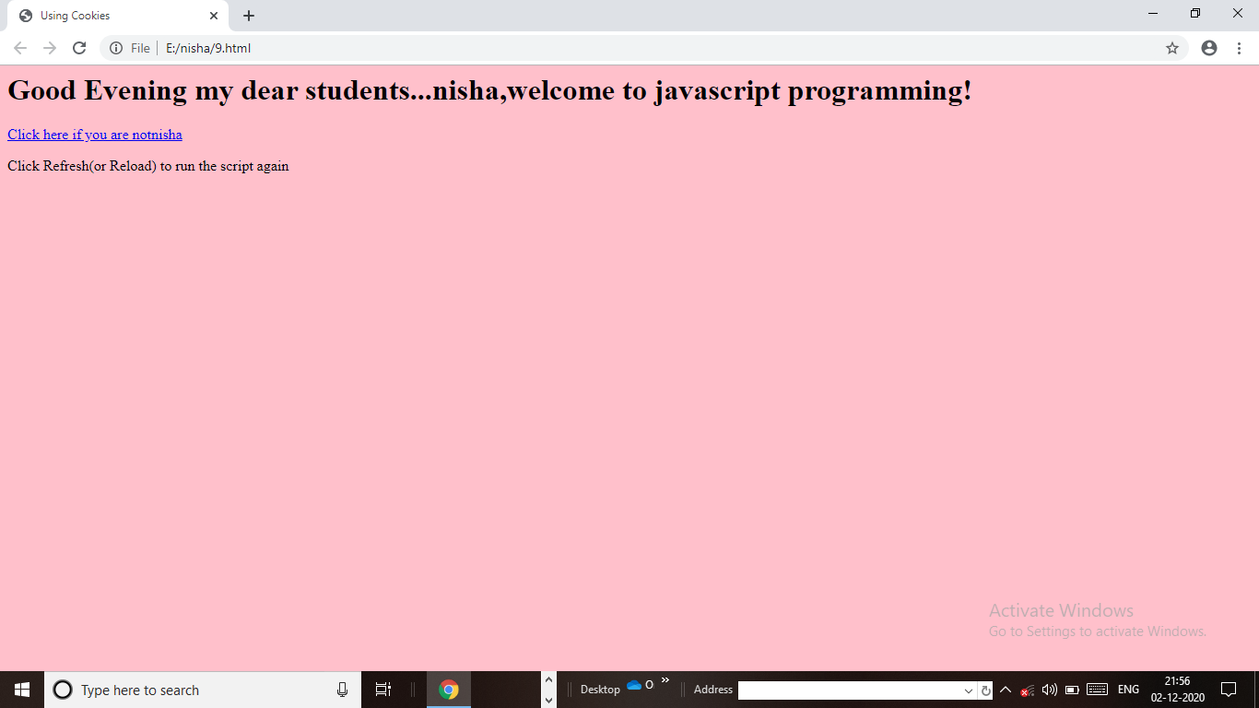

**10. MOUSE EVENT**

<html>

<head>

<script>

function bigImg(x)

{

x.style.height="175px";

x.style.width="275px";

}

function normalImg(x)

{

x.style.height="144px";

x.style.width="144px";

}

</script>

</head>

<body bgcolor="blue">

<img onmouseover="bigImg(this)".onmouseout="normalImg(this)"border="0"

src="E:\nisha\images\eiffel tower.jpg" alt="Smiley" width="32" height="32">

<p>The function bigImg() is triggered when the user moves the mouse pointer over the image</p>

<p>The function normalImag() is triggered when the mouse pointer is moved out of the image</p>

</body></html>

**Output**

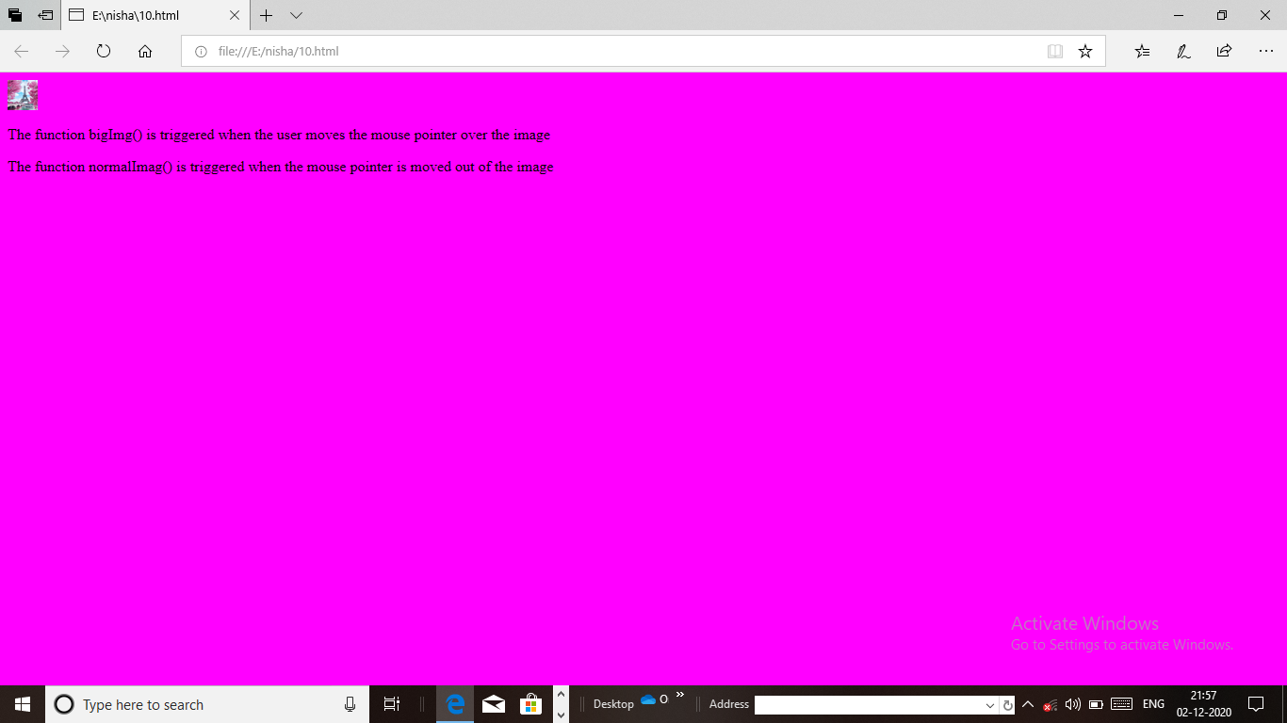

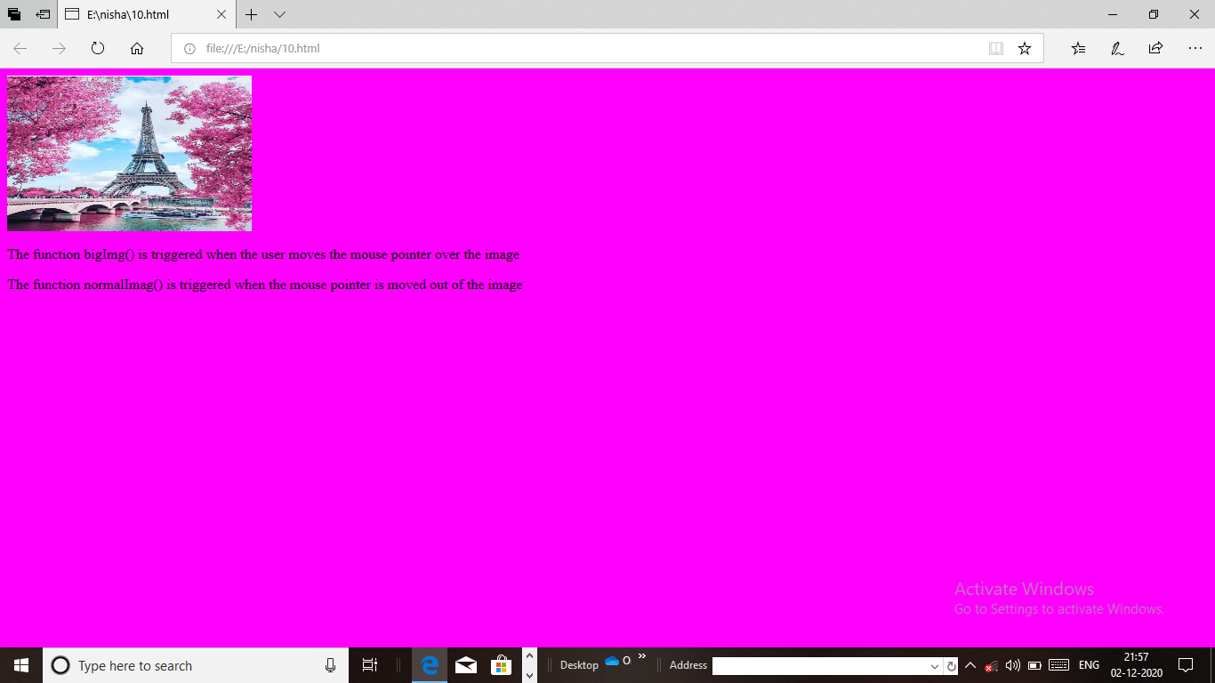

**11. DYNAMIC COLOR CHANGING OF AN IMAGE**

<html>

<head>

<title>Color Changing of an Image</title>

</head>

<style type="text/css">

img{width:500px; height:500px; z-index:900px;}

#canvas{width:500px; height:500px;position:absolute; opacity:0.3; z-index:999px;}

button{float:center; margin-left:10px;}

</style>

<body bgcolor="cyan">

<h1>Color changing of an Image</h1>

<p align="left">

<div id="canvas"></div>

<img src="Taj Mahal.jpg" id="image">

<br/><br/>

<button id="pink">pink</button>

<button id="violet">violet</button>

<button id="yellow">yellow</button>

</p>

</body>

<script>

document.getElementById("pink").addEventListener("click",function(){

document.getElementById("canvas").style.backgroundColor="pink";});

document.getElementById("violet").addEventListener("click",function(){

document.getElementById("canvas").style.backgroundColor="violet";});

document.getElementById("yellow").addEventListener("click",function(){

document.getElementById("canvas").style.backgroundColor="yellow";});

</script>

</html>

**Output**

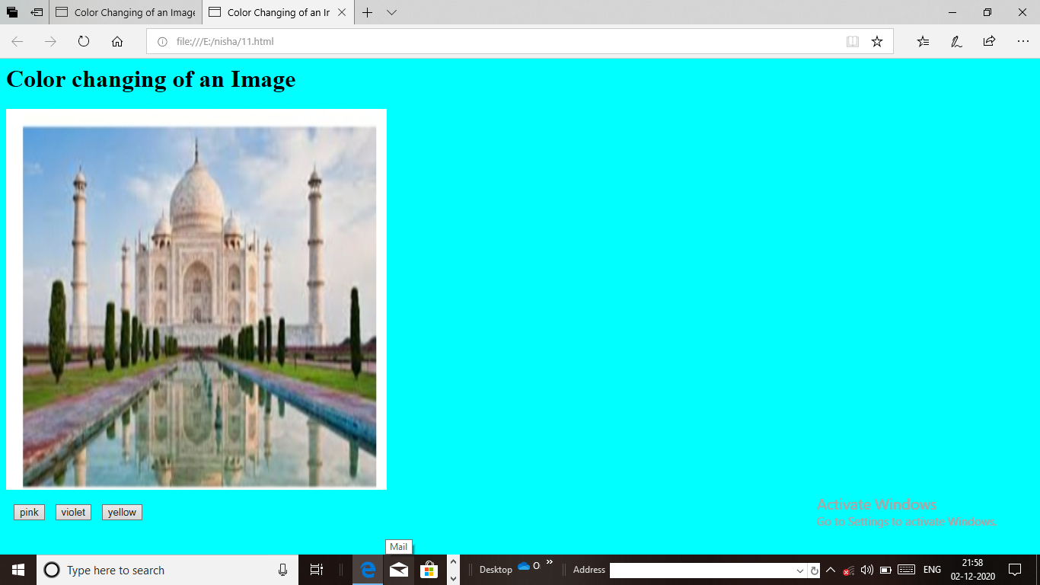

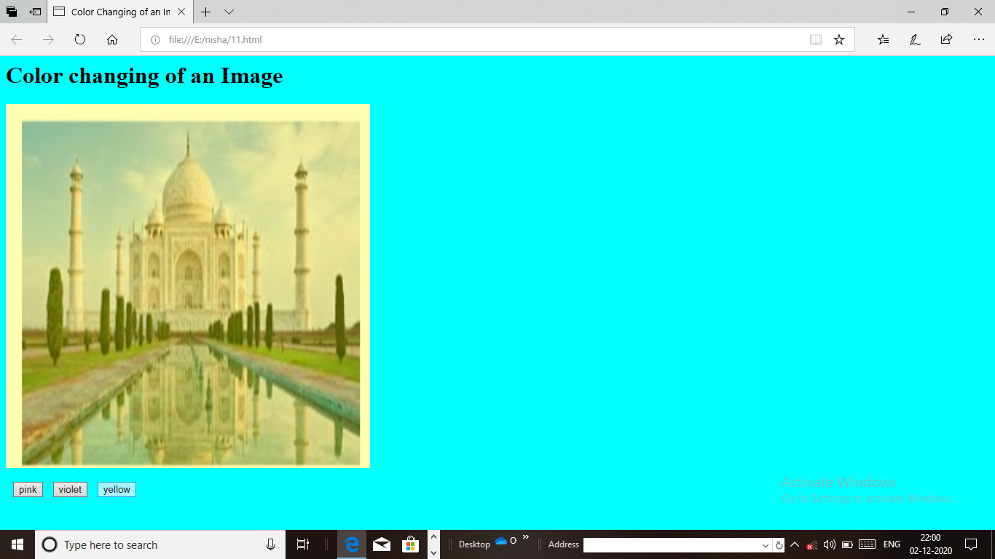

**12.EMPLOYEE DETAILS**

<html>

<head>

<title>Registration Form</title>

<script type="text/javascript">

function calc()

{

var bp,HRA,GP,PF,TAX,Deduction,NetPay,name,id,desg;

name=document.form1.firstname.value;

id=document.form1.userid.value;

desg=document.form1.designation.value;

bp=parseInt(document.form1.bp.value);

DA=bp*0.5;

HRA=bp*0.5;

GP=bp+DA+HRA;

PF=GP*0.02;

Tax=GP*0.01;

Deduction=Tax+PF;

NetPay=GP-Deduction;

document.form1.da.value=DA;

document.form1.hra.value=HRA;

document.form1.gp.value=GP;

document.form1.pf.value=PF;

document.form1.tax.value=Tax;

document.form1.deduction.value=Deduction;

document.form1.netpay.value=NetPay;

}

</script>

</head>

<body bgcolor="cyan">

<center>

<h2>Employee Details</h2>

<form name="form1">

<table border="1" bordercolor="red" bgcolor="yellow">

<tr>

<td>Name</td>

<td><input type="text" name="firstname"/></td>

</tr>

<tr>

<td>User ID</td>

<td><input type="text" name="userid"/></td>

</tr>

<tr>

<td>Designation</td>

<td><input type="text" name="designation"/></td>

</tr>

<tr>

<td>Basic Pay</td>

<td><input type="text" name="bp"/></td>

</tr>

<tr>

<td colspan="2" align="center">

<input type="button" name="calculate" value="Click Here To Calculate"onclick="calc()"></td>

</tr>

<tr>

<td>Dearness Allowance</td>

<td><input type="text" name="da"/></td>

</tr>

<tr>

<td>House Rent Allowance</td>

<td><input type="text" name="hra"/></td>

</tr>

<tr>

<td>GP</td>

<td><input type="text" name="gp"/></td>

</tr>

<tr>

<td>Provident Fund</td>

<td><input type="text" name="pf"/></td>

</tr>

<tr>

<td>Tax</td>

<td><input type="text" name="tax"/></td>

</tr><tr>

<td>Deduction</td>

<td><input type="text" name="deduction"/></td>

</tr><tr>

<td>NetPay</td>

<td><input type="text" name="netpay"/></td>

</tr>

</table>

</form>

</center>

</body>

</html>

**Output**

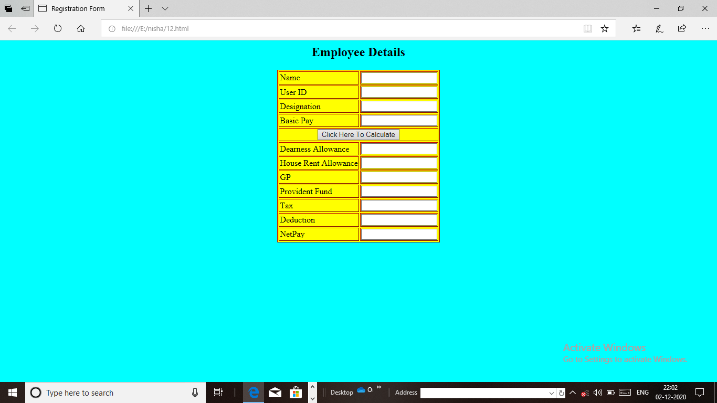

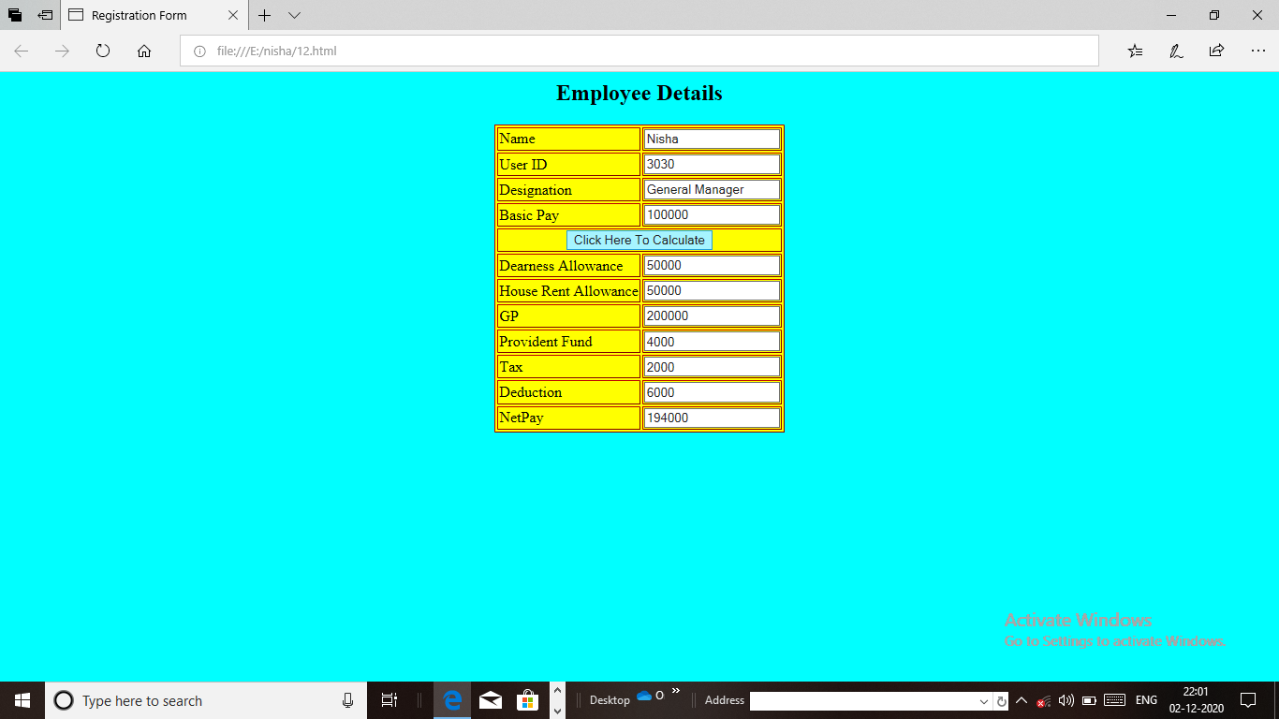

**13. STUDENT ‘S MARKLIST**

<html>

<head>

<title>Registration Form</title>

<script type="text/javascript">

function calc()

{

var m1,m2,m3,avg=0,total=0,result="",grade="";

m1=parseInt(document.form1.wt.value);

m2=parseInt(document.form1.ost.value);

m3=parseInt(document.form1.cc.value);

m4=parseInt(document.form1.dm.value);

m5=parseInt(document.form1.ns.value);

total=m1+m2+m3+m4+m5;

avg=total/5;

if(m1<35||m2<35||m3<35)

{

result="fail";

grade="D";

}

else if(avg>=75)

{

result="Distinction";

grade="A+";

}

else if(avg>=60&&avg<75)

{

result="First class";

grade="A";

}

else if(avg>=50&&avg<60)

{

result="Second class";

grade="B";

}

else if(avg>=35&&avg<50)

{

result="pass class";

grade="C";

}

else if(avg<35)

{

result="Fail";

grade="D";

}

document.form1.result.value=result;

document.form1.grade.value=grade;

document.form1.total.value=total;

document.form1.average.value=avg;

}

</script>

</head>

<body bgcolor="red"><center>

<h1>Students Marklist</h1>

<form name="form1">

<table border="1" bordercolor="red" bgcolor="yellow">

<tr>

<td>Student Name</td>

<td><input type="text"/></td>

</tr>

<tr>

<td colspan="2" align="center"><b>Subject Marks</td>

</tr>

<tr>

<td>Web Technology</td>

<td><input type="text" name="wt"/></td>

</tr>

<tr>

<td>Open Source Technologies</td>

<td><input type="text" name="ost"/></td>

</tr>

<tr>

<td>Cloud Computing</td>

<td><input type="text" name="cc"/></td>

</tr>

<td>Data Mining</td>

<td><input type="text" name="dm"/></td>

</tr>

<tr>

<td>Network Security</td>

<td><input type="text" name="ns"/></td>

</tr>

<tr>

<td colspan="2" align="center">

<input type="button" onclick="calc()" value="calculate"/></td></tr>

<tr>

<td>Total</td>

<td><input type="text" name="total"/></td></tr>

<tr>

<td>Average</td>

<td><input type="text" name="average"/></td></tr>

<tr>

<td>Result</td>

<td><input type="text" name="result"/></td></tr>

<tr>

<td>Grade</td>

<td><input type="text" name="grade"/></td>

</tr>

</table>

</form>

</body></html>

**Output**

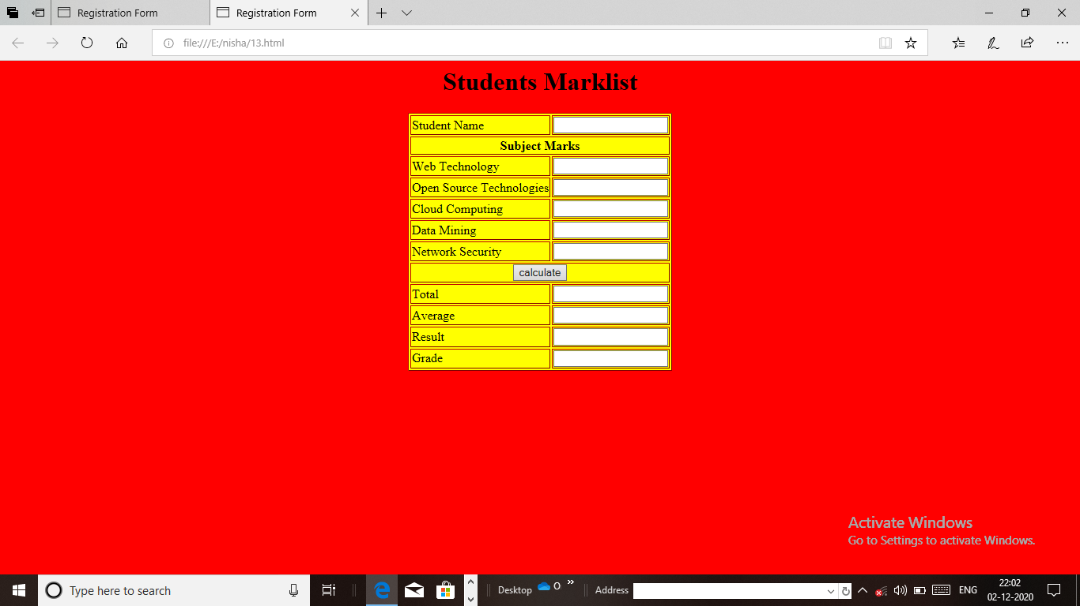

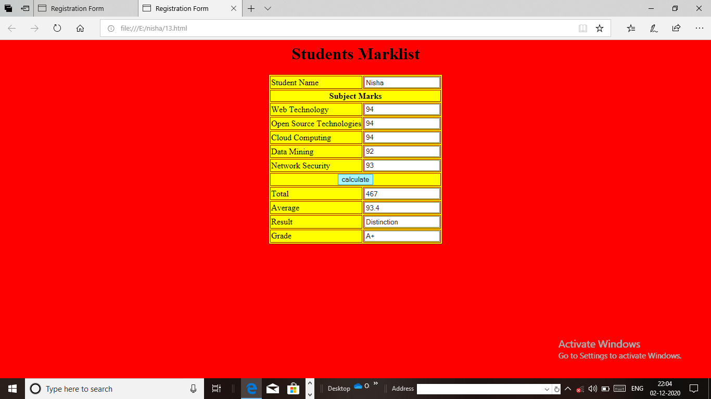

**14. RAILWAY RESERVATION**

<html>

<head>

<title>Railway Reservation Form</title>

<style type="text/css">

body

{

background-image:url('rails.jpg');

background-repeat:no-repeat;

background-attachment;fixed;

background-size:cover;

}

</style>

</head>

<body>

<form name="railway">

<center>

<h1><b><font color="black">Railway Reservation Form Online</h1>

<table>

<tr>

<td><b><font color="red">Train Name:</td>

<td><input type="text" name=""</td></tr>

<tr>

<td><b><font color="red">Train Number:</td>

<td><input type="number" value=""</td></tr>

<tr>

<td><b><font color="red">Seat Number:</td>

<td><input type="number" value=""</td></tr>

<tr>

<td><b><font color="red">From:</td>

<td><input type="text" name="railway"</td>

</tr>

<tr>

<td><b><font color="red">To:</td>

<td><input type="text" name="reservation"</td>

</tr>

<tr>

<td><b><font color="red">Travel Hours:</td>

<td><input type="number" value=""</td></tr>

<tr>

<td><b><font color="red">Passenger Name:</td>

<td><input type="text" name=""</td></tr>

<tr>

<td><b><font color="red">Gender:</td>

<td>

<font color="black"><input type="radio" name="Gender" value="female"/><b>Female<br/>

<font color="black"><input type="radio" name="Gender" value="male"/><b>Male<br/>

</td>

</tr>

<td><b><font color="red">Age:</td>

<td><input type="number" name=""</td>

</tr>

<tr>

<td><b><font color="red">Address:</td>

<td><textarea name="address" rows="4" cols="36"></textarea></tr><br/>

<tr>

<td><b><font color="red">Account Number:</td>

<td><input type="number" value=""</td></tr>

<tr>

<tr>

<td><b><font color="red">Date:</td>

<td><input type="text" value=""</td></tr>

<tr>

<td><b><font color="red">Payment options:</td>

<td>

<font color="black"><input type="radio" name="payment" value="cc"/><b>Credit Card<br/>

<font color="black"><input type="radio" name="payment" value="dc"/><b>Debit card<br/>

<font color="black"><input type="radio" name="payment" value="wallet/"><b>wallet<br/>

</td>

</tr>

<tr>

<td><input type="submit" value="submit"/></td>

<td><input type="submit" value="cancel"/></td>

</tr>

</table>

</body>

</html>

**Output**

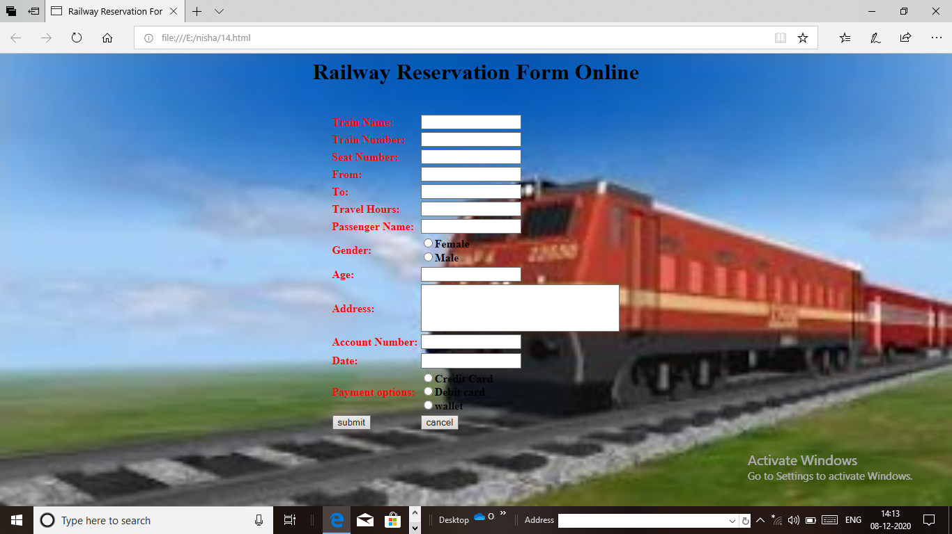

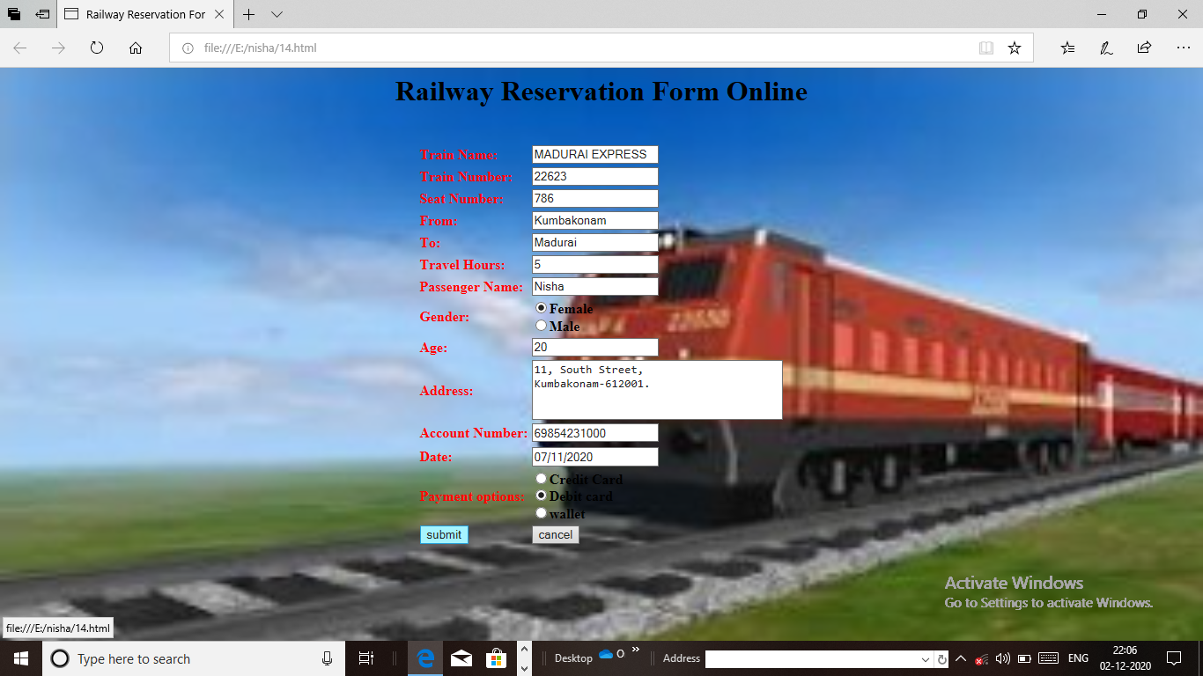

**15. BIO DATA**

<?xml version="1.0" encoding="utf-8"?>

<?xml-stylesheet type="text/xsl" href="bioo.xsl"?>

<biodata>

<details>

<v1>Name</v1>

<v2>S.Nisha</v2>

</details>

<details>

<v1>DOB</v1>

<v2>29.08.1996</v2>

</details>

<details>

<v1>Age</v1>

<v2>20</v2>

</details>

<details>

<v1>Gender</v1>

<v2>Female</v2>

</details>

<details>

<v1>Qualification</v1>

<v2>M.sc</v2>

</details>

<details>

<v1>Nationality</v1>

<v2>Indian</v2>

</details>

<details>

<v1>Religion</v1>

<v2>Muslim</v2>

</details>

<details>

<v1>Languages known</v1>

<v2>Tamil,English</v2>

</details>

<details>

<v1>Hobbies</v1>

<v2>Reading Books,Playing Game</v2>

</details>

</biodata>

**//Bioo.xsl**

<?xml version="1.0" encoding="utf-8"?>

<xsl:stylesheet version="1.0" xmlns:xsl="http://www.w3.org/1999/XSL/Transform">

<xsl:template match="/">

<html><head>

<title>BIO DATA</title></head>

<body bgcolor="cyan">

<xsl:apply-templates/>

</body></html>

</xsl:template>

<xsl:template match="biodata">

<table width="60%" border="1" align="center" cellpadding="10">

<tr>

<th bgcolor="red" colspan="2" align="center">BIODATA</th></tr>

<xsl:for-each select="details">

<tr>

<td width="30%" bgcolor="yellow">

<xsl:value-of select="v1"/></td>

<td width="30%" bgcolor="yellow">

<xsl:value-of select="v2"/>

</td>

</tr>

</xsl:for-each></table>

</xsl:template></xsl:stylesheet>

**Output**

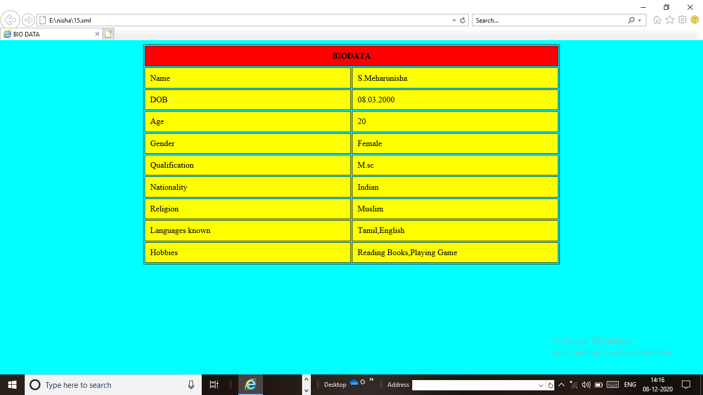

**16. USING XPATH TO LOCATE NODES IN AN XML DOCUMENT**

**<html xmlns="http"//www.w3.org/1999/xhtml">**

**<head>**

**<title>using xpath to locate nodes in an XML document</title>**

**<style type="text/css">**

**#outputDiv{font:10pt "Lucida Console", monospace;}**

**</style>**

**<script type="text/javascript">**

**var doc;**

**var outputHTML="";**

**var browser="";**

**function loadXMLDocument(url)**

**if(window.ActiveXObject)**

**{**

**doc=new ActiveXObject("Msxml2.DOMDocument.6.0");**

**doc.async=false;**

**doc.load(url);**

**browser="IE7";**

**}**

**else if(document.implementation&&document.implementation.createDocument)**

**{**

**doc=document.implementation.createDocument("","",null);**

**doc.load(url);**

**browser="FF2";**

**}**

**else**

**alert('This script is not supported by your browser');**

**}**

**function displayDoc()**

**{**

**document.getElementById("outputDiv").innerHTML=outputHTML;**

**}**

**function processXPathExpression()**

**{**

**var XPathExpression=document.getElementById("inputField").value;**

**output HTML="";**

**if(browser=="IE7")**

**{**

**var result=doc.selectNodes(XPathExpression);**

**for(var i=0;i<result.length;i++)**

**output HTML+="<div style='clear:both'>"+result.item(i).text+"</div>";**

**}**

**else**

**{**

**var result=document.evaluate(XPathExpression,doc,null,XPathResult.ANY_TYPE,null);**

**var current=result.iterateNext();**

**while(current)**

**{**

**output HTML+="<div style='clear:both'>"+current.textContent+"</div>";**

**current=result.iterateNext()**

**}**

**}**

**display Doc();**

**}**

**</script>**

**</head>**

**<body id="body" onload="load XMLDocument('sports.xml');">**

**<form action="" onsubmit="return false;">**

**<input id="inputField" type="text" style="width:200px"/>**

**<input type="submit" value="Get Matches" onclick="process XPathExpression()"/>**

**</form><br/>**

**<div id="outputDiv"></div>**

**</body></html>**

**17. SWITCH CONTENT ASYNCHORNOUSLY**

**<?xml version="1.0" encoding="utf-8"?>**

**<!DOCTYPE html PUBlIC"_//W3C/?DTD/XHTML1.0 Strict.dtd">**

**<http://www.w3.org/FR/xhtml/DTD/xhtml1-strict.dtd">**

**<html xmlns="http://www.w3.org/1999/xhtml">**

**<head>**

**<style type="text/css">**

**.box{border:1px solid black;**

**padding:10px}</style>**

**<title>Switch Content</title>**

**<script type="text/javascript" language="Javascript">**

**<!--**

**var asyncRequest;**

**function getContent(url)**

**{**

**try{**

**asyncRequest=new XMLHttpRequest();**

**asyncRequest.onreadystatechange=stateChange;**

**asyncRequest.open('GET'.url.true);**

**asyncRequest.send(null);**

**}**

**catch(exception)**

**{**

**alert("Request failed");**

**}}**

**function stateChange()**

**{**

**if(asyncRequest.readyState==4&&asyncRequest.status==200)**

**{**

**document.getElementById('contentArea').innerHtml=asyncRequest.responseText;**

**}**

**}**

**function clearContent()**

**{**

**document.getElementById('contentArea').innerHTML=";**

**}**

**</script></head><body>**

**<img src="E:\nisha\baby.png" width=200px height=200px onmouseover='getContent("17.html")' onmouseout='clearContent()'/>**

**<img src="E:\nisha\baby.png" width=200px height=200px onmouseover='getContent("17.html")' onmouseout='clearContent()'/>**

**<img src="E:\nisha\baby.png" width=200px height=200px onmouseover='getContent("17.html")' onmouseout='clearContent()'/>**

**<img src="E:\nisha\baby.png" width=200px height=200px onmouseover='getContent("17.html")' onmouseout='clearContent()'/>**

**<img src="E:\nisha\baby.png" width=200px height=200px onmouseover='getContent("17.html")' onmouseout='clearContent()'/>**

**<div class="box" id="contentArea">This baby is very Beautiful and very nice&nbsp;</div>**

**</body></html>**

**Output**

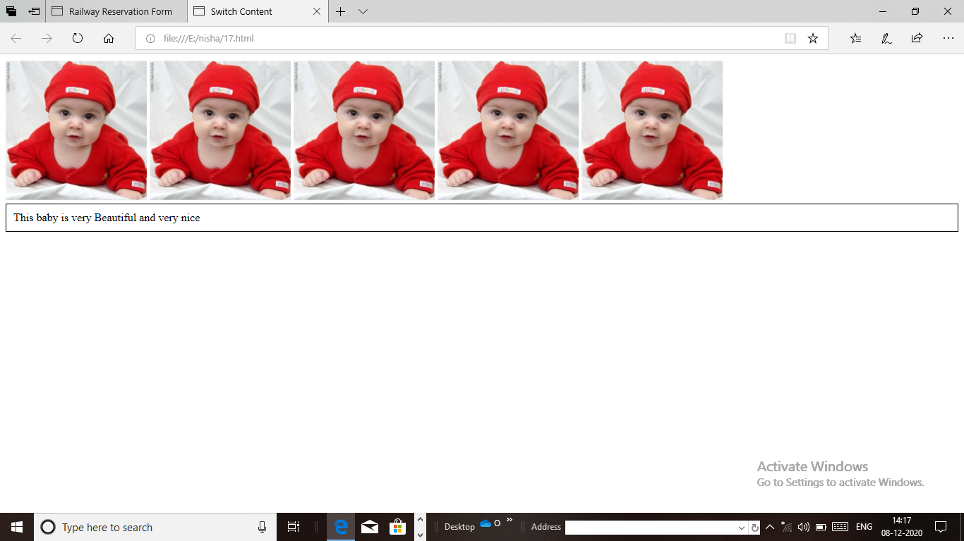

**18. CALENDAR PREPARATION**

**<html>**

**<head>**

**<title>javascript calendar</title>**

**<script>**

**functiondisplaycalendar();**

**var htmlcontent="";**

**var febNumberofDays="";**

**var count=1;**

**var dateNow=new date();**

**var month=dateNow.getmonth();**

**var nextmonth=month+1;\\+1;\\used to match up the current month with correct start date;**

**var prevmonth=month-1;**

**var day=dateNow.getDate();**

**var year=dateNow.getfullyear();**

**if(month==1)**

**{**

**if{(year%100!=0)&&(year%4==0)||(year%400==0))**

**{**

**febNumberofDays=29;**

**}**

**else**

**{**

**febNumberofDays=28;**

**}**

**}**

**var monthNames=("January",february","march","april","may","june","july","august","september","october","november","december");**

**var dayNames=["sunday","monday","tuesday","wednesday","thursday","friday","saturdays"];**

**var dayperMonth=["31","",febNumberofdays+,"","31","30","31","30","31","31","30","31","30","31");**

**var nextDate=new Date(nextmonth+1,year);**

**var weekdays=nextDate.getdays();**

**var weekdays 2=weekdays;**

**var numofDays=daypermonth(month);**

**while(weekdays>0)**

**{**

**htmlcontent+="<td class='monthpre'></td>";**

**weekdays--;**

**}**

**while(weekdays>0)**

**{**

**while(counter<=numofDays)**

**{**

**if(weekDays2>6)**

**{**

**wekdays2=0;**

**htmlcontent+=<"</tr>**

**<tr>";**

**}**

**if(counter==day)**

**{**

**htmlcontent+="<td class='daynow'>onmouseover="'this.style.background=/"#FF0000\";**

**this.stylecolor=\"#FFFFFF\""+"onmouseout=this.style.background="#FFFFFFF\"**

**this.stylecolor=\"#00FF00\">"+counter+""</td>";**

**else**

**{**

**htmlcontent+="<td class='monthnow'onmouseover="this.style.background=/"#FF0000""+"onmouseout="this.style.backgroundFFF/">"+counter+"</td>**

**}**

**}**

**weekdays2++;**

**counter++;**

**}**

**var calenderBody=<table class='clendar'><tr class='monthnow'><thcolspan='7'>"+monthnmes[month]+""+year+"<th></tr>";**

**calendarBody+="<tr class='daynames'><td>sun</td><td>mon</td><td>tues</td><td>wed</td><td>thurs</td><td>fri</td><td>sat</td>";**

**calenderBody+=htmlContent;**

**calenderBody+="</tr></table>";**

**document.getElementById("calendar").innerHTML=calendarBody;**

**}**

**</script>**

**</head>**

**<body onload=displayCalendar>**

**<div id="calendar"></div>**

**</body></style>**

**.monthpre{color.gray;text-align:center;}**

**.monthNow{color.blue;text-align:center;}**

**.dayNow{border:2pxsolidblack;color:#FF0000;text-align:center;}**

**.calendar td{htmlcontent:2px;width:40px;}**

**.monthNowth{background-color"#OOOOOO;color:#FFFFFF;text-align:center;}**

**.dayNames{background:#OFFOOO;color:#FFFFFF;text-align:center;}**

**</style></html>**

**WEB TECHNOLOGY LAB**

|  |  |  |  |  |
| --- | --- | --- | --- | --- |
| **S.NO** | **DATE** | **CONTENT** | **PAGE.NO** | **SIGNATURE** |
| 1. |  | a)Simple Table |  |  |
|  | b)Complex Table |  |  |
| 2. |  | Feedback Form |  |  |
| 3. |  | Internal Linking |  |  |
| 4. |  | Fixed Background Image While Scrolling |  |  |
| 5. |  | Drop-Down Menu |  |  |
| 6. |  | Z-Index Using CSS |  |  |
| 7. |  | Background Image&Indentation Using CSS |  |  |
| 8. |  | a)Checking The Multiple of an Integer |  |  |
|  | b)Biggest&smallest of Integers |  |  |
| 9. |  | User Identification Using Cookies |  |  |
| 10. |  | Mouse Event |  |  |
| 11. |  | Dynamic Color Changing of an Image |  |  |
| 12. |  | Employee Details |  |  |
| 13. |  | Student’s Marklist |  |  |
| 14. |  | Railway Reservation |  |  |
| 15. |  | Bio Data |  |  |
| 16. |  | Using Xpath To Locate Nodes In An XML Document |  |  |
| 17. |  | Switch Content Asynchronously |  |  |
| 18. |  | Calendar Preparation |  |  |