What is Phonology?

Phonology is the study of the patterns of sounds in a language and across languages. Put more formally, phonology is the study of the categorical organisation of speech sounds in languages; how speech sounds are organised in the mind and used to convey meaning. In this section of the website, we will describe the most common phonological processes and introduce the concepts of underlying representations for sounds versus what is actually produced, the surface form.

Phonology can be related to many linguistic disciplines, including psycholinguistics, cognitive science, sociolinguistics and language acquisition. Principles of phonology can also be applied to treatments of speech pathologies and innovations in technology. In terms of speech recognition, systems can be designed to translate spoken data into text. In this way, computers process the language like our brains do. The same processes that occur in the mind of a human when producing and receiving language occur in machines. One example of machines decoding language is the popular intelligence system, Siri.

**Phonology vs. Phonetics – the key differences**

Phonology is concerned with the abstract, whereas phonetics is concerned with the physical properties of sounds. In phonetics we can see infinite realisations, for example every time you say a ‘p’ it will slightly different than the other times you’ve said it. However, in phonology all productions are the same sound within the language’s phoneme inventory, therefore even though every ‘p’ is produced slightly different every time, the actual sound is the same. This highlights a key difference between phonetic and phonology as even though no two ‘p’s are the same, they represent the same sound in the language.

Also refer to the [Phonetics](http://all-about-linguistics.group.shef.ac.uk/branches-of-linguistics/phonetics/) page to get a better idea of the differences and similarities between these two related areas of linguistics.

**Phonemes V. Allophones**

Phonemes are the meaningfully different sound units in a language (the smallest units of sound). For example, ‘pat’ and ‘bat’ differ in their first phoneme: the “p” and “b”. Vowels are also phonemes, so “pat” and “pet” differ by a phoneme, too (But phonemes don’t always match up with spelling!). When two words differ by a single phoneme they are known as a minimal pair.  
Allophones are different ways to pronounce a phoneme based on its environment in a word. For example, the two allophones of /l/ in “little” are actually produced slightly differently, and the second one sounds slightly deeper. These different “l”s always occur in different environments in words, which is known as “complementary distribution”.

 n [linguistics](https://en.wikipedia.org/wiki/Linguistics), and particularly [phonology](https://en.wikipedia.org/wiki/Phonology), **stress** or **accent** is relative emphasis or prominence given to a certain [syllable](https://en.wikipedia.org/wiki/Syllable) in a [word](https://en.wikipedia.org/wiki/Word), or to a certain word in a phrase or [sentence](https://en.wikipedia.org/wiki/Sentence_(linguistics)). That emphasis is typically caused by such properties as increased [loudness](https://en.wikipedia.org/wiki/Loudness) and [vowel length](https://en.wikipedia.org/wiki/Vowel_length), full articulation of the [vowel](https://en.wikipedia.org/wiki/Vowel), and changes in [tone](https://en.wikipedia.org/wiki/Tone_(linguistics)).[[1]](https://en.wikipedia.org/wiki/Stress_(linguistics)#cite_note-1)[[2]](https://en.wikipedia.org/wiki/Stress_(linguistics)#cite_note-2) The terms *stress* and *accent* are often used synonymously in that context but are sometimes distinguished. For example, when emphasis is produced through pitch alone, it is called [*pitch accent*](https://en.wikipedia.org/wiki/Pitch-accent_language), and when produced through length alone, it is called *quantitative accent*.[[3]](https://en.wikipedia.org/wiki/Stress_(linguistics)#cite_note-Monrad-3) When caused by a combination of various intensified properties, it is called *stress accent* or *dynamic accent*; English uses what is called *variable stress accent*.

Since stress can be realised through a wide range of [phonetic](https://en.wikipedia.org/wiki/Phonetics) properties, such as loudness, vowel length, and pitch (which are also used for other linguistic functions), it is difficult to define stress solely phonetically.

The stress placed on [syllables](https://en.wikipedia.org/wiki/Syllable) within words is called **word stress** or **lexical stress**. Some languages have *fixed stress*, meaning that the stress on virtually any multisyllable word falls on a particular syllable, such as the [penultimate](https://en.wikipedia.org/wiki/Penult) (e.g. [Polish](https://en.wikipedia.org/wiki/Polish_language)) or the first (e.g. [Finnish](https://en.wikipedia.org/wiki/Finnish_language)). Other languages, like [English](https://en.wikipedia.org/wiki/Stress_and_vowel_reduction_in_English) and [Russian](https://en.wikipedia.org/wiki/Russian_language), have *variable stress*, where the position of stress in a word is not predictable in that way. Sometimes more than one level of stress, such as *primary stress* and [*secondary stress*](https://en.wikipedia.org/wiki/Secondary_stress), may be identified.

Stress is not necessarily a feature of all languages: some, such as [French](https://en.wikipedia.org/wiki/French_language) and [Mandarin](https://en.wikipedia.org/wiki/Standard_Chinese_phonology), are sometimes analyzed as lacking lexical stress entirely.

The stress placed on words within sentences is called **sentence stress** or **prosodic stress**.

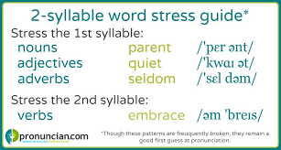

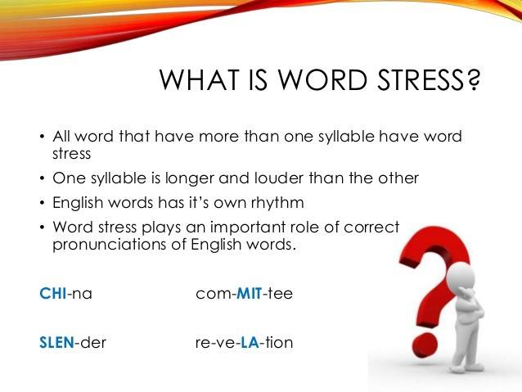

Phonetic Transcription

