Table of Contents

* [Taiga Climate or Boreal Climate](https://www.pmfias.com/taiga-climate-boreal-climate-siberian-climate-cool-temperate-continental-climate-continental-sub-polar-climate-coniferous-forests-lumbering/#Taiga_Climate_or_Boreal_Climate)
* [Boreal Climate OR Taiga Climate OR Siberian Climate OR Cool Temperate Continental Climate OR Continental Sub-Polar Climate.](https://www.pmfias.com/taiga-climate-boreal-climate-siberian-climate-cool-temperate-continental-climate-continental-sub-polar-climate-coniferous-forests-lumbering/#Boreal_Climate_OR_Taiga_Climate_OR_Siberian_Climate_OR_Cool_Temperate_Continental_Climate_OR_Continental_SubPolar_Climate)
  + [Distribution](https://www.pmfias.com/taiga-climate-boreal-climate-siberian-climate-cool-temperate-continental-climate-continental-sub-polar-climate-coniferous-forests-lumbering/#Distribution)
  + [Absent in Southern Hemisphere](https://www.pmfias.com/taiga-climate-boreal-climate-siberian-climate-cool-temperate-continental-climate-continental-sub-polar-climate-coniferous-forests-lumbering/#Absent_in_Southern_Hemisphere)
* [Taiga Climate](https://www.pmfias.com/taiga-climate-boreal-climate-siberian-climate-cool-temperate-continental-climate-continental-sub-polar-climate-coniferous-forests-lumbering/#Taiga_Climate)
  + [Temperature](https://www.pmfias.com/taiga-climate-boreal-climate-siberian-climate-cool-temperate-continental-climate-continental-sub-polar-climate-coniferous-forests-lumbering/#Temperature)
  + [Precipitation](https://www.pmfias.com/taiga-climate-boreal-climate-siberian-climate-cool-temperate-continental-climate-continental-sub-polar-climate-coniferous-forests-lumbering/#Precipitation)
  + [Climate Graph of Taiga Climate](https://www.pmfias.com/taiga-climate-boreal-climate-siberian-climate-cool-temperate-continental-climate-continental-sub-polar-climate-coniferous-forests-lumbering/#Climate_Graph_of_Taiga_Climate)
* [Natural Vegetation of Taiga Climate](https://www.pmfias.com/taiga-climate-boreal-climate-siberian-climate-cool-temperate-continental-climate-continental-sub-polar-climate-coniferous-forests-lumbering/#Natural_Vegetation_of_Taiga_Climate)
  + [Softwood trees](https://www.pmfias.com/taiga-climate-boreal-climate-siberian-climate-cool-temperate-continental-climate-continental-sub-polar-climate-coniferous-forests-lumbering/#Softwood_trees)
  + [Characteristics of Coniferous forests](https://www.pmfias.com/taiga-climate-boreal-climate-siberian-climate-cool-temperate-continental-climate-continental-sub-polar-climate-coniferous-forests-lumbering/#Characteristics_of_Coniferous_forests)
* [Economic Development of Taiga Region](https://www.pmfias.com/taiga-climate-boreal-climate-siberian-climate-cool-temperate-continental-climate-continental-sub-polar-climate-coniferous-forests-lumbering/#Economic_Development_of_Taiga_Region)
  + [Trapping](https://www.pmfias.com/taiga-climate-boreal-climate-siberian-climate-cool-temperate-continental-climate-continental-sub-polar-climate-coniferous-forests-lumbering/#Trapping)
  + [Lumbering](https://www.pmfias.com/taiga-climate-boreal-climate-siberian-climate-cool-temperate-continental-climate-continental-sub-polar-climate-coniferous-forests-lumbering/#Lumbering)
  + [Factors that favor lumbering](https://www.pmfias.com/taiga-climate-boreal-climate-siberian-climate-cool-temperate-continental-climate-continental-sub-polar-climate-coniferous-forests-lumbering/#Factors_that_favor_lumbering)
* [QUESTIONS](https://www.pmfias.com/taiga-climate-boreal-climate-siberian-climate-cool-temperate-continental-climate-continental-sub-polar-climate-coniferous-forests-lumbering/#QUESTIONS)

**Taiga Climate or Boreal Climate**

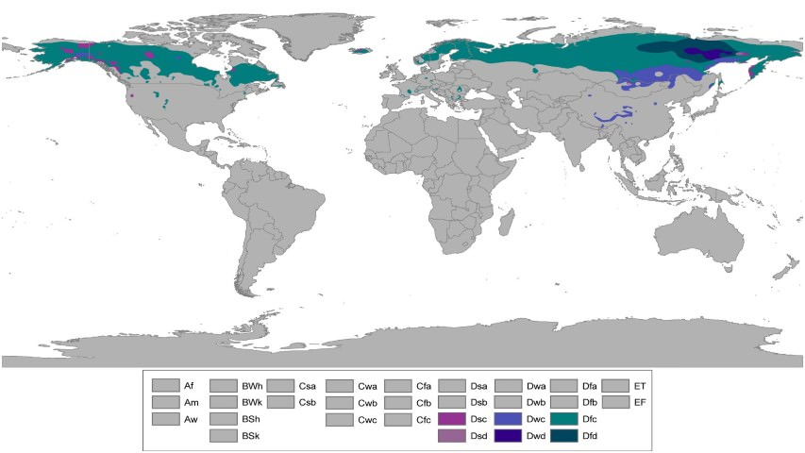

**Boreal Climate OR Taiga Climate OR Siberian Climate OR Cool Temperate Continental Climate OR Continental Sub-Polar Climate.**

* Found **only** in the northern hemisphere [due to great east-west extent. Absent in the southern hemisphere because of the narrowness in the high latitudes].
* Experienced in the regions **just below Arctic circle.**
* On its poleward side, it merges into the **Arctic tundra**.
* The climate fades into the temperate **Steppe climate.**

**Distribution**

* It stretches along a continuous belt across **central Canada**, some parts of **Scandinavian Europe** and most of **central and southern Russian**. **[50° to 70° N]**

**Absent in Southern Hemisphere**

* Narrowness of the southern continents in the high latitudes is the main reason.
* The **strong oceanic influence** reduces the severity of the winter.
* Coniferous forests are found only on the mountainous uplands of southern Chile, New Zealand, Tasmania and south-east Australia.

**Taiga Climate**

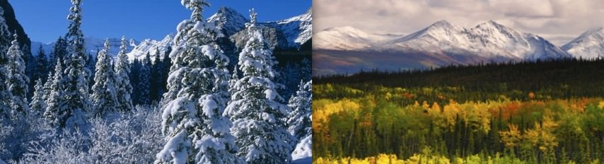

**Temperature**

* Summers are brief and warm reaching 20-25 °C whereas winters are long and brutually cold – always 30-40 °C below freezing.
* Annual temperature range of the Siberian Climate is the ***greatest [Almost 50-60 °C in Siberia].***
* Some of the lowest temperatures in the world are recorded in **Verkhoyansk** (68°N. 113°E) where -67 °C was once recorded.
* In North America, the extremes are less severe, because of the continent’s lesser east-west stretch.
* All over Russia, nearly all the rivers are **frozen**. In normal years, the Volga is ice-covered for about 150 days.
* Occasionally cold, northerly polar local winds such as the **blizzards of Canada** and **buran of Eurasia** blow violently.
* Permafrosts [a thick subsurface layer of soil that remains below freezing point throughout the year] are generally absent as **snow is a poor conductor of heat** and protects the ground from the severe cold above.

**Precipitation**

* Maritime influence in the interiors is absent.
* Frontal disturbances might occur in winter.
* Typical annual precipitation ranges from 38 cm to 63 cm.
* It is quite **well distributed throughout the year**, with a **summer maxima** [convectional rain in mid-summer – 15 °C to 24 °C]
* In winter the precipitation is in the form of snow, as mean temperatures are well below freezing all the time.

**Climate Graph of Taiga Climate**

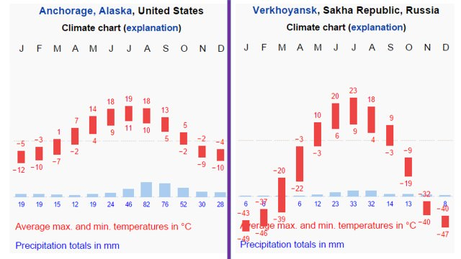

**Natural Vegetation of Taiga Climate**

* The predominant vegetation is **evergreen coniferous forest**.
* The conifers, which require little moisture are best suited to this type of sub-Arctic climate.
* The greatest single band of the coniferous forest is the **taiga** (a Russian word for coniferous forest) in Siberia.
* In Europe the countries that have a similar type of climate and forests are **Sweden** and **Finland**.
* There are small amounts of natural coniferous forest in Germany, Poland, Switzerland, Austria and other parts of Europe.
* In North America, the belt stretches from **Alaska** across **Canada** into **Labrador**.

**Softwood trees**

* The coniferous forest belts of Eurasia and North America are the **richest sources of softwood.**
* Softwood is used in building construction, furniture, matches, **paper and pulp, rayon** and other branches of the chemical industry.
* The world’s greatest softwood producers are Russia, U.S.A., Canada and the **Fenoscandian countries (Finland, Norway and Sweden).**
* In the production of **wood pulp** (by both chemical and mechanical methods), the U.S.A. is the leader.
* But in the field of newsprint, **Canada** accounts for almost half of the world’s total annual production.
* There are four major species in the coniferous forests – Pine, Fir, e.g. Douglas fir and balsam fir; Spruce and Larch.
* Their presence in **pure stands** and the existence of only a few species are a great advantage in commercial forest exploitation.
* Relatively inaccessible taiga of Siberia will remain the richest reserve of temperate softwood.

**Characteristics of Coniferous forests**

* Unlike the equatorial rain forests, Coniferous forests are of **moderate density** and are more uniform. The trees in coniferous forests grow straight and tall.
* Almost all conifers are **evergreen**. There is no annual replacement of new leaves as in deciduous trees.
* The same leaf remains on the tree for as long as five years. Food is stored in the trunks, and the bark is thick to protect the trunk from excessive cold.
* Conifers are conical in shape. Their conical shape and sloping branches prevent snow accumulation. It also offers little grip to the winds.
* Transpiration can be quite rapid in the warm summer. So, leaves are small, thick, **leathery** and needle-shaped **to check excessive transpiration.**
* The soils of the coniferous forests are **poor.** They are excessively **leached** and very **acidic**. Humus content is also low as the evergreen leaves barely fall and the rate of decomposition is slow. Under-growth is negligible because of the poor soil conditions.
* Absence of direct sunlight and the short duration of summer are other contributory factors.
* Coniferous forests are also found in regions with high elevation [Example: The forests just below the snowline in Himalayas].
* But on very steep slopes where soils are immature or non-existent, even the conifer cannot survive [Example: Southern slopes of Greater Himalayas].

**Economic Development of Taiga Region**

* Lot of coniferous forests in the northern hemisphere are still untouched due to **remoteness.**
* Only a small fraction of coniferous forests in Canada, Russia etc. are exploited leaving a huge potential for the future.
* More accessible forests are cleared for lumbering on a large scale.
* Agriculture is most unlikely as few crops can survive in the sub-Arctic climates.

**Trapping**

* Many fur-bearing animals are trapped in northerly lands of Canada and Eurasia.
* Wherever the cold is severe, the quality and thickness of the fur increases.
* The most severe winters produce the finest furs.
* In Canada trappers and hunters, armed with automatic rifles, reside in log cabins in the midst of the coniferous forests to track down these animals.
* Muskrat, ermine, mink, and silver fox are the most important fur-bearing animals.
* To ensure a more regular supply of furs many fur farms have been established in Canada and Siberia.

**Lumbering**

* This is the **most important occupation** of the Siberian type of climate.
* The vast reserves of coniferous forests provide the basis for the lumbering industry.
* **Lumberjacks:** Contract laborers called lumber jacks used to temporarily move to the forest regions to fell the trees. Now felling is done by machines.
* **Rivers for transportation:** The soft wood logs easily float on rivers. Hence rivers are used to transport logs to the sawmills located down the stream.
* **Sawmilling:** Logs are processed in saw mills into timber, plywood, and other constructional woods.
* **Paper and pulp industry:** Timber is pulped by both chemical and mechanical means to make wood pulp. Wood pulp is the raw material for paper-making and newsprint.
* **Canada and U.S.A**. are leading suppliers of **newsprint** and **wood pulp** respectively.
* **As a fuel:** Very little softwood is burnt as fuel as its industrial uses are far more significant.
* **As an industrial raw material:** In Sweden, matches form a major export item.
* From other temperate countries, timber is used for making furniture, wood- carvings, toys, packing cases etc..
* From the by-products of the timber, many chemically processed articles are derived such as rayon turpentine, varnishes, paints, dyes, liquid resins, wood-alcohols, disinfectants and cosmetics.

**Factors that favor lumbering**

Coniferous forests is characterized by the following favorable features for Lumbering.

* The conifers are **limited in species**. Pine, spruce and fir in the northern forests and larch in the warmer south are the most important.
* Unlike rainforests, they occur in **homogeneous groups [Pure stands]**. This saves time, costs and enhances the commercial value of the felled timber.
* Lumbering is normally carried out in the winter when the sap ceases to flow. This makes felling much simpler.
* The snow-covered ground makes logging and haulage [commercial transport of goods] a relatively easy job.
* The logs are dragged to the rivers and float to the saw-mills downstream when the rivers thaw [unfreeze] in spring. This has greatly assisted the lumbering industry in eastern Canada and Sweden.
* Lumbering is quite easy in Canada, Norway and Sweden as the rivers are not frozen for a greater part of the year. But in Russian taiga most of Siberian rivers drain poleward into the Arctic Ocean which is frozen for three-quarters of the year, and there are few saw-mills there.
* With the use of the Northern Sea Route, which links Murmansk and Vladivostok via the Arctic Ocean, development is increasing.
* Cheap hydro-electricity for driving the saw-mills is harnessed in the mountainous uplands of North America and Europe and has greatly assisted the lumbering industry.

**QUESTIONS**

**Which one among the following covers the highest percentage of forest area in the world? [2003]**

1. Temperate coniferous forests
2. Temperate deciduous forests
3. Tropical monsoon forests
4. Tropical rain forests

* **Distinguish between hardwoods and softwoods. What industrial uses are made of them? Account for their large scale production for export in any one country.**
* **What is meant by**

1. the taiga
2. the veld
3. the selvas