**ECOSYSTEM**

What is an Ecosystem?

The ecosystem is the structural and functional unit of ecology where the living organisms interact with each other and the surrounding environment. In other words, an ecosystem is a chain of interaction between organisms and their environment. The term “Ecosystem” was first coined by A.G.Tansley, an English botanist, in 1935.

Read on to explore the structure, components, types and functions of the ecosystem in the ecosystem notes provided below.

Types of Ecosystem

An ecosystem can be as small as an oasis in a desert, or as big as an ocean, spanning thousands of miles. There are two types of ecosystem:

* Terrestrial Ecosystem
* Aquatic Ecosystem

Terrestrial Ecosystems

Terrestrial ecosystems are exclusively land-based ecosystems. There are different types of terrestrial ecosystems distributed around various geological zones. They are as follows:

1. Forest Ecosystems
2. Grassland Ecosystems
3. Tundra Ecosystems
4. Desert Ecosystem

Forest Ecosystem

A forest ecosystem consists of several plants, animals and microorganisms that live in coordination with the abiotic factors of the environment. Forests help in maintaining the temperature of the earth and are the major carbon sink.

Grassland Ecosystem

In a grassland ecosystem, the vegetation is dominated by grasses and herbs. Temperate grasslands, savanna grasslands are some of the examples of grassland ecosystems.

Tundra Ecosystem

Tundra ecosystems are devoid of trees and are found in cold climates or where rainfall is scarce. These are covered with snow for most of the year. The ecosystem in the Arctic or mountain tops is tundra type.

Desert Ecosystem

Deserts are found throughout the world. These are regions with very little rainfall. The days are hot and the nights are cold.

Aquatic Ecosystem

[**Aquatic ecosystems**](https://byjus.com/biology/aquatic-ecosystem/) are ecosystems present in a body of water. These can be further divided into two types, namely:

1. Freshwater Ecosystem
2. Marine Ecosystem

Freshwater Ecosystem

The freshwater ecosystem is an aquatic ecosystem that includes lakes, ponds, rivers, streams and wetlands. These have no salt content in contrast with the marine ecosystem.

Marine Ecosystem

The marine ecosystem includes seas and oceans. These have a more substantial salt content and greater biodiversity in comparison to the freshwater ecosystem.

Structure of the Ecosystem

The structure of an ecosystem is characterised by the organisation of both biotic and abiotic components. This includes the distribution of energy in [**our environment**](https://byjus.com/biology/our-environment/). It also includes the climatic conditions prevailing in that particular environment.

The structure of an ecosystem can be split into two main components, namely:

* Biotic Components
* Abiotic Components

The biotic and abiotic components are interrelated in an ecosystem. It is an open system where the energy and components can flow throughout the boundaries.

Biotic Components

Biotic components refer to all life in an ecosystem.  Based on nutrition, biotic components can be categorised into autotrophs, heterotrophs and saprotrophs (or decomposers).

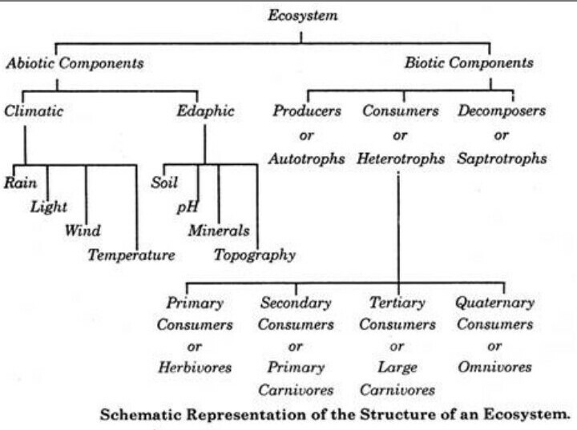

* **Producers**include all autotrophs such as plants. They are called autotrophs as they can produce food through the process of photosynthesis. Consequently, all other organisms higher up on the food chain rely on producers for food.
* **Consumers**or heterotrophs are organisms that depend on other organisms for food. Consumers are further classified into primary consumers, secondary consumers and tertiary consumers.
  + ***Primary consumers*** are always herbivores that they rely on producers for food.
  + ***Secondary consumers*** depend on primary consumers for energy. They can either be a carnivore or an omnivore.
  + ***Tertiary consumers*** are organisms that depend on secondary consumers for food.  Tertiary consumers can also be an omnivore.
  + ***Quaternary consumers***are present in some food chains. These organisms prey on tertiary consumers for energy. Furthermore, they are usually at the top of a food chain as they have no natural predators.
* **Decomposers**include saprophytes such as fungi and bacteria. They directly thrive on the dead and decaying organic matter.  Decomposers are essential for the ecosystem as they help in recycling nutrients to be reused by plants.

Abiotic Components

Abiotic components are the non-living component of an ecosystem.  It includes air, water, soil, minerals, sunlight, temperature, nutrients, wind, altitude, turbidity, etc.

Functions of Ecosystem

The functions of the ecosystem are as follows:

* 1. It regulates the essential ecological processes, supports life systems and renders stability.
  2. It is also responsible for the cycling of nutrients between biotic and abiotic components.
  3. It maintains a balance among the various trophic levels in the ecosystem.
  4. It cycles the minerals through the biosphere.
  5. The abiotic components help in the synthesis of organic components that involves the exchange of energy.

## Important Ecological Concepts

### 1. Food Chain

The sun is the ultimate source of energy on earth. It provides the energy required for all plant life. The plants utilise this energy for the process of photosynthesis, which is used to synthesise their food.

During this biological process, light energy is converted into chemical energy and is passed on through successive levels. The flow of energy from a producer, to a consumer and eventually, to an apex predator or a detritivore is called the food chain.

Dead and decaying matter, along with organic debris, is broken down into its constituents by scavengers. The reducers then absorb these constituents. After gaining the energy, the reducers liberate molecules to the environment, which can be utilised again by the producers.

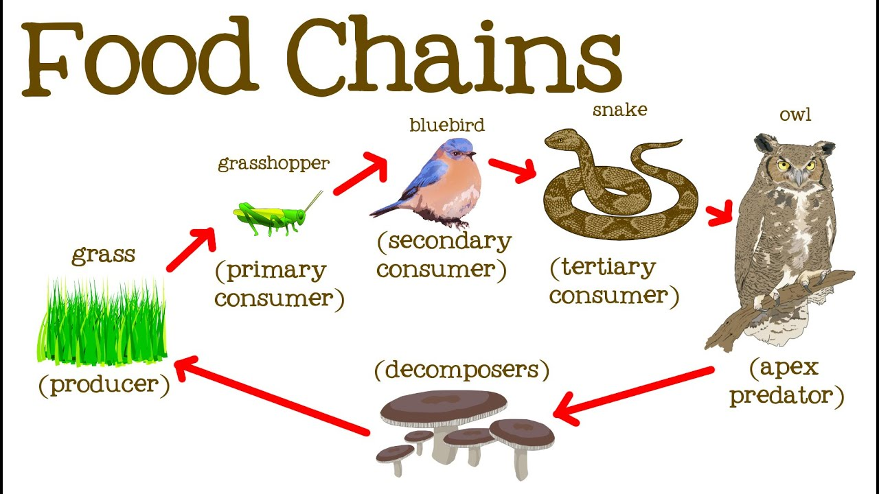

Ecological Pyramids

An ecological pyramid is the graphical representation of the number, energy, and biomass of the successive trophic levels of an ecosystem. Charles Elton was the first ecologist to describe the ecological pyramid and its principals in 1927.

The biomass, number, and energy of organisms ranging from the producer level to the consumer level are represented in the form of a pyramid; hence, it is known as the ecological pyramid.

The base of the ecological pyramid comprises the producers, followed by primary and secondary consumers. The tertiary consumers hold the apex. In some food chains, the quaternary consumers are at the very apex of the food chain.

The producers generally outnumber the primary consumers and similarly, the primary consumers outnumber the secondary consumers. And lastly, apex predators also follow the same trend as the other consumers; wherein, their numbers are considerably lower than the secondary consumers.

For example, Grasshoppers feed on crops such as cotton and wheat, which are plentiful. These grasshoppers are then preyed upon by common mice, which are comparatively less in number. The mice are preyed upon by snakes such as cobras. Snakes are ultimately preyed on by apex predators such as the brown snake eagle.

In essence:

|  |
| --- |
| **Grasshopper →Mice→  Cobra → Brown Snake Eagle** |

3. Food Web

Food web is a network of interconnected food chains. It comprises all the food chains within a single ecosystem. It helps in understanding that plants lay the foundation of all the food chains. In a marine environment, phytoplankton forms the primary producer.

