**Agro-climate**

Agro-climate is defined as the total climatic conditions making possible to cultivate the crops economically, which can be done by using agro climatic indices.

Planning of Agro climatic zones of India

With the 329 million hectares of the geographical area the country presents a large number of complex agro-climatic situations.

Several attempts have been made to delineate major agro-ecological regions in respect to soils, climate, physiographic and natural vegetation for macro-level planning on a more scientific basis. They are as follows.

Agro-climatic regions by the Planning Commission

Agro-climatic zones under National Agricultural Research Project (NARP)

Agro-ecological regions by the National Bureau of Soil Survey & Land Use Planning (NBSS & LUP)

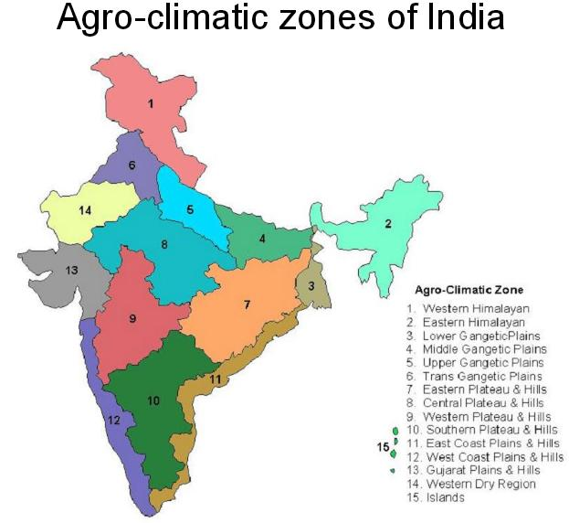

Agro-climatic regions by the Planning Commission

The Planning Commission, as a result of the mid-term appraisal of the planning targets of the Seventh Plan, has divided the country into fifteen broad agro-climatic zones based on physiography, soils, geological formation, Climate, cropping patterns, and development of irrigation and mineral resources for broad agricultural planning and developing future strategies. Fourteen regions were in the main land and the remaining one in the islands of Bay of Bengal and the Arabian Sea. The main objective was to integrate plans of the agro-climatic regions with the state and national plans to enable policy development based on techno-agro-climatic considerations. In the agro-climatic regional planning, further sub-regionalization was possible based on agro-ecological parameters.

Agro-climatic zones under National Agricultural Research Project (NARP)

National Agricultural Research Project (NARP) was launched by ICAR for initiating agricultural research in the agro-climatic zones of the country. The objective was to set up or upgrade a zonal research station in each agro-climatic zone for generating location specific, need based research targeted for specific agro-ecological situations. The focus was on analyzing agro-ecological conditions and cropping patterns and come out with a programme directly targeted to solve the major bottle necks of agricultural growth in a zone based on natural resources, major crops, farming systems, production constraints and socio-economic conditions prevalent in that zone. Stress was on technology generation. In NARP, the country was divided into 127 agro-climatic zone.

Agro-ecological regions by the National Bureau of Soil Survey & Land Use Planning (NBSS & LUP)

The National Bureau of Soil Survey & Land Use Planning (NBSS&LUP) came up with twenty agro-ecological zones based on the growing period as an integrated criteria of effective rainfall, soil groups, delineated boundaries adjusted to district boundaries with a minimal number of regions. Subsequently, these twenty agro-ecological zones were sub- divided into 60 sub-zones.

Western Himalayas

Western Plain, Kachchh, and part of Kathiwara Peninsula

Deccan Plateau

Northern Plain and Central Highlands including Aravallis

Central Malwa Highlands, Gujarat Plains, and Kathiawar Peninsula

Deccan Plateau, hot semi-arid ecoregion

Deccan (Telengana) Plateau and Eastern Ghats

Eastern Ghats, Tamil Nadu Plateau and Deccan (Karnataka)

Northern Plain, hot sub-humid (dry) ecoregion

Central Highlands (Malwas, Budelkhand, and Eastern Satpura)

Eastern Plateau (Chattisgarh), hot sub-humid ecoregion

Eastern (Chotanagpur) Plateau and Eastern Ghats

Eastern Plain

Western Himalayas

Bengal and Assam plains

Eastern Himalayas

North Eastern Hills (Purvanchal)

Eastern Coastal Plain

Western Ghats and Coastal Plain

Island of Andaman Nicobar and Lakshadweep