***AUTOMOBILE INDUSTRY IN INDIA***

1. ***Introduction***

The automobile industry is an important driver of the economic growth in India and one of the successful sectors in which the country has high participation in global value chains (GVCs).This is analyzes the role of government policy, infrastructure, and other enabling factors in the expansion of the automobile and automotive component sectors and the direction they are likely to take for growth path in the next few years.

The analysis in this chapter is organized into seven sections: The first section discusses the structure and makeup of the Indian automobile industry. The second section analyzes the growth of the sector over the past decades, while the third section discusses the role of government. The fourth section deals with other enabling factors in the growth of the industry. The fifth section analyzes initiatives in upgrading and innovation. The sixth section includes a discussion of the future scenario and the seventh section concludes.

1. **Structure and Makeup of the Indian Automobile Industry**

The Indian automobile industry – comprising of the automobile and the automotive components segments  – is one of the key drivers of economic growth of India. Being deeply integrated with other industrial sectors, it is a major driver of the manufacturing gross domestic product (GDP), exports, and employment. This sector has grown on account of its traditional strengths in casting, forging and precision machining, fabricating (welding, grinding, and polishing) and cost advantages (on account of availability of abundant low-cost skilled labour), and significant foreign direct investment (FDI) inflows. India was the sixth largest producer of automobiles globally with an average annual production of about 29 million vehicles in 2017–2018, of which about 4 million were exported.

India is the largest tractor manufacturer, second largest two-wheeler manufacturer, second largest bus manufacturer, fifth largest heavy truck manufacturer, sixth largest car manufacturer, and eighth largest commercial vehicle manufacturer. The contribution of this sector to GDP has increased from 2.77% in 1992–1993 to about 7.1% now and accounts for about 49% of manufacturing GDP (2015–2016).

It employs more than 29  million people (direct and indirect employment). The turnover of the automobile industry is approximately US$ 67 billion (2016–2017) and that of the component industry is US$ 43.5 billion (2015–2016). As per the OICA statistics, the Indian industry accounted for 4.92% of vehicle production globally in 2017 (5.38% of production in the car segment and 3.48% of production in the commercial vehicle segment).

India is a prime destination for many multinational automobile companies with aspirations of business expansion in Asia. It attracted about US$ 14.48  billion (5.2% of total) in cumulative FDI equity inflows between 2000 and 2015. The basic advantages that the country provides as an investment destination include cost-effectiveness of operations, efficient manpower, and a fast-growing dynamic market. In the past, major investments have come from Japan, Italy, and the USA followed by Mauritius and Netherlands. The industry manufactures a wide range of products to meet both domestic and international demands.

Table 1 Indian Automobile Market and Market Share (%) by segment, 2017–2018

|  |  |
| --- | --- |
| Commercial Vehicles | 3 |
| Three wheelers | 3 |
| Passenger vehicles | 13 |
| Two wheelers | 81 |

Table 1 shows the market share of different segments of the motor vehicles industry in 2015–2016. Irrespective of any policy regime, the two-wheelers segment has dominated the market share. Its share in production increased from around 54% in 1970–1971 to 80% in 1990–1991, close to 75% in the 1990s and 80% now.

Till the 1980s, the commercial vehicles were the second largest segment (after two-wheelers) holding around 20% share in production. After themid-1980s, passenger vehicles emerged as the second dominant segment, increasing its share from 7% in 1985–1986 to around 15% in 2011–2012 and 14% in 2015–2016. Sales of passenger cars touched 1.2 million units in 2006 and 3 million units in 2016–2017 to maintain the second largest market share in the industry.

Production in the sector is mainly concentrated around four large auto manufacturing hubs across the country: Delhi-Gurgaon-Faridabad in the north, Mumbai-Pune-Nashik-Aurangabad in the west, Chennai- Bengaluru-Hosur in the south, and Jamshedpur-Kolkata in the east of India.

3. **Growth Path of the Indian Automotive Industry**

3.1 **From 1950 to 1980: Very Slow-Paced Growth**

India’s indigenous passenger car industry was launched in the 1940s with the establishment of Hindustan Motors and Premier Automobiles Limited. The two companies together garnered most of the market share till the 1970s, along with Telco, Ashok Leyland, Mahindra & Mahindra (M&M), and Bajaj Auto. The market for automobiles was not large given the low rate of economic growth in the country at this time, and thus the industry had a very slow-paced growth till the 1980s.

Efforts to establish an integrated auto component industry were initiated in the 1950s. The industry was protected by high import tariffs, and the production was catered to the demands of local automobile manufacturers. Manufacturing was licensed, and there existed quantitative restrictions on imports of automobiles and automotive components. However, a significant demand for passenger cars was emerging as the country’s population and per capita income began to grow. The government felt the need to introduce modern, fuel-efficient, and low-cost utility cars that could also be affordable for “the common man.”

3.2 **First Wave of FDI from 1981 to 1991**

FDI in automotive assembly was allowed in two major waves in 1983 and in 1993. This FDI was mainly “market-seeking” in nature. Government policies such as import barriers and local content requirements contributed to the influx of FDI and helped the industry to compete with international players.

In February 1981, an Indian company called the Maruti Udyog Limited (MUL) was incorporated as a government company with Suzuki Motor Corporation as aminor partner to make an efficient people’s car for middle-income class in the country. In October 1982, the company signed the license and joint venture agreement with Suzuki. Suzuki took up 26% equity in the company and made an investment of US$ 260 million. MUL created history by rolling out its first vehicle in 13 months, the Maruti 800 in 1984. This was the first domestically produced car in the country with completely modern technology. MUL made significant strategic moves including building a very strong ancillary vendor network around it and achieved an installed capacity of one lakh unit garnering about 62% of market share in a decade.13 In 1989, Suzuki increased its equity stake to 40% and in 1992 to 50%. However, private sector participation was still restricted in the passenger car segment with only three major players  – MUL, Hindustan Motors, and Premier Automobiles Limited.

India also allowed four Japanese firms – Toyota, Mitsubishi, Mazda, and Nissan – to enter the market for light commercial vehicles through joint ventures (JVs) with Indian companies and some sharing equity with state-level governments in the 1980s.Around this time, the government also put in place a Phased Manufacturing Programme (PMP) for localization of components, under which domestic original equipment manufacturers (OEMs) had to increase the proportion of domestic inputs used in their output over a specific period. The Indian companies went ahead to have JV collaboration with several Japanese and foreign OEMs. This enabled Indian companies to benefit from equity inflows and technology transfers.15 This phase is widely regarded as the first wave of FDI in the sector.

3.3 **Second Wave of FDI Since 1992**

In the middle of 1991, the Indian Government made significant changes to its economic and industrial policies leading to the liberalization of the markets. This provided the impetus for the Indian automobile industry to flourish further. A new automobile policy was launched in 1993, facilitating the entry of global assemblers.

Auto licensing was abolished in 1991, and the weighted average tariff was loweredfrom 87% to 20.3% in 1997. The PMP policy ended in 1992. The Indian Government introduced a memorandum of understanding (MOU) system that continued to emphasize localization of components, up to 50%, for approving financial collaboration proposals on a case-by-case basis, which was raised to 70% later. Mass emission regulatory norms for vehicles were introduced, and a national highway policy was announced in this decade.

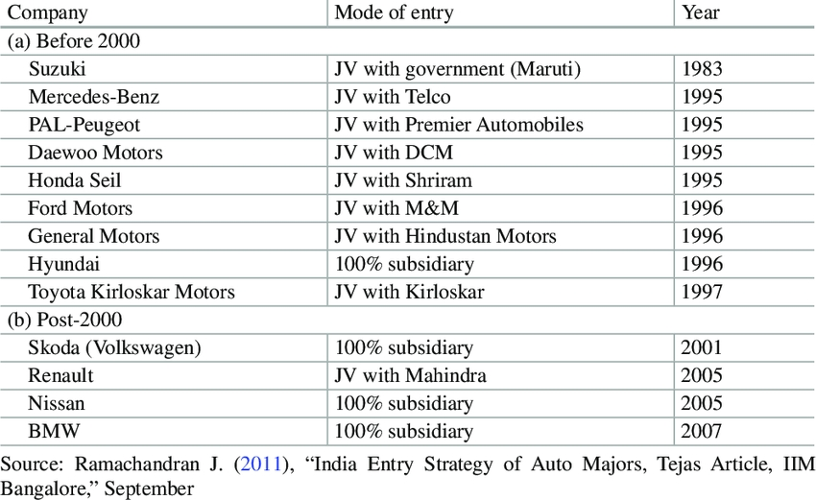

In 1997, automatic FDI approval of JVs with a 51% majority share for the foreign partner was allowed. Liberalized policies and the attraction of a huge unsaturated market made many globally competitive automakers to enter the passenger car market. The most common route of entry was through JVs with Indian firms. Some manufacturers also left the market due to increased competition.

illustrates the entry of major assemblers in the Indian market and their mode of entry for the period between 1983 and 2007. Japanese participation in the Indian automobile industry brought significant changes to the structure of the passenger car market, including utility vehicles. Gradually, established players such as Telco entered the commercial passenger car segment capitalizing on their engineering capabilities, and economies of scale,18and domestic players in the commercial vehicle segment started developing passenger cars on a limited scale. Indian companies such as Telco, M&M, Hindustan Motors, Premier Automobiles, and DCM entered into JVs with Ford, Mercedes, General Motors (GM), and Peugeot for assembly of medium-sized cars from knocked-down units. This increased the market competition and restructured pressures on existing players.

The post-1992 period is widely regarded as the second wave of FDI in the sector, which played a crucial role in bringing dynamism, diversification, and intense com-petition in the industry. Many companies started operating at a significant scale in the market and started operations in the midsize car segment. Indian companies such as Tata Motors introduced special purpose vehicles and platforms to enter the passenger car segment. This period saw creation of wide networks, as many companies had full technology and competence in producing state-of-the-art models of vehicles and had contractual arrangements with their component suppliers. The role of foreign presence in the passenger vehicle segment grew much more than all the other segments of automobiles, followed by the multi-utility vehicle segment. Thus, foreign partners now hold all or a greater share of the equity in most of these cases even though most of them initially formed JV of equal sharing of equity. The inability of the Indian partners to contribute toward capacity expansion allowed foreign partners to increase their stake or take total control by buying out their Indian partners.

In both the waves of FDI that occurred in 1983 and post-1992 period, a significant amount of FDI by the multinational corporations (MNCs) flowed into the country to build modern plants. Maruti Suzuki’s investment in the early 1980s was made possible mainly due to its willingness to invest capital. Subsequently, various MNC manufacturers have made investments of millions of US dollars in the country.

In the post-2000 period, Indian firms such as Maruti Suzuki slowly started moving toward building its own design and development capabilities. Tata Motors made rapid strides toward developing an advanced level of technological capability by launching the first indigenously developed Indian car, “Tata Indica” (1998). In 2002, M&M launched “Scorpio” as a sport utility vehicle (SUV) – a product of in-house design and development effort. In 2004, Tata Motors signed a JV with Daimler-Benz for manufacturing Mercedes-Benz passenger cars in India. The Mercedes-Benz India Limited plant assembled completely knocked-down units imported from abroad.

Increased competition led to restructuring and cutting of costs, enhanced quality, and improved responsiveness to demand. MNC automakers such as Hyundai, Nissan, Toyota, Volkswagen, and Suzuki which had established production plants in India eventually started using India as an export platform for their overseas networks. The small car segment did particularly well, and India’s potential as a global hub for manufacturing small cars began to be recognized.

Between the years 2001 and 2010, passenger vehicle sales grew at a compound annual growth rate (CAGR) of 15.67%. Of the total sales, roughly 10% were contributed by exports. Between 2000 and 2015, the average year-on-year growth rate of export of vehicles from the country was approximately 23%.22 The industry is known for export of mini hatchbacks and an evolving export base for midsize cars and compact SUVs.23 As per the World Trade Organization’s World Trade Statistical Review 2017, India was the tenth largest exporter of automobile products world-wide in 2016, accounting for US$ 13 billion worth of exports.

3.4 **Since 2001 Fully De-licensed, Free Imports and 100% FDI Allowed**

In the last decade again, various trade and investment restrictions were removed to speed up momentum for large-scale production. As of today, the government encourages foreign investment and allows 100% FDI in the sector via the automatic route. The industry is fully de-licensed, and free imports of automotive components are allowed. India is the second fastest-growing market for automobiles and components globally (after China). With an outward vision of component makers, and competitive pressures from international firms, the component industry had to upgrade process and product qualities and technology standards to gain and sustain capabilities. Many manufacturers now adhere to the global environmental norms regarding emission/technological standards and quality certifications. The industry grew by around 20% annually in the 1990s, and the average annual growth of exports was around 15% during that period. Over the years, it has been able to modernize its technology and improve quality and has developed capabilities to manufacture components for new-generation vehicles. Indian companies maintained their traditional strengths in casting, forging and precision machining, and fabricating (welding, grinding, and polishing) at technology levels matching the required scale of operations. They achieved significant success in garnering engineering capabilities and adapted to local requirements through local design.29 High growth has taken place in engine, drive transmission, and steering parts. Engine parts, being high value-added in its nature, have been contributing most to total production. Endowed with the potential of low-cost quality products, India edges over many other developing countries in component manufacturing.

Automobile production, domestic sales, and exports (in numbers) from 2011–2012 to 2016–2017.31 Further, using estimates from the SIAM of India, it is calculated that between 2001 and 2018, the CAGR of export of all vehicles from India was 20.02%.32 The estimates for other parameters – production, domestic sales, and exports – as percentage of production. Comparable data for the selected categories before 1995 is not available. However, calculations have been made by other authors for earlier periods and different segments.

There are many reasons for the impressive growth achieved by Indian manufacturers over the last two decades. These are discussed in detail in the next section. The main strengths have been a large unsaturated domestic market for small cars (and presence of a large middle economic class), low production costs (on account of availability of low-cost labor and other inputs), and skilled engineering talent.

Global affiliations and tie-ups also enabled technology upgrading and expansion of scale of production in the industry. In the passenger car segment, there are more than 30 international quality models in the market, some of which are now being exported to MNCs’ home markets.

Leading Indian manufacturers are in the process of transforming from local players to global companies. India’s domestic carmakers, viz., Tata Motors, M&M, and Ashok Leyland, have developed manufacturing facilities, significant R&D, technology development, and testing centers. In addition, Indian companies have bought capacity or made alliances with other manufacturers in East Asia, South America, Africa, and Europe. Low cost of labor and economies of scale have made India an ideal export hub for small cars. The Indian auto industry is expected to be the world’s third largest automotive market by volume by 2026. Promotion of exports has been part of companies’ business strategies for better utilization of installed capacities. Low cost of manufacturing and economies of scale achieved as a result of catering to overseas markets have allowed vehicle makers to become competitive and offset weak demand in the domestic market. Companies which have had partnerships with foreign players or received FDI have benefited in terms of engagement in GVCs.

4 **Role of the Government**

The automobile industry has in many ways been shaped by the Indian Government’s policy and nurtured in microeconomic environment it helped to create. Apart from the direct impact through fiscal policy instruments, the industry policy even influenced firm-level learning processes and shaped technological capability accumulation.

Since 1970, the Indian Government gradually added the automotive industry to a list of its core or “pillar” industries, recognizing it as a significant driver to achieve economic growth since it had many forward and backward linkages.38 The industry began to be prioritized in the manufacturing sector for promotion and favourable policy support to promote productivity. In 1975, as a general industrial policy, the government permitted an automatic capacity expansion by 25% every 5 years and removed price controls.

The share of commercial vehicles and passenger car segment also changed in response to policy changes. Indian policy had favoured the development of the commercial vehicles industry, i.e., light and heavy vehicles (for public transport of goods and passengers), as opposed to the development of passenger vehicles. Cars in particular were considered as luxury goods.40 By the early 1980s, the government had realized the need to develop the passenger vehicle segment and took decisions like permitting increased foreign capital and overseas collaborations and reduced production licenses on manufacturing operations. In 1981, the policy of “broad-banded” licenses was announced  – permitting vehicle manufacturers to produce different kinds of vehicles instead of just one kind decreed earlier. Firms were allowed greater flexibility in operations through policies such as minimum economic scale requirements, exemption from detailed Monopolies and Restrictive Trade Practices (MRTP) Act41 notification procedures. The components sector was also de-licensed substantially.

In the 1980s, government-funded training programs and cluster building also led to changes in supplier relations, enabling vendor development and effective supply chain management. More liberal import policies were introduced in 1986 when importers of capital equipment were allotted about 50% increase in their foreign exchange quota.

In July 1991, the New Industrial Policy was introduced which removed most of the constraints relating to investment, expansion, and foreign investment in the Indian industry. The system of industrial licensing was abolished for all (except 18) industries, and the passenger car industry was de-licensed in May 1993. Foreign investment was allowed on an automatic basis in 34 industries, including the automotive industry. Liberal policies of the 1990s led to the entry of new competitors and spill over benefits, especially on the technology side, and to increased expenditure on R&D and a desire to innovate to distinguish products in the market. The time span between productions of new products shortened rapidly. The policies remained tilted in favor of the domestic industry as MNCs were still required to make specified capital investments and meet export obligations. In 2001, the government removed auto import quotas and permitted 100% FDI in the sector. Excise duties were reduced to 24% on passenger cars. High tariffs forced the OEMs to set up parts-manufacturing plants in India. Institutional support for developing supplier capabilities led to the establishment of flexible supplier relationships which further helped the industry in building innovation capabilities as well. An initiative specifically targeted in this direction was the setting up of the National Automotive Testing and R&D Infrastructure Project (NATRIP) under the Automotive Mission Plan 2006–2016 (AMP 2016), costing US$ 388.5  million to enable the industry achieve parity with global standards.

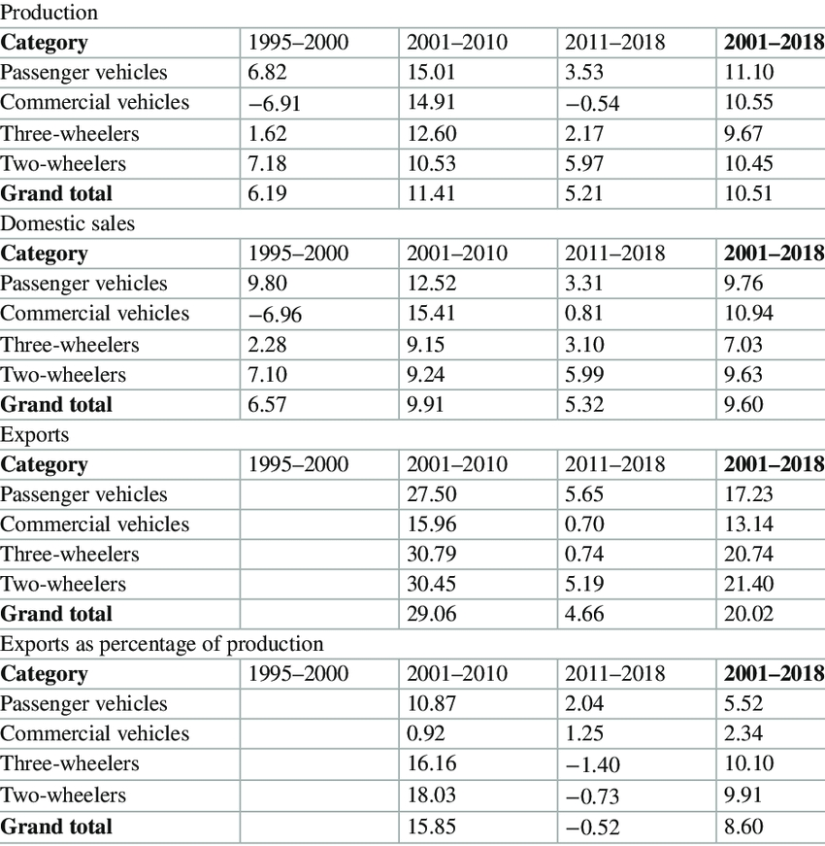

The Indian car industrial policy also protected the domestic market by setting up challenges for firms such as requirements for higher local content. This policy helped the development of basic capabilities in manufacturing and laid foundations of the auto component supplier industry. The protection policies of the 1980s and 1990s encouraged acquisition of basic production capabilities. Local content requirements or indigenization of up to 70% forced OEMs and their suppliers to make significant capital investments and created a chain of world-class component suppliers. The process of indigenization has also been recognized as a key regulation responsible for enhancing technological capabilities. This entailed collaborative effort between local suppliers and engineers from parent company and led Indian firms toward development of technological capabilities. Key interventions undertaken by the government under this plan have been in areas of tariff policy, infrastructure (improved and expanded road network, development of auto wagon rakes, creation of few specialized ports in the private sector), R&D (setting up of NATRIP, upgradation of existing canters), and promotion of electric and hybrid vehicles. Currently, the automobile manufacturing policy in Other Enabling Factors in the Growth of the Industry Other enabling factors in the growth of the industry include domestic market demand, FDI, JVs, and corporations’ competitive strategies.

5.1 **Role of Domestic Demand**

A growing working population and an expanding middle-class have been the key demand drivers for automobiles in India. India has the second largest road network in the world at 4.7  million kilometers. Road development activity has gradually increased over the years with an improvement in connectivity between cities, towns, and villages in the country. The Government of India’s policy to set aside substantial investment layout for infrastructure development in every 5-year plan has included the focus on the development of country’s roads. This has given a fillip to the demand for cars and other vehicles.

India is home to the second largest population in the world. The estimated population is about 1.3 billion people. The GDP per capita has grown from approximately US$ 1432 in 2010 to US$ 1500 in 2012 and US$ 1939 in 2017. Factors like increasing disposable incomes in the rural agriculture sector, presence of a large pool of skilled and semiskilled workers, and a strong educational system will continue to increase vehicle demand in future. It is estimated that by 2020, migration on account of urbanization will be over 140 million. India is projected to add over 68 million households to its already significant middle-class by 2030, which would drive an increased demand for automobiles. The number of registered motor vehicles per 1000 population was only 167 in 2015.55 These facts point to a huge potential of increasing private vehicle ownership penetration in the future.

5.2 **Impact of FDI**

The impact of FDI can be seen in terms of output and productivity, technology, and better practices, all of which could make the industry more competitive.

5.2.1 **Output and Productivity**

FDI has positive impact of output and productivity growth. In the period 1947–1983, the output growth remained limited. The models of cars sold were unchanged for decades, and foreign models assembled in the country were primarily European. The number of models manufactured in the passenger car segment was 2 in 1982–1983, which rose to 8 in 1994–1995 and 28 in 2001–2002.The most prominent spill over impact of FDI was on the component industry, whose turnover more than tripled from 1992–1993 to 2001–2002. Supplier productivity increased as foreign firms co-located suppliers (i.e., put them in a common area) and required home-country suppliers to invest in India. Competition was also provided by international MNCs which entered the sector to serve international assemblers, resulting in increased quality and reliability. This led to the establishment of a reliable component supplier industry, which encouraged more MNCs to enter the Indian market after the 1990s.

5.2.2 **Technology**

A significant infusion of global technology occurred with the entry of foreign firms. The first 192 cars to roll out of the Maruti Suzuki factory in December 1983 were almost entirely Japanese cars, with only tires and batteries sourced from MRF and Chloride India, respectively. Localization ambitions of Indian firms were facilitated through 40 JVs between Indian vendors and Japanese collaborators by the end of the century.

There were 50 greenfield investment projects58 in the sector between 2000 and 2007. In some clusters such as Pune and Chennai, global OEMs played important or even dominant roles in technology diffusion and were responsible for development of domestic innovation capability.

5.3 **Role of JVs**

As mentioned before, JVs and technical collaboration played a vital role as a source of innovation for local auto component supplier firms in India. Some important partnerships in the Indian automobile industry. Acquiring knowledge and skills through external collaboration is an efficient way to achieve innovation within automotive clusters. Collaborations result in frequent interactions, reflected in acquisition of knowledge, sharing, diffusing, and creation of it. Linkages among settings such as clusters result in learning through networking and interacting and are seen as important for innovative activities.

There are a number of examples in India which have shown that the JV collaboration has been an efficient way of achieving greater growth in the industry through benefits such as technology sharing, learning best practices, and training of workers. For instance, MUL’s first established plant was a close copy of Suzuki’s Kosai plant in Japan in terms of plant layout, equipment, the organization of production, and operating principle.62 Also, it was the first firm to introduce a partial “just-in-time” and total quality management in India, which aimed to reduce inventory cost. MUL followed a strategy of massive investment in the program of vendor development, involving stable and close supplier relations with its first-tier suppliers (40 top sup-pliers), equity participation in key suppliers, and promotion of technical collaboration between its suppliers with Suzuki’s suppliers in Japan.

Other lead firms of Indian origin including the TVS Group, the Rane Group, and Ashok Leyland Limited have played critical role in the development of the Chennai automobile cluster. Ashok Leyland Limited, one of the largest manufacturer of commercial vehicles, trucks, and buses in India and the world, entered into an agreement with Leyland Motors, UK, to manufacture Leyland vehicles way back in 1950. Brakes India Private Limited was founded in 1962 as a JV between TVS and Lucas Industries Limited of the UK (100% subsidiary of ZF TRW) and is the largest manufacturer of braking components and systems in India with an annual turnover of more than US$ 600 million. It exports products to 35 countries and caters to over 60% of the domestic OEM market. The Rane Group which plays a dominant role in the component segment has had critical partnerships with foreign firms like ZF TRW (USA) and NSK and Nisshinbo (Japan) for a long time. Other group firms, such as Brakes India, Sundaram-Clayton Ltd., Sundram Fasteners Ltd., and Turbo Energy Ltd., were established in the 1960s, as JVs with British firms. M&M and Bajaj Tempo also operated through JVs and developed quality products over the years.

5.4 **Firm Strategies, Ownership, and Managerial Vision**

In addition to the aforementioned reasons, an important role was played by firm strategies, ownership, and managerial vision of diversified and big business groups such as the Tata Group and M&M in building technological capabilities in the sector. For instance, the ambition and vision of Tata’s head Ratan Tata to develop the first “Indian car” and then “people’s car” were the driving forces behind the development of Tata Indica and Tata Nano. The company’s diaspora connections and family-owned diversified businesses also facilitated inter-sector learning and played a significant role.

Firms like Tata Motors and M&M had global aspirations, and their business models were focused on domestic as well as markets in other countries with similar characteristics such as those in Africa, Latin America, and South Asia. In 2004, Tata Motors bought the Daewoo’s truck-manufacturing unit in South Korea. In 2005, Tata acquired 21% share in Hispano Carrocera, SA, a Spanish bus-manufacturing firm. In 2005, M&M acquired Stokes Group, a leading auto component manufacturer in the UK. In 2008, M&M acquired Jaguar and Rover and established plants in Malaysia, Kenya, Bangladesh, Spain, Ukraine, and Russia to assemble knocked-down units exported to these countries. The same model extended to Australia, South Africa, Italy, and Uruguay. In 2006, M&M formed a JV with Marco Polo, a Brazilian firm to manufacture and assemble fully built buses and coaches. In November 2017, M&M opened its new manufacturing plant with an investment of US$ 230 million in Detroit, USA.

The profitability of group-affiliated firms exceeded that of other companies due to advantages such as greater access to funds, diversified and skilled labor, and other resources. These business groups or conglomerates were often able to fill the institutional gaps typically found in developing countries by building institutions for the benefit of group members.66

6 **Upgrading and Innovation**

Indian lead firms have made significant efforts toward upgrading over the years, including the use of advanced modular platforms, new materials, and platform sharing in India. The concept of upgrading refers to the capacity of firms to make better products, more efficiently, and move into more skilled activities. The government has been encouraging R&D in this sector by offering tax cuts on such expenditure. The NATRIP project, initiated in 2005, was set up to enable the industry to adopt and implement global performance standards and provide low cost manufacturing and product development solutions. Among Indian companies, M&M and Ashok Leyland have made significant investment in R&D centers and technology development and testing centers and have ventured abroad. Global firms have been putting up development centers in India, either on their own or in partnership with local players (for instance, GM, DaimlerChrysler AG, Johnson Controls International Plc, Delphi and Bosch). These have helped their partners acquire the global best technologies and standards in short period of time. Several global OEMs such as Ford, GM, Hyundai, Toyota, and Volvo India Pvt. Limited (Volvo) have established technology centers in India for doing R&D in automobile design. FDI in R&D and design in India has followed FDI in manufacturing. Collaborative R&D activities have opened avenues for material substitution, better vehicular design that are resource and energy efficient.

Table Number of patents granted to some leading Indian manufacturers in India (January 1,1990–July 31, 2018)

|  |
| --- |
| S. no Name of company 1990–2000 2001–2010 2011–2018 |
| 1. Tata Motors – 10 57 |
| 2. M&M Limited – 16 29 |
| 3 TVS Motor Company Limiteda 87 161 |
| 4. Maruti Suzuki Limited – – 10 |
| 5. Bajaj Auto Limited – 13 14 |
| 6. Ashok Leyland – 4 11 |
| 7. Sona Koyo Steering Systems Limited – 4 2 |

With upgraded R&D, the innovative capacity goes up naturally. One outcome or measure of this is their intellectual property (IP) rights. Most leading automobile companies are actively engaged in filing for their IP in the country. The recent patent deployment strategies of established players demonstrate considerable improvement in areas such as propulsion technology, telematics, vehicle safety, and security. Statistical data published by the World Intellectual Property Organization (WIPO) and the Office of Controller General of Patents, Designs & Trade Marks under the Indian Ministry of Commerce and Industry provide estimates related to patent applications filed by the automobile industry in India. Table 5 shows the number of patents granted to some leading Indian manufacturers in India between the period January 1, 1990 and July 31, 2018. It can be seen that the number of patent grants has increased in the last 10 years. Among Indian companies, TVS Group, Tata Motors, and M&M have been among the top Indian applicants for patents.

The majority of Indian patent applications filed by automobile companies fall under the categories of mechanical engineering, in areas like arrangement or mounting of propulsion units, transmissions systems, instrumentation for vehicles, con-joint control of drive units, arrangements in connection with cooling, air intake, gas exhaust, or fuel supply of propulsion units in vehicles.

However, suppliers or vendors are often small and medium enterprises (SMEs) which do not have many opportunities or resources to upgrade. The major challenges faced by the indigenous component manufacturers are high cost of capital, nonavailability of skilled labor, and rising price of operational cost. Stiff competition from China and other Asian countries on the price front is also emerging. Under these pressures, converging toward international safety standards would encourage firms to adopt (and contribute to) international good practices. Adoption of automation and robotics in recent times has helped the industry to significantly improve quality, productivity, and delivery outcomes and reduce costs.72 To meet the needs of the future (including electrification of vehicles) and stay competitive, SME manufacturers also need to rise up to the challenges of constant upgradation, digitization, and automation. However, in the process, they may require support from lead firms and the government.

**7 The Future Scenario**

The current policy debate in India is around the issue of achieving greater competitiveness, efficiency standards, and the need for introducing electric vehicles. The Draft National Automotive Policy 2018 formulated by the Department of Heavy Industries (Government of India) envisages increasing exports to 35–40% of the output and to make India one of the major automotive export hubs in the world. It also envisages long-term roadmap for emission standards beyond Bharat Stage VI and harmonization with the global standards by 2028.

With a view to promoting electric mobility in the country, the Indian Government approved the National Mission on Electric Mobility (NMEM) in 2011, and subsequently a National Electric Mobility Mission Plan 2020 was unveiled in 2013. This Mission Plan was designed considering the fuel security and environmental pollution in the country. It aims for a cumulative fuel saving of about 9500 million liters equivalent resulting in reduction of pollution and greenhouse gas emission of 2 million tonnes with targeted market penetration of 6–7 million vehicles by 2020. As part of this mission, the Department of Heavy Industries launched a scheme called Faster Adoption and Manufacturing of (Hybrid &) Electric Vehicles in India (FAME-India) in April 2015. The scheme is proposed to be implemented over a period of 6 years, i.e., 2020, wherein it is intended to support the hybrid electric vehicles market development and the manufacturing ecosystem to achieve self-sustenance. The scheme has four focus areas – technology development, demand creation, pilot projects, and charging infrastructure. Under this scheme, 148,275 electric/hybrid vehicles have been given direct support by way of demand incentives amounting to approximately US$ 28 million since its launch on April 1, 2015 and till June 30, 2017.

Another major initiative in this area has been the launch of the New Green Urban Transport Scheme in 2017. The objective of this scheme is to promote low-carbon sustainable public transport system in urban areas. The scheme is to be executed with the help of private sector including assistance from the central and state governments under a 7-year mission with a total cost of US$ 10.76 billion. It pushes for promotion of non-motorized transport, public bike sharing, bus rapid transit systems, intelligent transport systems, and urban freight management. With the plans of introducing electric vehicles, car manufacturers in India are gearing up to new production processes and machines. In 2017, the NITI Aayog suggested that 40% of private vehicles in the country could go electric by 2030. Currently, M&M is the only manufacturer of an electric car  – the e20, a micro vehicle at present. Mahindra Electric, a fully owned subsidiary of M&M, has announced its EV 2.0 platform roadmap for electric vehicles.

Maruti Suzuki has revealed plans to manufacture electric vehicles at a factory in Gujarat in 2017. Other companies like Volvo are also planning to expand their plug-in hybrid and electric vehicle portfolio in India. The major reason for the push toward electric mobility has been to steer India away from its overdependence on imported oil. However, about 50% of electric cars currently built by domestic companies are imported. This includes the batteries, the main part of the vehicle. Global companies like Suzuki and Toshiba have announced plans to set up battery plants in India. However, challenges like capital investment and large-scale infrastructure development remain to be addressed.

8 **Conclusion**

With its buoyant economy, a large young population, and growing foreign direct investment, India has been an attractive investment destination for global automobile and component manufacturers since the last two decades. Its growth story has been dominated by more home grown lead firms. However, absorption of global best practices has been slower than in China. Strategies of firms in the Chinese auto industry provided a boost to technological learning more quickly and broadly than in India.78 Capable of end-to-end production, India has also become an assembly hub for large cars and manufacturing hub for small cars. Firms have started exporting to other countries. India-based manufacturers are engaged in global innovation networks and sourcing suitable technologies from all over the world to complement their own R&D efforts.

The AMP 2026 envisions that by the year 2026, the Indian automotive industry will be among the top three of the world in engineering, manufacture, and export of vehicles and auto components, growing in value to over 12% of India’s GDP and generating an additional 65 million jobs. According to OICA statistics, the Indian industry accounted for just 5.38% of production in the cars segment and 3.48% of production in the commercial vehicle segment in 2017. It has also not created lead firms or MNCs of the scale that other more successful players like Japan, South Korea, and other western countries have created. In spite of the success of government policy in building auto supplier industry, India continues to be a net importer of auto components with its trade deficit for auto components increasing from US$ 210 million in 2004–2005 to US$ 4.4 billion in 2009–2010 and US$ 13.8 billion in 2015–2016.

The current policy debate is around the issue of how greater resource efficiency can be achieved and the need for newer materials in light of the industry’s plans to produce electric vehicles in India. Innovation in new product development is lagging behind and remains critical for the future of India to achieve competitive superiority or at least maintain its low-cost advantage. Manufacturing technologies need to be upgraded continuously. Large investments for developing new indigenous technologies that are green and compliant with recognized high efficiency standards would help India move up the value chain.