***CEMENT INDUSTRY IN INDIA***

***Introduction***

Cement Industry is mainly based on non-metallic mineral. Its major raw materials are limestone and coal. At present, the raw-materials that have emerged as an alternative are oceanic shells, sluge and stage. The cement industries which use oceanic shells as a raw material has been set up at Dwarka (Gujarat), Thiruananthapuram (Kerala), and Chennai (Tamil Nadu).

India is one of the largest cement producers in the world after China. First cement plant was set up in Porbandar, Gujarat in 1904 whereas the production of cement was started in 1904 in Madras (Now Chennai).

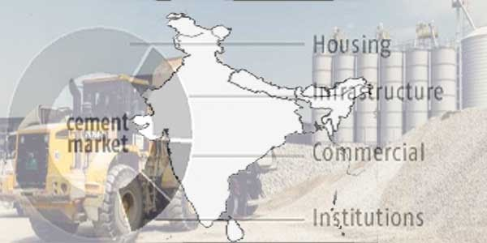

Cement is indispensible for building and construction work and cement industry is considered to be an important infrastructure core industry. It is one of the most advanced industries of India. In a developing country like India, the cement industry can play a significant role in the overall economic growth.

The per capita consumption of cement is taken as one of the important indicators of well being of the people. The average per capita consumption of cement in India was 110 kg in 2003-04 against the world average of 240 kg. This is much lower than some of the advanced countries and there is vast scope for improving the situation. India is currently on a fast track of economic growth and if, the present growth trends continue, the per capita consumption is expected to touch 130 kg in 2010 even in the face of fast growing population.

The Indian Cement Industry with Modernization and technology up-gradation has become a continuous process for industry. At present international standards and benchmarks in the quality of cement and building materials produced are met in India and is able to compete international markets.

**Plants that use Plants based sea shells, sludge and slag as raw material**

1. **Plants based sea shell:** Dwarika, Chennai, Thiruvnanthapuram and Porbandar.
2. **Plant based on sludge:** Sludge obtained from the fertilizer plant in Sindri is the base for the cement plant in Sindri.

### **Plant based on slag:** Jhinkpani (Chaibasa, Jharkhand), Bhadravati, Rourkela, Durgapur, Vishakhapatnam, Durg (Chhattisgarh) cement plants have been set up near iron and steel plants.

### ***Locational Factors:***

Manufacturing of cement requires heavy, low value and weight loosing materials and is primarily a raw material oriented industry. Limestone is the main raw material and comprises 60-65 per cent of the total product. On an average 1.5 tonnes of limestone are required to produce one tonne of cement. Hence, the location of a cement plant is based on the limestone deposits.

The other raw materials used are sea shells, slag from steel plants and slag from fertilizer plants and these raw materials influence the localisation of cement industry in their own way. Silica (20-25%) and alumina (5-12%) are also important ingredients. Gypsum is necessary to regulate the setting time of cement. Power is used in raw material grinding, clinkerisation of limestone in the kiln operation and clinker grinding along with gypsum to form cement.

The older plants required 120 to 130 units per tonne of cement produced. Modern energy efficient plants consume only 80 to 90 units per tonne. Coal is another major input along with electricity and forms 40 per cent of the total cost. Coal is used not only as fuel in the kiln but also to burn the limestone.

The ash of the burnt coal combines with the limestone to form clinkei. On an average 250 kg of coal is required to produce one tonne of cement. The quantum of other materials required to produce one tonne of cement are 4 kg of gypsum, 0.4 kg of bauxite and 0.2 kg of clay.

Cement and its raw materials are low value bulk materials and the transportation over long distance by rails and roads involves huge costs. Some of the transportation cost of transporting limestone is reduced by beneficiating this mineral at the quarry heads.

The transportation cost is also reduced if the manufacturing plant is located near the market. In fact ready market is the pre-requisite for the proper growth of an industry, producing heavy commodity with low specific cost like cement.

It is obvious from the above discussion that availability of raw materials, bulk transport facilities at reasonably low cost and market are the three main localisational factors, in that order, which favour the growth of cement industry in India.

### ***Growth of Cement Industry:***

The first attempt to manufacture cement in India was made in 1904 when a mill based on sea shells as a source of limestone was established at Chennai. But this attempt proved abortive and a really successful attempt was made in 1912-13 when the Indian Cement Co. Ltd. set up a plant at Porbandar.

World War I gave impetus to cement industry in India. Consequently, Katni Cement and Industrial Co. Ltd. at Katni (M.P.) started production in 1915 and Killick Nixon’s Bundi Portland Cement Co. at Lakheri (Rajasthan) commenced in 1916. A number of companies came into existence to make use of the post war boom. Six new factories at Dwarka (Gujarat), Japla (Bihar), Banmore, Mehgaon, Kymore (M.P.) and Shahabad (Karnataka) were erected by 1922-23.

Cement Production virtually took off the ground only after tariff protection was granted to this industry in 1924. A turning point came in 1934 when 10 out of 11 existing companies merged into the Associated Cement Co. Ltd. (ACC). The Dalmia Cement Group was also formed in 1937. This group set up factories at Dalmianagar (Bihar), Dalmiapuram (Tamil Nadu) and Dalmia (Charkhi) Dadri in Haryana.

By 1947, there were 18 cement factories with a capacity of 21.15 lakh tonnes and production of 20.16 lakh tonnes. Rapid economic progress associated with massive building programmes during the plan period accelerated the demand for cement and provided stimulus to this industry. India achieved self sufficiency in cement only in 1980s during the short five year period of partial decontrol.

Prior to that Indian cement industry had seen days of total controls, partial decontrol and imports. This industry was totally decontrolled in March, 1989 and it grew in leaps and bounds in 1990s. Today, in terms of quality, productivity and efficiency, the industry is second to none in the world. Its technology is state- of-the-art, its cost of production is one of the lowest in the world and its productivity is easily one of the highest.

Currently, the Indian cement industry is the second largest in the world after that of China. With a turnover of around Rs. 30,000 crore, the industry is the second biggest contributor to the exchequer. The Central government gets about Rs. 4,000 crore from excise duty and various state governments another Rs. 4,000 crore from sales tax yet another Rs. 2,000 crore comes from royalties, octroi and cesses.

The industry provides direct employment to 1.5 lakh persons and indirect employment to 1.2 million persons. As on 30 April 2004 there were 16 large cement plants with an installed capacity of 144.98 million tonnes. Apart from these, there are 300 mini and tiny plants spread all over the country. The estimated capacity of mini plants is about 11 million tonnes per annum. The mini plants play a supplementary role.

The concept of mini plants was accepted by the Government in 1979 to exploit smaller deposits of limestone scattered in remote and inaccessible areas. This concept was supported by incentives like 50 per cent reduction in excise duty. The main advantage of mini cement plants is that they provide employment opportunities to rural and remote areas and make cement easily available there.

Further, they help in dispersal of production capacity and reduce strain on transportation infrastructure. Over 60 companies are engaged in the production of cement. The industry has been going through a period of re-alignment or consolidated since early 1990s but still has a long way to go in this regard. The late 1990s also saw the entry of a couple of multinational through the acquisition route.

The production of cement has increased considerably during the plan period. It increased from a low of 2.7 million tonnes in 1950-51 to 8.0 million tonnes in 1960-61, 1970-71, 48.8 million tonnes in 1999-91 and 123.4 million tonnes in 2003-04

Given the enormous need for infrastructure and housing, which require large quantities of cement as a basic building material, the prospects of industry are bright. The Working Group on Cement Industry for the formulation of Tenth Five Year Plan and other studies on global competitiveness of the Indian cement industry highlight constraints such as high cost of power, high freight cost, inadequate infrastructure and poor quality of coal. In order to utilize the excess production capacity available with the cement industry, the Government has identified the following thrust areas for increasing demand:

i. Further push to housing development programmes

ii. Promotion of concrete highways. Proposed construction of 1,700 km of concrete roads under Prime Minister’s Golden Quadrilateral scheme is likely to increase demand for cement to great extent.

iii. Use of ready-mix concrete in large infrastructure projects.

iv. Construction of concrete roads in rural areas under Prime Minister’s Gram Sadak Yojana.

The Indian Cement industry today produces 11 varieties of cement including ordinary Portland cement (71%), Portland pozzolana cement (18%) and Portland blast furnace slag cement (10%). The balance one per cent is of all special cements.

***Geographical Distribution of Cement Industry in India***

Madhya Pradesh is the largest cement producer in India and hold 23 cement plants in the state. Followed by the Andhra Pradesh which holds 19 plants, Rajasthan with 15 plants and Gujarat.

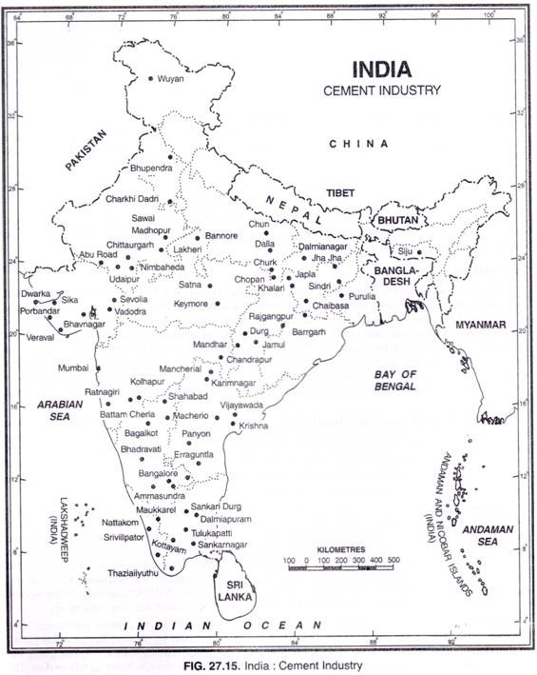

1. **Madhya Pradesh and Chhattisgarh**

The combined installed capacity and production of these two neighbouring states have enabled them to occupy a leading position among the cement producing states of India. These two states account for about 21 per cent of the installed capacity and around 22.5 per cent of the total production.

There are at present 14 cement plants in the state. The main centres of production are Satna, Kymore, Katni, Maihar, Mandhar, Gopalnagar, Durg, Akaltara, Jamul, Banmore and Tilda. Several new plants especially in the Chhattisgarh are coming up.

**Major Centre:** Katni, Jamul, Satna, Durg, Maihar, Neemach.

**2. Andhra Pradesh**

With 10.7 per cent of the total installed capacity and about 18 per cent of the total production of India. Andhra Pradesh occupies second place among the cement producing states of India. Most of the 18 plants are concentrated in the Telangana belt. The location of plants along the trunk rail route skirting the plateau along its junction with the coastal plain offers the best advantages with respect to raw material, market and transport.

Peddapalli is the biggest plant with an installed annual capacity of 7 lakh tonnes. The other important producers are Krishna, Karimnagar, Cementnagar, Vijaywada, Panyon, Macherla, Mancherial, Tandur, Vishakhapatnam, Vizianagram, Nadikundi, Erranguntla, Yerranguntala, Adilabad, etc. Several mini plants are also coming up.

**Major Centre:** Vijayawada, Karimnagar, Cementnagar, Krishna, Adilabad.

**3. Rajasthan**

Rajasthan has surpassed Tamil Nadu and is now the third largest cement producing state accounting for over 11 per cent of India. The major cement plants skirt the Aravali Range where plenty of limestone is available. The large scale conversion of metre gauge railway lines into broad gauge has given the much needed improved transport facilities and stimulates cement industry in this region.

The state has 10 major plants and the main centres of production are Sawai Madhopur, Lakheri, Chittaurgarh, Udaipur, Nimbaheda and Sirohi. With an annual capacity of 8.5 lakh tonnes, the plant at Sawai Madhopur is the largest in Rajasthan.

**Major Centre:** Hopur, Chittorgarh, Udaipur.

**4. Karnataka**

**Major Centre:** Bhadravati.

**5. Gujarat**

Gujarat has suffered a decline in its share of cement production from 12.8 per cent in 1970 to 9 per cent in 2003-04 and is now relegated to fourth position among the major cement producing states of India. Gujarat had the advantage of an early start and the earliest successful attempt to manufacture cement was made at Porbandar.

The industry enjoys the benefit of large deposits of limestone in the state. Besides, sea shell can also be used. Large market of Western India is readily available. Ten plants of the state are located at Sika, Sevolia, Okha, Porbandar, Dwarka, Vadodara, Ranavav, Veraval and Bhavnagar.

**Major Centre:** Porbandar