***ATMOSPHERE***

The atmosphere is the blanket of gases which surrounds Earth. It is held near the surface of the planet by Earth's gravitational attraction.

We all know that earth is a unique planet due to the presence of life. The air is one among the necessary conditions for the existence of life on this planet. The air is a mixture of several gases and it encompasses the earth from all sides. The air surrounding the earth is called the atmosphere.

***Earth and it's atmosphere***

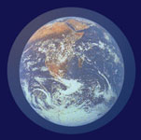

Without the atmosphere there could be no life on Earth. The atmosphere:

* contains the air we breathe;
* protects life from harmful radiation from the Sun;
* helps keep the planet's heat from the Sun from escaping back into space;
* is a major element of the water cycle;
* keeps the climate on Earth moderate compared to that of other planets.

The atmosphere is made up of a mixture of gases, mostly nitrogen, oxygen, argon and carbon dioxide. It reaches over 500km above the surface of the planet. There is no exact boundary between the atmosphere and outer space. Atmospheric gases become thinner the higher up you go. The atmosphere just keeps getting less and less dense, until it "blends" into outer space.

## ***Composition of the atmosphere***

* The atmosphere is made up of different gases, water vapour and dust particles.
* The composition of the atmosphere is not static and it changes according to the time and place.

### **Gases of the atmosphere**

* The atmosphere is a mixture of different types of gases.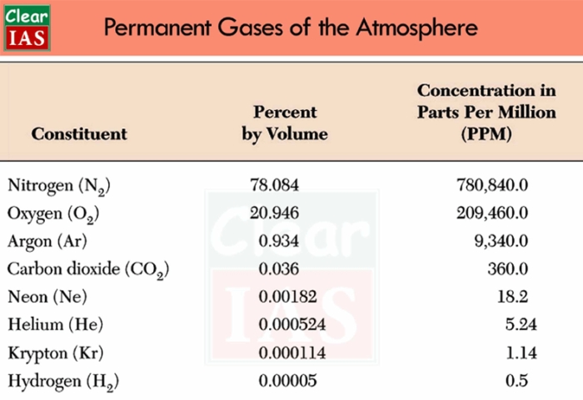
* Nitrogen and oxygen are the two main gases in the atmosphere and 99 percentage of the atmosphere is made up of these two gases.
* Other gases like argon, carbon dioxide, neon, helium, hydrogen, etc. form the remaining part of the atmosphere.
* The portion of the gases changes in the higher layers of the atmosphere in such a way that oxygen will be almost negligible quantity at the heights of 120 km.
* Similarly, carbon dioxide (and water vapour) is found only up to 90 km from the surface of the earth.

#### CARBON DIOXIDE:

* Carbon dioxide is meteorologically a very important gas.
* It is transparent to the incoming solar radiation (insolation) but opaque to the outgoing terrestrial radiation.
* It absorbs a part of terrestrial radiation and reflects back some part of it towards the earth’s surface.
* Carbon dioxide is largely responsible for the greenhouse effect.
* When the volume of other gases remains constant in the atmosphere, the volume of the carbon dioxide has been rising in the past few decades mainly because of the burning of fossil fuels. This rising volume of carbon dioxide is the main reason for global warming.

#### OZONE GAS:

* Ozone is another important component of the atmosphere found mainly between 10 and 50 km above the earth’s surface.
* It acts as a filter and absorbs the ultra-violet rays radiating from the sun and prevents them from reaching the surface of the earth.
* The amount of ozone gas in the atmosphere is very little and is limited to the ozone layer found in the stratosphere.

### **Water Vapour**

* Gases form of water present in the atmosphere is called water vapour.
* It is the source of all kinds of precipitation.
* The amount of water vapour decreases with altitude. It also decreases from the equator (or from the low latitudes) towards the poles (or towards the high latitudes).
* Its maximum amount in the atmosphere could be up to 4% which is found in the warm and wet regions.
* Water vapour reaches in the atmosphere through evaporation and transpiration. Evaporation takes place in the oceans, seas, rivers, ponds and lakes while transpiration takes place from the plants, trees and living beings.
* Water vapour absorbs part of the incoming solar radiation (insolation) from the sun and preserves the earth’s radiated heat. It thus acts like a blanket allowing the earth neither to become too cold nor too hot.
* Water vapour also contributes to the stability and instability in the air.

### **Dust Particles**

* Dust particles are generally found in the lower layers of the atmosphere.
* These particles are found in the form of sand, smoke-soot, oceanic salt, ash, pollen, etc.
* Higher concentration of dust particles is found in subtropical and temperate regions due to dry winds in comparison to equatorial and polar regions.
* These dust particles help in the condensation of water vapour. During the condensation, water vapour gets condensed in the form of droplets around these dust particles and thus clouds are formed.