***THE PACIFIC OCEAN***

#### **PACIFIC OCEAN – INTRODUCTION**

* Largest and deepest ocean.
* Covers about **one-third** of the earth’s surface.
* Average depth is generally around **7,300 metres**.
* Its shape is roughly **triangular** with its apex in the north at the **Bering Strait**.
* Many marginal seas, bays and gulfs occur along its boundaries.
* The Pacific Ocean is the largest ocean in the Earth covering one-third area.
* It extends for 16,000 kms from the East coast of Asia (west) to the West coast of Americas (east). Its north-south extension is 15,000 kms from Bering Strait (north) to the north of Cape Adre, Antarctica (south).
* The overall shape of the ocean is triangular and the average depth is 4,500 m.
* Both the coasts of the Pacific Ocean are paralleled by the chains of folded mountains, resulting in the steep abyssal plains.

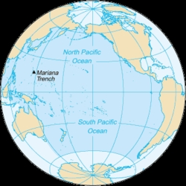

* Nearly 20,000 islands dot this vast ocean.
* The ocean has the largest number of islands (>2000). It has numerous islands, island arcs and festoons in the western coast and only few islands in the eastern coast.
* At 165,250,000 square kilometers (63,800,000 square miles) in area (as defined with an Antarctic southern border), this largest division of the [World Ocean](https://en.m.wikipedia.org/wiki/World_Ocean)—and, in turn, the [hydrosphere](https://en.m.wikipedia.org/wiki/Hydrosphere)—covers about 46% of Earth's water surface and about 32% of its total surface area, making it larger than all of Earth's land area combined (148,000,000 square kilometers).
* The centers of both the [Water Hemisphere](https://en.m.wikipedia.org/wiki/Land_and_water_hemispheres) and the [Western Hemisphere](https://en.m.wikipedia.org/wiki/Western_Hemisphere) are in the Pacific Ocean.
* Ocean circulation (caused by the Coriolis effect) subdivides it into two largely independent volumes of water, which meet at the [equator](https://en.m.wikipedia.org/wiki/Equator): the **North(ern) Pacific Ocean** and **South(ern) Pacific Ocean**. The [Galápagos](https://en.m.wikipedia.org/wiki/Gal%C3%A1pagos_Islands) and [Gilbert Islands](https://en.m.wikipedia.org/wiki/Gilbert_Islands), while straddling the equator, are deemed wholly within the South Pacific.

## ***North and Central Pacific***

* Characterized by **maximum depth** and a large number of **deeps, trenches and islands.**
* Some well-known trenches are **Aleutian**and **Kuril**.
* There are also a large number of **seamounts** and **guyots**. [Hawaiian Hotspot]

## ***West and South-West Pacific***

* Average depth is about **4,000 m.**
* It is marked by a variety of islands, marginal seas, continental shelves and submarine trenches.
* **Mariana Trench** and **Mindanao Trench** are very deep with a depth of more than 10,000 metres.

## ***South-East Pacific***

* This part is conspicuous for the **absence of marginal seas**, and has submarine ridges and plateaus.
* The **Tonga** and **Atacama** trenches are prominent.

#### **CONTINENTAL SHELF**

* The Shelves are **broad** and **extensive** along the **Eastern coasts** of **Australia** and **Asia** where the width varies from 160 – 1600 km and the depth ranges between 1000 – 2000 m.
* Several Islands are seated on broad continental shelves. E.g. Kuril Islands, Japanese Islands, Philippines, Indonesia, New Zealand, etc.
* The continental shelves carry numeral marginal seas like Bering Sea, Okhotsk Sea, Japan Sea, Yellow Sea, China Sea, Java Sea, Coral Sea, Tasmanian Sea, Arafura Sea, etc.
* The continental shelves are less extensive along the western coast of Americas, because of presence of cordillerean chains of folded mountains to the coastal lands.

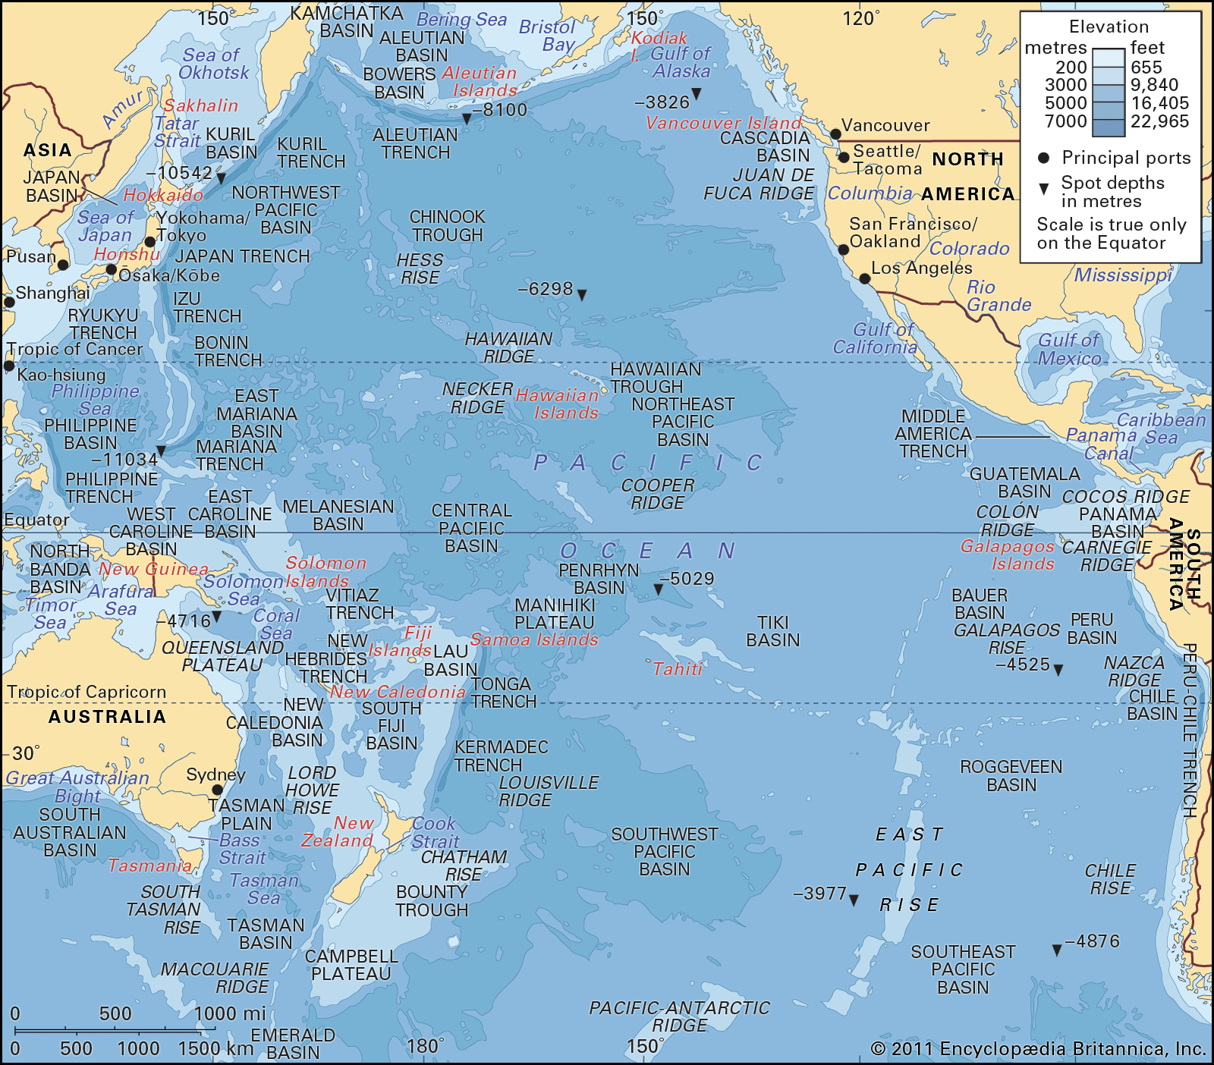

#### **EAST PACIFIC RISE**

* The Pacific Ocean does not have mid-oceanic ridge like Atlantic or Indian Ocean (only few scattered ridge of local importance).
* The East Pacific Rise or Ridge known as **Albatross Plateau** is 1600 km wide and it extends from north of New Zealand to the Californian coast.
* Other significant features in East Pacific Rise: New Zealand ridge, Fiji plateau, Hawaiian rise (most extensive ridge of the Pacific Ocean), New Guinea rise, etc.
* Fracture zones: Mendocino fracture zone, Murray fracture zone, Eastern Island fracture zone, Challenger fracture zone, etc.

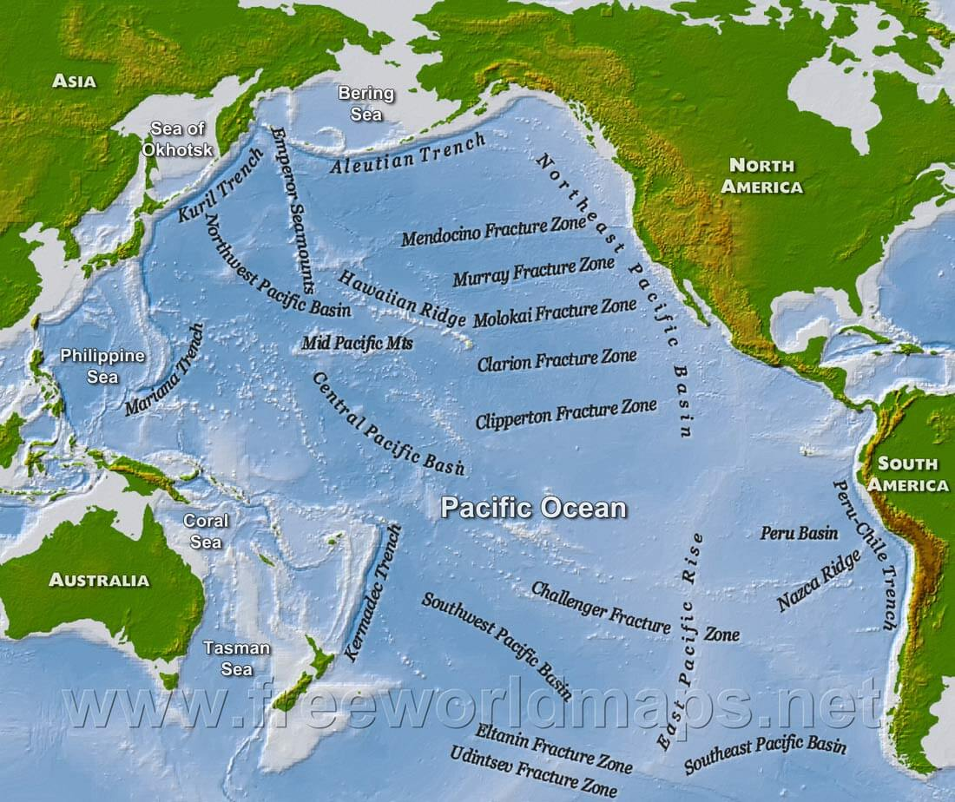

#### **OCEAN BASINS**

* There are different basins of different shapes and sizes. These basins are separated by ridges and ‘rises’.
* **Philippines Basin** is located to the east of Philippines and extends from south of Japan to 5°N latitude. Kyushu – Paian Ridge runs through the middle of  
  the basin. Average depth ranges from 5000 m – 6000 m.
* **Fiji Basin** is located to the south of Fiji Island between 10° S and 32° S latitudes and the average depth is 4000 m. The basin to the north of 20° S is known as North Fiji Basin whereas the South Fiji basin between 20° and 32°S.
* **East Australian Basin** is situated between the east coast of Australia and New Zealand Ridge with average depth of more than 5000 m.
* **South Australian Basin** also known as Jeffreys Basin is located to the south-east of Australia having average depth of 5000 m.
* Peru Basin is located to the west of Peru coast between 5° S and 24° S latitudes extends upto 110° W longitude. The average depth of the basin is 4000 m.

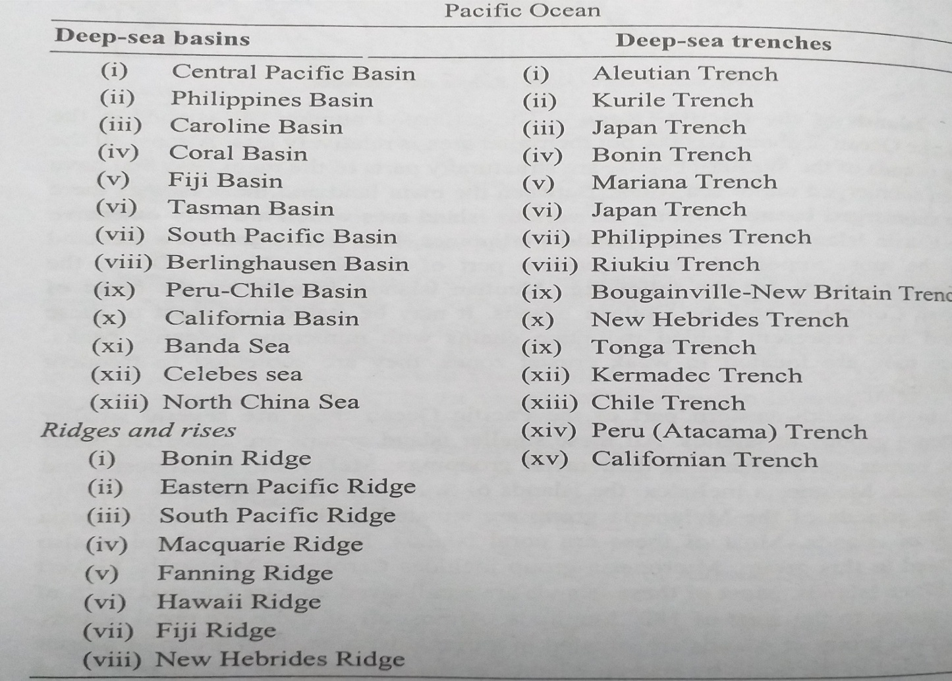

#### **OCEAN DEEPS**

* There are several trenches and deeps in the Pacific Ocean. These depressions are located either along the island arcs or mountain chains.
* These trenches are found mainly in the western Pacific Ocean.

#### **CLASSIFICATION OF PACIFIC ISLANDS**

1. the continental islands (Ateutian Islands, islands off British Columbia of Canada, and Chilean island),
2. island arcs and fes­toons (Kuriles, Japanese Archipilago, Philippines and Indonesian islands), and
3. **scattered smaller islands which are further subdivided into two major sub-categories e.g.:**

**(i) islands based on racial grouping such as:**

(a) Malanesia (Solomons, New Hebrides and Fizi),

(b) Micronesia (Marshalls, Carolines, Gilbert and Ellice),

(c) Polynesia (Society, Cook, and Tuamotu)

**(ii)** islands formed of volcanic materials and coral reefs (Hawaii island-volcanic island, Fizi, Faunafuti, Ellice etc. coral islands).

***THE ATLANTIC OCEAN***

# ***ATLANTIC OCEAN – INTRODUCTION***

* The Atlantic is the **second largest** ocean after the Pacific.
* It is roughly **half** the size of the Pacific Ocean.
* It’s shape resembles the letter ‘**S’**.
* 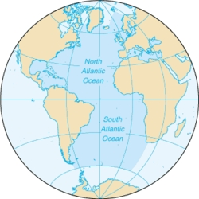In terms of **trade**, it is the most significant of all oceans.
* The **Atlantic ocean,** area of about 106,460,000 km2 (41,100,000 sq mi).
* It covers approximately 20 percent of [Earth's surface](https://en.m.wikipedia.org/wiki/Earth#Surface) and about 29 percent of its water surface area.
* It is known to separate the "[Old World](https://en.m.wikipedia.org/wiki/Old_World)" from the "[New World](https://en.m.wikipedia.org/wiki/New_World)" in [European](https://en.m.wikipedia.org/wiki/Europe) perception of [the World](https://en.m.wikipedia.org/wiki/Earth).

## ***CONTINENTAL* *SHELF***

* It has prominent continental shelf with varying widths.
* The length of the continental shelf is maximum in Northern Atlantic coasts.
* The largest width occurring off north-east America and north-west Europe.
* Grand banks continental shelf is the most productive continental shelf in the world. [Recall fishing industry in Laurentian Climate]
* The Atlantic Ocean has numerous marginal seas occurring on the shelves, like the Hudson Bay, the Baltic Sea, and the North Sea, and beyond the shelves like the Gulf of Florida (Mexican Gulf).

## ***MID-ATLANTIC RIDGE***

* The most remarkable feature of the Atlantic Ocean is the Mid-Atlantic Ridge which runs from north to the south paralleling the ‘S’ shape of the ocean.
* The ridge has an average height of 4 km and is about **14,000 km long.**

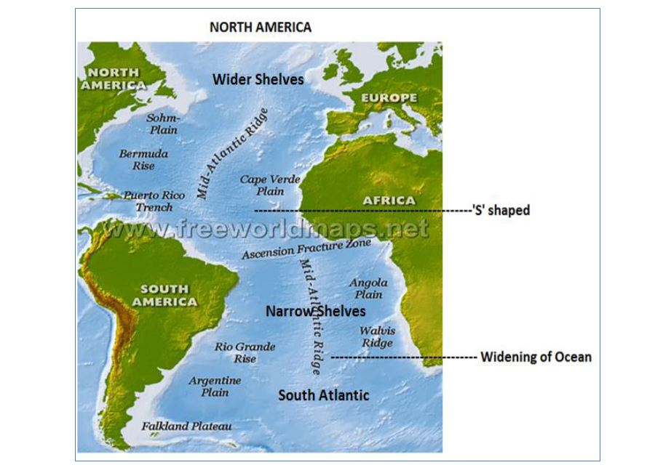

***SEAMOUNTS AND GUYOTS***

* They are present in significant numbers but not as significant as in pacific ocean.
* Several seamounts form islands of the mid-Atlantic. Examples include **Pico Island of Azores, Gape Verde Islands, Canary Islands etc.**.
* Also, there are coral islands like **Bermuda** and volcanic islands like, **St Helena** etc..

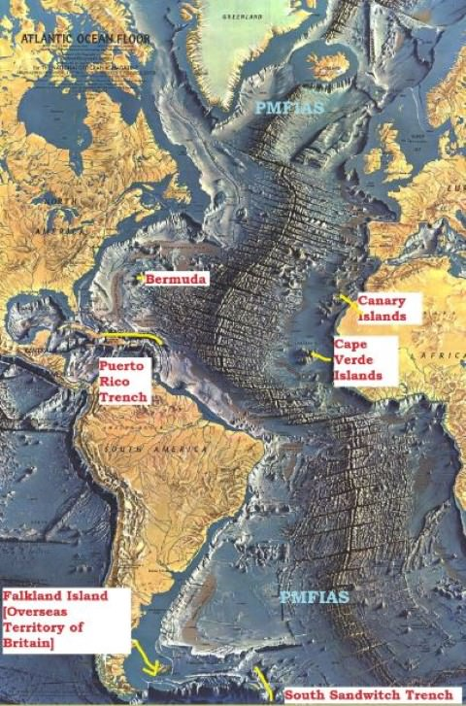

***BASINS***

* There are numerous basins surrounded by ridges and rises on the floor of the Atlantic Oceans.
* Labrador Basin – It is situated between the continental shelf of Greenland in the north and Newfoundland rise in the south. It is a comparatively shallow basin of 4000 m. depth.
* North East Atlantic Basin – It is an elongated basin stretching from north-east to south-west direction. Along the Iberian Peninsula it is known as Iberian basin. The basin is deeper in its southern portion where its depth exceeds 5000 m.
* North Western Atlantic Basin – It is perhaps the biggest basin in the North Atlantic. The depth of the whole of the basin is more than 5000 m. with few deeps in the central part.
* Cape Verde Basin – Extending longitudinally, Cape Verde basin is situated between central ridge and Africa. The basin is between 5000-7000 m. deep.
* Guinea Basin – Along the Guinea coast Africa stretching form north-west to south-east, the basin lies between Sierra Leone and Guinea ridge. It is in the form of separated basins along the coast between 5000 and 7000 m. depth. The northern basin is known as Sierra Leone Basin while the southern is Guinea basin.
* Brazilian Basin – In the South Atlantic the Brazilian basin extends south of Para rise. The depth here is more than 6000m.

## ***TRENCHES***

* The Atlantic Ocean floor is characterized by a general absence of linear deeps. This is due to the absence of rather recent fold lines along the Atlantic coast. However, there are a few very important deeps found on the ocean floor. These oceanic deeps are usually called ‘deep-sea trenches’ or ‘troughs’.
* Just to the north of Puerto Rico there is a very deep trough called Puerto Rico Deep. It is the deepest of all the troughs or deeps found on the floor of the Atlantic Ocean. It is 4812 fathoms deep.
* Atlantic Ocean**lacks** significant troughs and trenches, which are most characteristic to the Pacific Ocean.
* **North Cayman** and **Puerto Rico** are the two troughs and **Romanche** and **South Sandwich** are the two trenches in the Atlantic Ocean.

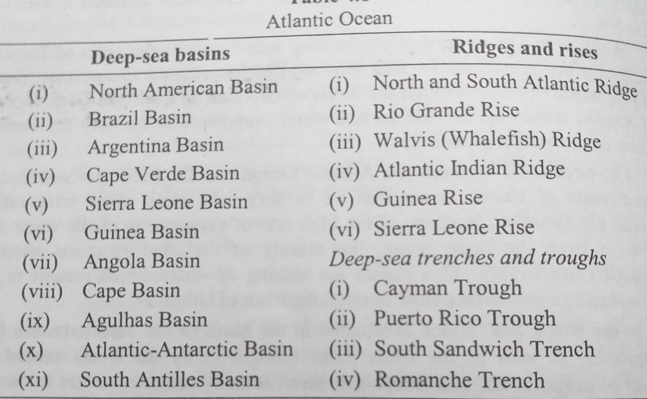

***THE INDIAN OCEAN***

***THE INDIAN OCEAN-INTRODUCTION***

* Indian Ocean is the third largest of the world’s oceanic divisions.
* Smaller and less deep than the Atlantic Ocean.



* The **Indian Ocean** is the third-largest of the world's [oceanic](https://en.m.wikipedia.org/wiki/Ocean) divisions, covering 70,560,000 km2 (27,240,000 sq mi) or 19.8% of the [water](https://en.m.wikipedia.org/wiki/Water) on [Earth](https://en.m.wikipedia.org/wiki/Earth)'s surface.
* It is bounded by [Asia](https://en.m.wikipedia.org/wiki/Asia) to the north, [Africa](https://en.m.wikipedia.org/wiki/Africa) to the west and [Australia](https://en.m.wikipedia.org/wiki/Australia_(continent)) to the east. To the south it is bounded by the [Southern Ocean](https://en.m.wikipedia.org/wiki/Southern_Ocean) or [Antarctica](https://en.m.wikipedia.org/wiki/Antarctica), depending on the definition in use.
* Along its core, the Indian Ocean has some large marginal or regional seas such as the [Arabian Sea](https://en.m.wikipedia.org/wiki/Arabian_Sea), the [Laccadive Sea](https://en.m.wikipedia.org/wiki/Laccadive_Sea), the Somali Sea, [Bay of Bengal](https://en.m.wikipedia.org/wiki/Bay_of_Bengal), and the [Andaman Sea](https://en.m.wikipedia.org/wiki/Andaman_Sea).

## ***SUBMARINE RIDGES***

* Submarine ridges in this ocean include the **Lakshadweep-Chagos Ridge [Reunion Hotspot]**, the **Socotra-Chagos Ridge**, the **Seychelles Ridge**, the **South Madagascar Ridge**, **Carlsberg Ridge etc..**
* These ridges divide the ocean bottom into many basins. Chief among these are the Central Basin, Arabian Basin, South Indian Basin, Mascarene Basin, West Australian and South Australian Basins.

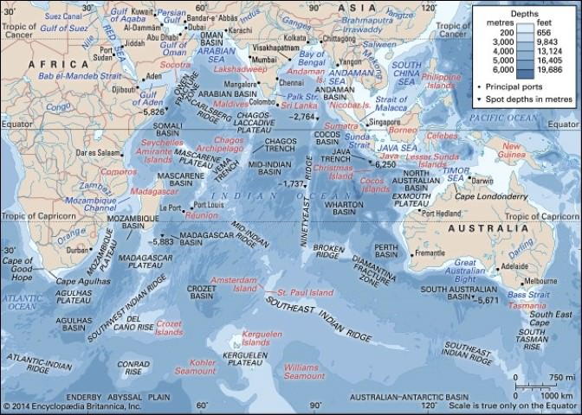

## ***SEAMOUNTS***

* Most of the islands in the Indian Ocean are **continental islands** and are present in the north and west.
* These include the Andaman and Nicobar, Sri Lanka, Madagascar and Zanzibar. The **Lakshadweep** and **Maldives** are **coral islands** and **Mauritius** and the **Reunion Islands**are of volcanic origin. The eastern section of the Indian Ocean is almost free from islands

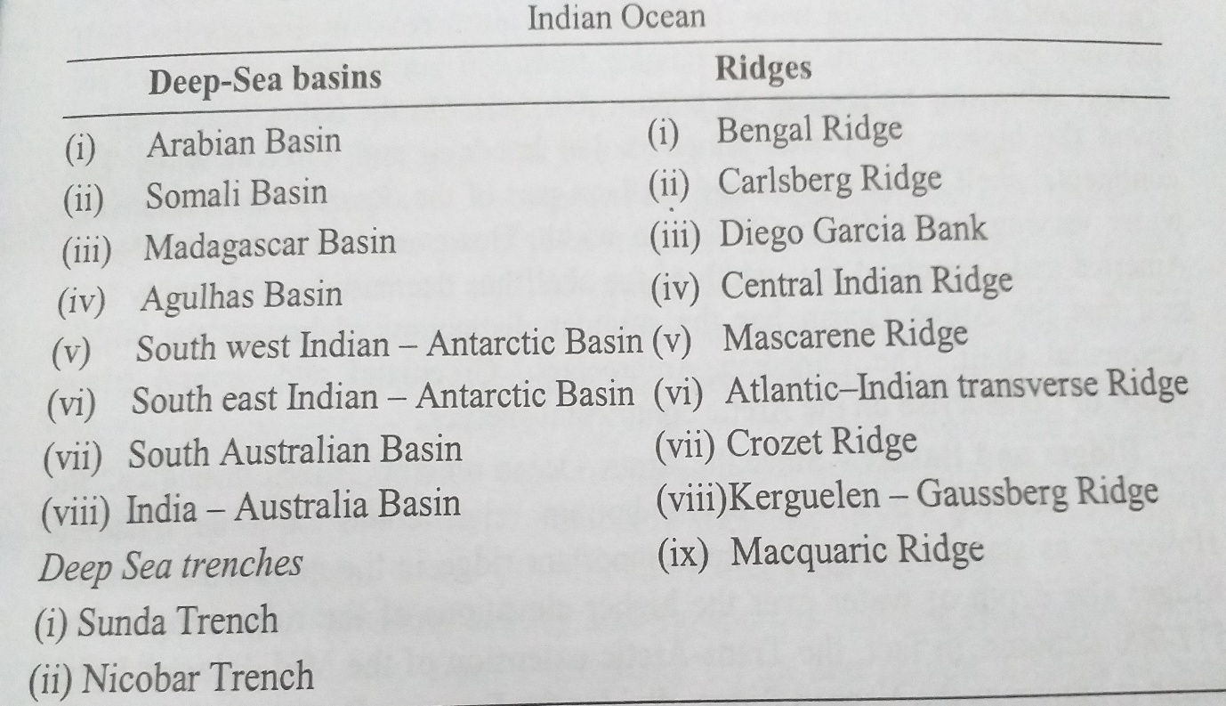

## ***CONTINENTAL SELF***

* The ocean’s continental shelves are narrow, averaging 200 kilometres (120 mi) in width.
* An exception is found off Australia’s northern coast, where the shelf width exceeds 1,000 kilometres (620 mi).
* The average depth of the ocean is 3,890 m (12,762 ft).

## ***TRENCHES***

* **Linear deeps are almost absent.** Few exceptions are **Sunda Trench**, which lies to the south of the island of Java and **Diamantina Trench**, west of Australia.
* Its deepest point is **Diamantina Deep in Diamantina Trench**, at 8,047 m. Sunda Trench off the coast of Java is also considerably deep.

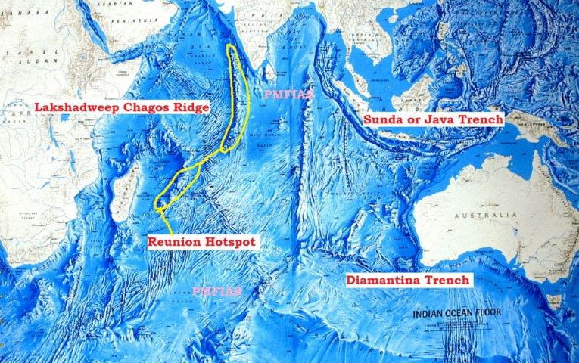

## ***STRAITS***

* Most of the straits in Indian Ocean are important trade roots.
* The major choke points include **Bab el Mandeb, Strait of Hormuz**, the **Lombok Strait**, the **Strait of Malacca** and the **Palk Strait**.

## ***MARGINAL SEAS***

* Persian Gulf
* Red Sea
* Gulf of Oman
* Gulf of Aden
* Strait of Bab-el-Mandeb connecting Arabian Sea
* Gulf of Kutch
* Gulf of Khambat
* Palk Strait connecting Arabian Sea and Bay of Bengal
* Andaman Sea
* Malacca Strait
* Mozambique Channel
* Great Australian Bight
* Gulf of Mannar
* Laccadive Sea