***BOTTOM RELIEF FEATURES OF THE OCEAN***

***INTRODUCTION:***

* About **three – fourth of the earth** is covered by **Hydrosphere**.
* The hydrosphere covers nearly 71% of the total surface area of the earth.
* The Hydrosphere is divided into Oceans, Inland Seas, Small enclosed seas, Bays, etc. on the basis of their size and location.
* The five major oceans of the earth are **Pacific Ocean, Atlantic Ocean, Indian Ocean, Antarctic Ocean** and **Arctic** **Ocean**.
* The ‘land’ under the waters of the oceans, is known as the ocean floor exhibits complex and varied features as like observed over the land
* The ocean floors are characterized by four **relief zones – Continental Shelf, Continental Slop**e, **Deep** **Sea** **Plain** and **Oceanic** **deep** or **trench**.
* Besides, these divisions, there are also major and minor relief features in the ocean floors like ridges, hills, seamounts, guyots, trenches, canyons, etc.
* The average depth of ocean is 3,800 m against the 840 m average height of lithosphere

Subterranean Water Body: The World’s largest underground ocean, i.e. Subterranean Water Body was discovered in the year 2007. This massive underground ocean extends from Indonesia to the northern tip of Russia for a length of 700 km – 1400 km below the ground surface.

#### **CONTINENAL SHELF**

* The Continental marginal areas submerged under oceanic water with average water depth of 100 fathoms (1 fathom – 6 feet) and gently sloping (1°-3°) towards the sea are called Continental Shelves.
* Continental Shelf is the extended margin of each continent occupied by relatively shallow seas and gulfs.
* It is the shallowest part of the ocean showing an average gradient of 1° or even less.
* The shelf typically ends at a very steep slope, called the shelf break.
* The continental shelves are covered with variable thicknesses of sediments brought down by rivers, glaciers, wind, from the land and distributed by waves and currents.
* Massive sedimentary deposits received over a long time by the continental shelves, become the source of fossil fuels.

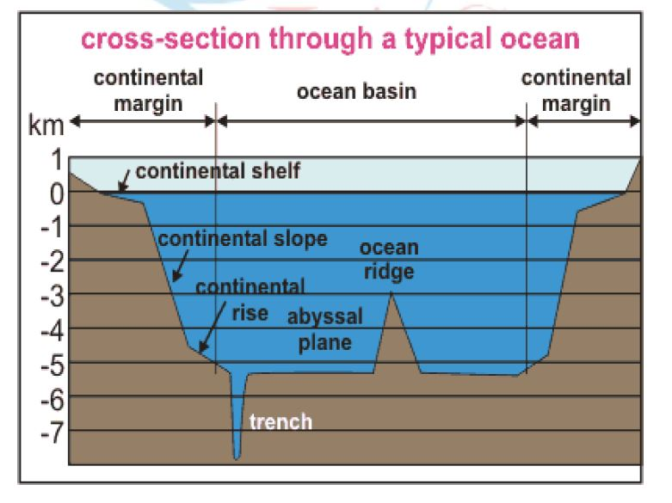

CONTINENTAL SHELF – DISTRIBUTION

* The width of the continental shelves varies from one ocean to another. The average width of continental shelves is about 80 km. The depth of the shelves also varies. It may be as shallow as 30 m in some areas while in some areas it is as deep as 600 m.  
  The width of continental shelves largely depends on the nature of reliefs of the coastal land. They are

#### The shelves are narrow, where high mountains are very close and parallel to the coast. (E.g. Pacific continental shelf along the west coast of South America, as Mount Andes run parallel to it- The shelves are almost absent or very narrow along some of the margins like the coasts of Chile).

#### The shelves are wider where the coast lands are wide plains. (E.g. The Siberian shelf in the Arctic Ocean, the largest in the world, stretches to 1,500 km in width).

### ECONOMIC SIGNIFICANCE –CONTINENTAL SHELF

* Most commercial exploitation from the sea, such as metallic-ore, non-**metallic ore, and hydrocarbon extraction,** takes place on the continental shelf.
* The shallowness enables sunlight to penetrate through the water, which encourages the growth of minute plants and other microscopic organisms – planktons (food for fishes). Thus continental shelves are the **richest fishing grounds** in the world. E.g. Grand Banks of Newfoundland, the North Sea and the Sunda shelf.
* Their limited depth and gentle slope increase the height of tides. Since ships can only enter and leave port on the tide, most of the World’s **greatest seaports** including Southampton, London, Hong Kong, Singapore and Rotterdam are located on Continental Shelves.

#### **CONTINENTAL SLOPE**

* The zone of steep slope extending from the Continental shelf to the deep sea plains is called **Continental Slope** which varies from 5°to more than 60° at different places.
* At the edge of the Continental Shelf, there is an abrupt change of gradient, forming the **Continental Slope**.
* The Continental Slope connects the continental shelf and the ocean basins.
* The most significant reliefs on the continental slopes are found  
  between 20°N and 50°N latitudes and on 80°N and 70°S latitudes.
* Generally, the steep gradient of the continental slopes does not allow any marine deposits.
* It begins where the bottom of the continental shelf sharply drops off into a steep slope.
* The**gradient** of the slope region varies between **2-5°.**
* The depth of the slope region varies between **200** and **3,000 m**.
* The slope boundary indicates the end of the continents.
* **Submarine Canyons** and **trenches** are significant reliefs in this region, generally transverse to the continental shelves and the coasts.

#### **DEEP SEA PLAIN**

* Deep Sea Plain is the flat and rolling submarine plain lying two or three miles below sea level, and covering **two-thirds of the ocean floor**, generally termed as **Abyssal Plains**.
* These are **gently sloping** areas of the ocean basins cover 75% of the total area of the ocean to the other.
* These are the flattest and smoothest regions of the world. (Modern sounding services reveal that abyssal plain is not being level and it has extensive submarine plateaux ridges, trenches, guyots basins and oceanic islands)
* The depths vary between 3,000 and 6,000 m.
* These plains are covered with fine-grained sediments like clay and silt.
* The submarine ridges with steep side-slopes reach the sea level and even project above the water surface and appear as islands. E.g. Mid-Atlantic ridge.
* Abyssal plains are the extremely flat and featureless plains of the deep ocean floor.
* Abyssal plains are considered as the levelest areas on the earth.
* They cover a major portion of the ocean floors between the depths of 3000m to 6000m.
* Abyssal plains are as irregular as the continental plains with submarine plateaus, hills, guyots, and seamounts.
* The floor of the abyssal plain is covered by sediments.
* The sediments which are formed from the remains of living things are called **Oozes**.
* Oozes can be seen in those seas which favour an abundant growth of organisms.
* Another type of sediments is **red clay**which is of volcanic origin or made up of tiny particles brought by wind and rivers.

### **OCEANIC DEEPS OR TRENCHES**

* Ocean deeps represent depressions and trenches (reaches depth of 5,000 fathoms) on the ocean floors, are the deepest parts of the ocean basins.
* Ocean deeps are grouped into
* Deeps: very deep but less extensive depressions.
* Trenches: long and narrow linear depressions. (E.g. Mariana Trench located to the west of Philippines in the North Pacific Ocean is the  
  deepest trench (11,000 metres)).
* These are generally located parallel to the coasts facing mountains and along the islands. They are more often found close to the continents, particularly in the Pacific Ocean.
* The trenches are relatively steep sided, narrow basins. They are some 3-5 km deeper than the surrounding ocean floor.
* They occur at the bases of continental slopes and along island arcs and are associated with active volcanoes and strong earthquakes. That is why they are very significant in the study of plate movements.
* As many as 57 deeps have been explored so far; of which 32 are in the Pacific Ocean; 19 in the Atlantic Ocean and 6 in the Indian Ocean.

### ***MINOR RELIEF FEATURES***

Apart from the above mentioned major relief features of the ocean floor, some minor but significant features predominate in different parts of the oceans.

#### I. MID-OCEANIC RIDGES

* A mid-oceanic ridge is composed of two chains of mountains separated by a large depression.
* The mountain ranges can have peaks as high as 2,500 m and some even reach above the ocean’s surface.
* Iceland, a part of the mid- Atlantic Ridge, is an example.

### Submarine Ridges

* The oceanic mountains are called as submarine ridges.

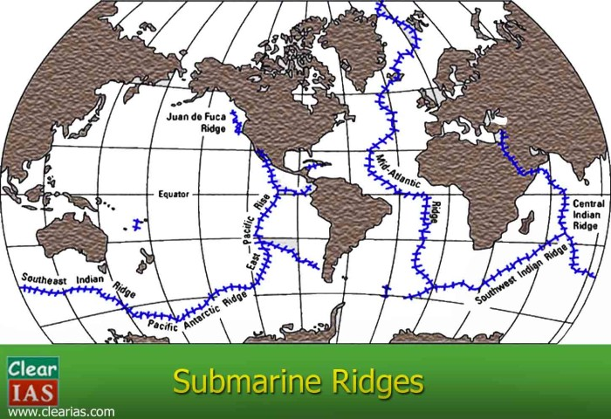

* They are linear belts occurring near the middle of the oceans and are also called mid-oceanic ridges.
* The oceanic ridge is the site of frequent earthquakes.
* Volcanism is common in ocean ridges and it produces many relief features.
* The Mid-Atlantic Ridge is the largest continuous submerged mountain ridge which runs from north to south in the Atlantic Ocean.
* At some places, the peaks rise above the sea surface to form Islands.

#### II. SEAMOUNT

* It is a mountain with pointed summits, rising from the seafloor that does not reach the surface of the ocean.
* Seamounts are volcanic in origin.
* These can be 3,000-4,500 m tall.
* The Emperor seamount, an extension of the Hawaiian Islands in the Pacific Ocean, is a good example.

#### III. SUBMARINE CANYONS

* These are long, narrow and very deep valleys located on the continental shelves and slopes with vertical walls resembling the continental canyons are called submarine canyons.
* They are sometimes found cutting across the continental shelves and slopes, often extending from the mouths of large rivers.
* Submarine canyons are classified on the morphogenesis as
* Glacially eroded canyons
* Non-glacial canyons
* The Hudson Canyon is the best known canyon in the world.

#### IV. GUYOTS

* It is a flat topped seamount.
* They show evidences of gradual subsidence through stages to become flat topped submerged mountains.
* It is estimated that more than 10,000 seamounts and guyots exist in the Pacific Ocean alone.

#### V. ATOLL

* These are low islands found in the **tropical oceans** consisting of **coral reefs surrounding a central depression**.
* It may be a part of the sea (lagoon), or sometimes form enclosing a body of fresh, brackish, or highly saline water.