Structural Detailsfor Vitamin B12
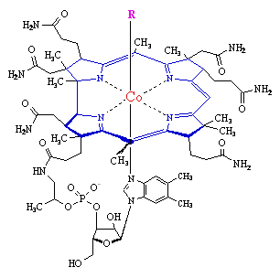 | Vitamin B₁₂ is the only known essential biomolecule with a stable metal-carbon bond, that is, it is an organometallic compound. The cobalt can link to:  - a methyl group - as in methylcobalamin  - a 5'-deoxyadenosine at the the 5' positon - as in adenosylcobalamin (coenzyme B₁₂  - a cyanide group - as in Vitamin B₁₂ - as supplied from drug companies  The particular link in the cobalamin has a profound effect upon the mechanism of the enyme reaction.  A methyl-nickel intermediate on acetyl-CoA synthase is also known, but only as an intermediate rather than a stable, isolable compound as the three cobalamins. Other organometals such as the methylmercury ion are highly toxic, it is interesting that there is an unfortunate connection between CH₃Hg⁺ and methylcobalamin.
Click on the diagrams to show Chime enhanced structures
The core of the molecule is a corrin ring with various attached sidegroups. The ring consists of 4 pyrrole subunits, joined on opposite sides by a C-CH₃ methylene link, on one side by a C-H methylene link, and with the two of the pyrroles joined directly. It is thus like a porphyrin, but with one of the bridging methylene groups removed. The nitrogen of each pyrolle is coordinated to the central cobalt atom. . | 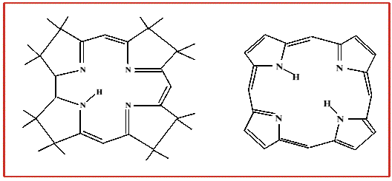

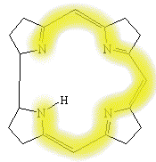  Links are to Chime pbd files to enable comparisons of the structures | The sixth ligand below the ring is a nitrogen of a 5,6-dimethylbenzimidazole. The other nitrogen of the 5,6-dimethylbenzimidazole is linked to a five-carbon sugar, which in turn connects to a phosphate group, and thence back onto the corrin ring via one of the seven amide groups attached to the periphery of the corrin ring. The base ligand thus forms a 'strap' back onto the corrin ring. An important aspect of the corrin ring, when compared to the porphyrin, is the relative flexibility of the corrin system, the corrin ring is also less flat when viewed from the side than is a porphyrin ring. This adds up to some considerable differences between the chemistry of a cobalt porphyrin and a cobalt corrin. In addition, the corrin only has a conjugated chain around part of the ring system, whereas a porphyrin is delocalised around the whole four pyrolle rings.
The center-piece in the structure is of course the cobalt(III), the octahedral coordination to five nitrogens and a carbon is common to all three cobalamins, and can be found in a number of simple coordination complexes. The simple complexes have attracted wide interest as models for cobalamins.

